
PRESS RELEASE
Swissbit at GPEC 2024: Secure data retention for police agencies and government authorities
May 6–8, 2024
Hall 2, Booth J41
Bronschhofen, Switzerland. April 4, 2024 – For the first time, storage and security specialist Swissbit will be represented at the General Police Equipment Exhibition & Conference (GPEC) to be held from May 6 to 8, 2024 in Leipzig, Germany. GPEC is the largest closed-to-the-public special event for police and other security agencies in Europe. Swissbit will present its innovative iShield Archive solution in Hall 2 at Booth J41. The microSD card was developed especially for the secure retention of video and image recordings, making it ideal for use by police agencies, government authorities, and other organizations where the confidentiality of sensitive data and privacy protection as per GDPR have top priority. Several state police agencies in Germany are already using iShield Archive cards in drones.
The secure storage of evidence plays a central role in police operations. With iShield Archive, police agencies can ensure that video and image recordings of crime scenes, deployments or observations remain confidential and safe from unauthorized access at all times. The microSD card encrypts all data on the hardware side with the proven AES 256-bit standard for the highest level of security. Since it is compatible with all popular camera types, it can be easily integrated into existing systems. With iShield Archive, authorities can add another layer of security to drones, body cams and numerous other types of cameras.
Plug-and-play for easy operation
Setting up iShield Archive is easy. With the free iShield Archive Tool (iAT), administrators can configure the security settings and assign user PINs. Once set up, the iShield Archive card records the data on its hardware reliably and encrypted with AES 256-bit.
Access protection via user PIN and WORM mode
After the camera has been turned off or the microSD card removed from it, the data recorded on iShield Archive is no longer visible. It can be read, downloaded or deleted only with the iAT software and the correct user PIN. Optionally, the data can also be protected from deletion with an admin PIN, which is why the iShield Archive can also be used in environments with role-based access controls.
In the so-called WORM (write once, read many) mode, regular users have only read access via their user PIN and are therefore unable to change or delete data. This method is particularly suitable for storing evidence or other sensitive data that must be archived in a manner that is legally secure and cannot be altered.
Field-tested: Agencies rely on iShield Archive
The increasing importance of data security and privacy in police work is also reflected in the acceptance of iShield Archive. Several German state police agencies are already using the microSD card to protect sensitive data in their drones.

Available images
The following images are available for download in printable format at: https://kk.htcm.de/press-releases/swissbit/
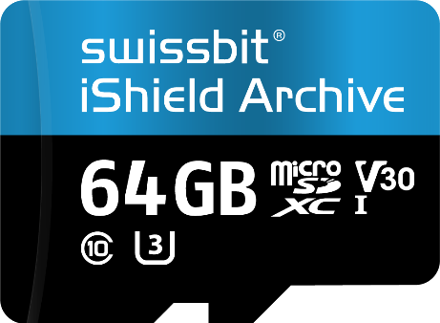  Image source: Swissbit  iShield Archive from Swissbit: The microSD card features encryption functionality for effective access protection of video and image data. |   Image source: Swissbit  Swissbit will be at the GPEC (General Police Equipment Exhibition & Conference) for the first time in 2024.

About Swissbit
Swissbit AG is the leading European manufacturer of storage, security and embedded IoT solutions for demanding applications. Swissbit combines its unique competences in storage and embedded IoT technology with its advanced packaging know-how. This expertise allows our customers to reliably store and protect data in industrial, NetCom, automotive, medical, and fiscal applications as well as across the Internet of Things (IoT).
Swissbit develops and manufactures industrial-grade storage and security products “Made in Germany” with high reliability, long-term availability, and custom optimization.
Swissbit’s storage range includes SSDs with PCIe and SATA interface such as mSATA, Slim SATA, CFast™, M.2 and 2.5” as well as CompactFlash, USB flash drives, SD Memory Cards, micro-SD Memory Cards and managed NAND BGAs like e.MMC. Security products are available in various application specific editions as USB flash drives, SD Memory Cards, and micro-SD Memory Cards.
Swissbit was founded in 2001 and has offices in Switzerland, Germany, USA, Japan and Taiwan. Swissbit owns the registered trademarks Swissbit® and Hyperstone®. Since 2020, the independent investment firm Ardian is holding a majority stake in the company to support its growth.
For further information, please visit www.swissbit.com
Regional Headquarters:  Swissbit Germany AG  Bitterfelder Strasse 22  12681 Berlin  Germany  Tel: +49 30 936 954 0  Email: info@swissbit.com  www.swissbit.com | Headquarters:  Swissbit AG  Industriestrasse 4  9552 Bronschhofen  Switzerland  Tel: +41 71 913 03 03  Email: info@swissbit.com  www.swissbit.com
Contact:  Swissbit AG  Marian Weber  Industriestrasse 4  9552 Bronschhofen  Switzerland  Tel: +49 172 854 88 26  Email: marian.weber@swissbit.com  www.swissbit.com | Press Agency:  HighTech communications GmbH  Brigitte Basilio  Brunhamstrasse 21  81249 Munich  Germany  Tel: +49 89 500778-20  Email: b.basilio@htcm.de  www.htcm.de

