PRESS RELEASE
Automatic program change in the intelligent factory
The PCB controls the SMT line
Munich (Germany), March 20, 2024 – On SMT production lines with ASMPT hardware and software, program changes can now be carried out fully automatically – even without a barcode reader – by passing the data of the respective PCB from machine to machine via a standardized interface.
The IPC-HERMES-9852 industry standard makes it possible to electronically transmit PCB data from machine to machine. Based on this capability, DEK TQ solder paste printers, Process Lens SPI systems and SIPLACE placement machines from ASMPT can automatically load the respective production program as needed. It is no longer necessary to read a barcode on each machine. The open, standardized interface also makes it possible for each conveyor system to automatically adapt to the respective width of the PCBs, regardless of the manufacturer.
PCB data is automatically checked
Already at the start of the line, as PCBs are unloaded from a magazine, their data is transmitted to the solder paste printer, either via a barcode reader or via IPC-HERMES-9852. The system uses this data to select the production program to be executed. If a batch change is required, the new production program is downloaded automatically. If any retooling is required, WORKS Operations, the application that controls the human operators on the lines, calls a qualified specialist.
SPI systems and placement machines also change automatically
Once printed, the PCB is passed along to the Process Lens along with its IPC-HERMES-9852 data. The SPI system checks the board data and changes the program, if necessary. Then it’s the turn of the placement machines, which, like the solder paste printer, check the PCB data, automatically change the program if necessary, and call an operator via WORKS Operations.
Standardized interfaces instead of barcode readers
“Previously, PCB data could not be passed from machine to machine. Instead, each machine had to query this data individually from a higher-level system after reading the barcode,” explains Volker Sindel, Senior Product Manager at ASMPT. “Now, the data can be passed on much more elegantly via the IPC-HERMES-9852 interface, which eliminates the need for a barcode reader on each machine. Thanks to the standardized interface, automatic program changes can also be supported by third-party systems, making it possible to implement them along the entire SMT line in the intelligent factory.”

Illustrations for downloading
The following print-ready artwork is available on the internet for downloading:
https://kk.htcm.de/press-releases/asmpt/

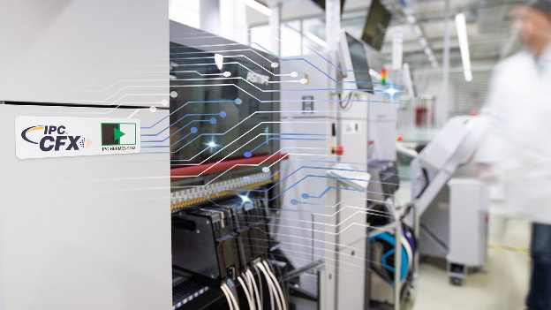
Via the IPC-HERMES-9852 interface, PCB data can be seamlessly passed from machine to machine in the SMT line.

Image credit: ASMPT

About ASMPT Limited (“ASMPT”)
ASMPT Limited is a leading global supplier of hardware and software solutions for the manufacture of semiconductors and electronics. Headquartered in Singapore, ASMPT’s offerings encompass the semiconductor assembly & packaging, and SMT (surface mount technology) industries, ranging from wafer deposition to the various solutions that organise, assemble and package delicate electronic components into a vast range of end-user devices, which include electronics, mobile communications, computing, automotive, industrial and LED (displays). ASMPT partners with customers very closely, with continuous investment in R&D helping to provide cost-effective, industry-shaping solutions that achieve higher productivity, greater reliability, and enhanced quality.
ASMPT is listed on the Stock Exchange of Hong Kong (HKEX stock code: 0522), and is one of the constituent stocks of the Hang Seng Composite MidCap Index under the Hang Seng Composite Size Indexes, the Hang Seng Composite Information Technology Industry Index under Hang Seng Composite Industry Indexes, the Hang Seng Corporate Sustainability Benchmark Index, and the Hang Seng HK 35 Index.
To learn more about ASMPT, please visit us at asmpt.com.

The ASMPT SMT Solutions segment
The mission of the SMT Solutions segment within ASMPT is to implement and support the Intelligent Factory at electronics manufacturers worldwide.
ASMPT solutions support the networking, automation, and optimization of central workflows with hardware, software and services that enable electronics manufacturers to transition to the Intelligent Factory in stages and enjoy dramatic improvements in productivity, flexibility, and quality. With its integrated open automation concept, ASMPT opens the door for its customers to economically feasible automation, entirely in accordance with their individual requirements – modular, flexible, and vendor-independent.
The product range includes hardware and software such as SIPLACE placement solutions, DEK printing solutions, inspection and storage solutions, and the Software Suite WORKS. With WORKS, ASMPT offers electronics manufacturers high-quality software for planning, controlling, analyzing and optimizing all processes on the shop floor. Maintaining close relationships with customers and technology partners is a central component of ASMPT’s strategy.
For more information about ASMPT SMT Solutions visit smt.asmpt.com.

Media contacts:
Global ASMPT Press Office
ASMPT Ltd.
Susanne Oswald
Rupert-Mayer-Strasse 48
81379 Munich
Germany
Tel: +49 89 20800-26439
E-Mail: susanne.oswald@asmpt.com
Website: asmpt.com

HighTech communications GmbH
Barbara Ostermeier
Brunhamstrasse 21
81249 Munich
Germany
Tel.: +49-89 500778-10
Fax: +49-89 500778-78
E-mail: b.ostermeier@htcm.de
Website: www.htcm.de

