PRESS RELEASE
Safe power distribution in mobile machines
Robust high-voltage power distributors based on printed circuit boards
Niedernhall, Germany, 19 March 2024 – The trend towards electromobility is present throughout the world of mobile machinery and commercial vehicles. There is hardly any vehicle manufacturer that does not deal with this topic. As a development partner and supplier of power distribution systems for these industries, Würth Elektronik ICS assists and helps its customers to implement new machines with alternative drives. With its High Voltage Power Distribution Units (HV PDUs), the company offers solutions for power distribution up to 1000 V that are compact, robust and can also be flexibly configured.
In developing its HV PDUs, Würth Elektronik ICS is able to draw on its decades of expertise in the areas of high-current management and press-fit technology. This technology has proven to be particularly beneficial in the series production phase. Many well-known manufacturers of mobile machines and commercial vehicles have implemented successful projects and are now impressed by the advantages of PCB-based HV PDUs.
Press-fit technology offers major benefits
‘We have enormous expertise when it comes to connecting components to the PCB and we have our own portfolio of connectors and Powerelements using press-fit technology. This allows us to connect a wide variety of HV components to the circuit board and so map a large number of safety-relevant and diagnostic functions,’ explains Ludovic Frelin, Product Manager for HV solutions at Würth Elektronik ICS.
Press-fit technology makes it possible to implement compact and robust solutions that have proven to be reliable and successful under extreme operating conditions. Low contact resistance leads to high current-carrying capacity and low heat generation. Power distribution solutions with press-fit technology also offer a decisive advantage in the series production phase as the need for time-consuming and error-prone wiring is eliminated. Often, the cables can simply be connected using plug-and-play. Maintenance is just as easy.
Power distributors in the high-voltage range
The HV PDUs from Würth Elektronik ICS ensure stable and secure connections in the voltage range of 60 V_{DC} to 1000 V_{DC} for an optimal distribution of power between battery, on-board charger, inverter and other consumers such as heaters or DC/DC converters. The compact power distributors are fitted in carefully sealed, corrosion-proof housings and allow important components and functions to be integrated. These include: fuses and protective devices, pre-charging functions, current, voltage and temperature measurement, insulation monitoring, HVIL and shielding. Parts of battery management can also be integrated into PDUs. This reduces the overall size of the system and makes it more reliable.
Further control and diagnostic functions can be added by integrating controllers into the HV PDUs. Here too, Würth Elektronik ICS draws on its many years of expertise in electronics development and offers customised control modules for the HV PDUs on customer request.
‘Power distributors are one of the few components in the HV electrical system that are developed individually for each vehicle,’ explains Ludovic Frelin. ‘We offer a complete service with electromechanical and electronic design, from concept to series production, hardware development, software development, testing and qualification. This way, we can help our customers – including many start-ups in the field of e-mobility – to achieve their ambitious goals.’

Available images
The following images are available for download in printable format at:
https://kk.htcm.de/press-releases/wuerth-ics/
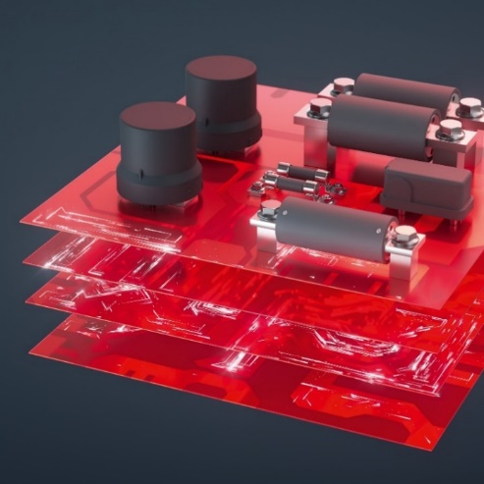  Image source: Würth Elektronik ICS  The ongoing electrification of vehicles has strengthened one particular product area at Würth Elektronik ICS: high-voltage solutions | 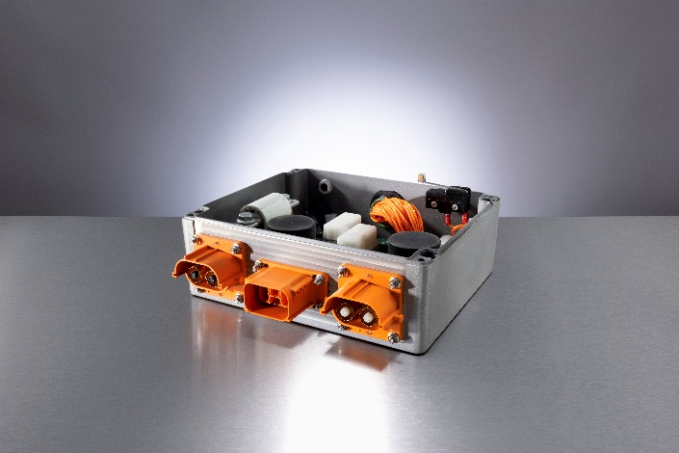  Image source: Würth Elektronik ICS  HV Power Distribution Units in the voltage range of 60 V_{DC} to 1000 V_{DC} distribute power between the battery, on-board charger, inverter and other consumers such as heaters and DC/DC converters.

About Würth Elektronik ICS GmbH & Co. KG
Würth Elektronik ICS is a system provider for electromechanical and electronic solutions for signal and power distribution, function control as well as display and operating solutions. Its main customers include well-known manufacturers of construction and agricultural machinery, as well as commercial vehicles. Sectors such as industrial technology or renewable energies also benefit from products and services provided by ICS. Its company headquarters are located in Niedernhall-Waldzimmern, Germany. There are subsidiaries of the company in France, Italy, the UK, the US and India.
Würth Elektronik is part of the Würth Group, the global market leader in the development, manufacture and sale of assembly and fastening materials, and employs 7,900 people. In 2023, the Würth Elektronik Group generated sales of €1.24 billion.
Würth Elektronik: more than you expect!
You can find more information at www.we-online.de/ics
Further information:  Würth Elektronik ICS GmbH & Co. KG  Sandra Herter  Gewerbepark Waldzimmern  Würthstrasse 1  74676 Niedernhall, Germany  Tel.: (+49-7940) 9810-1503  E-mail: sandra.herter@we-online.de  www.we-online.de/ics | Press contact:  HighTech communications GmbH  Marcus Planckh  Brunhamstrasse 21  81249 Munich, Germany  Tel.: (+49-89) 5007-7822  E-mail: m.planckh@htcm.de  www.htcm.de

