Press release
Schröder Group: Review of Dach + Holz 2024
PowerBend Multi steals the Show
Wessobrunn-Forst (Germany), 18 March 2024 – The Schröder Group, known for its folding machines and shears, can look back on an extremely successful Dach + Holz. Especially on the second and third day of the exhibition in Stuttgart, the machine manufacturer experienced a veritable rush on its stand 7.410 in hall 7, where it presented motorized folding machines and shears in addition to classic manual sheet metal folders. Visitors were particularly fascinated by the capabilities of the PowerBend Multi folding machine.
Just like the other MAKU motorized folding machine on display, the PowerBend Multi is also capable of conical bending. Thanks to the electronically controlled two-axis back gauge, it can be used to produce conical and form-fit plug-in profiles with a precision in the tenth of a millimeter range.
Another innovation of this folding machine for processing thin sheet metal up to 2.5 mm sheet thickness is the clamping function: in combination with the option of the rotating clamping beam, it is possible to reset the clamping beam, clamp the sheet and make room for the folding beam to fold hems. The demonstration of radius bending was also met with great interest. Here, the PowerBend Multi benefits from NC control technology developed within the Schröder Group for industrial folding machines: The PowerBend Multi masters "radius step bending". This involves pressing the sheet metal with the clamping beam against an angle formed by the bottom beam and the folding beam. This creates a slight curve. This is now repeated in fine steps as often as required. The result is a rounded sheet that shows no signs of its gradual reshaping.

Available images
The following images are available for download in printable format at:
https://kk.htcm.de/press-releases/schroeder/
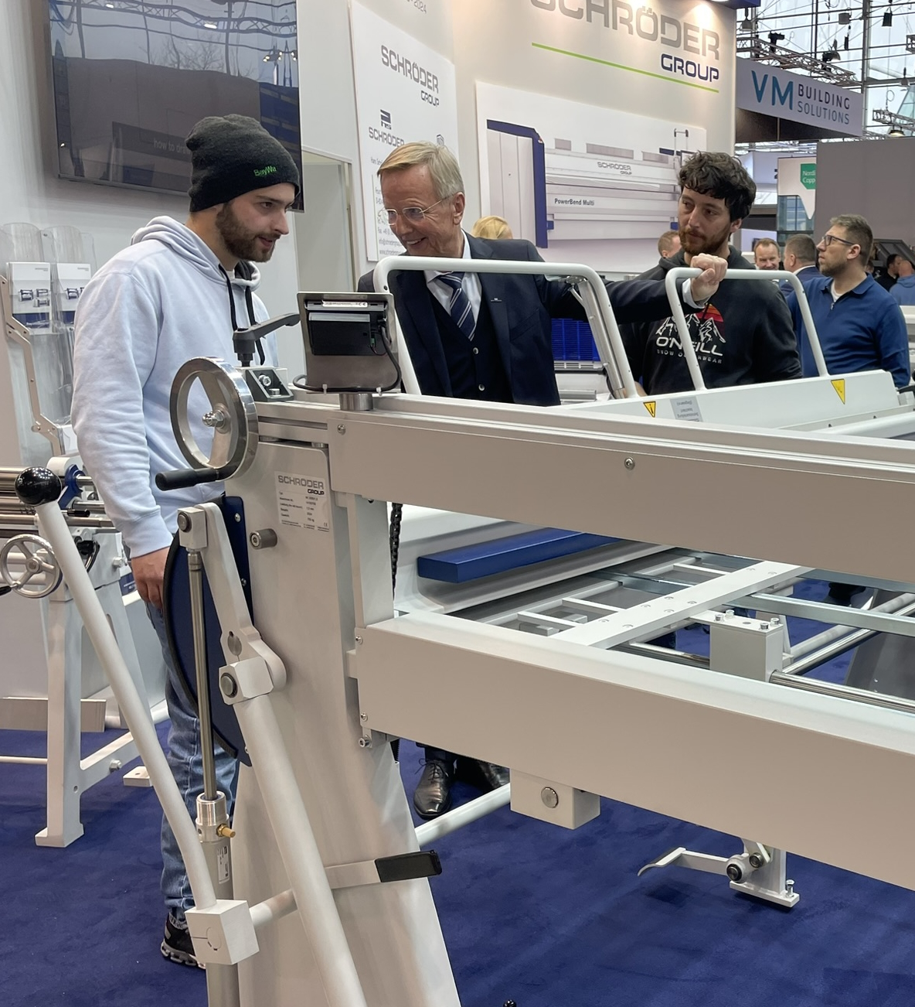  Image source: Schröder Group  Today, the boss does the bending himself: Managing Director Franz Schröder shows the classic folding bench, the AK 2000x1.5 with digital display on the manual back gauge. | 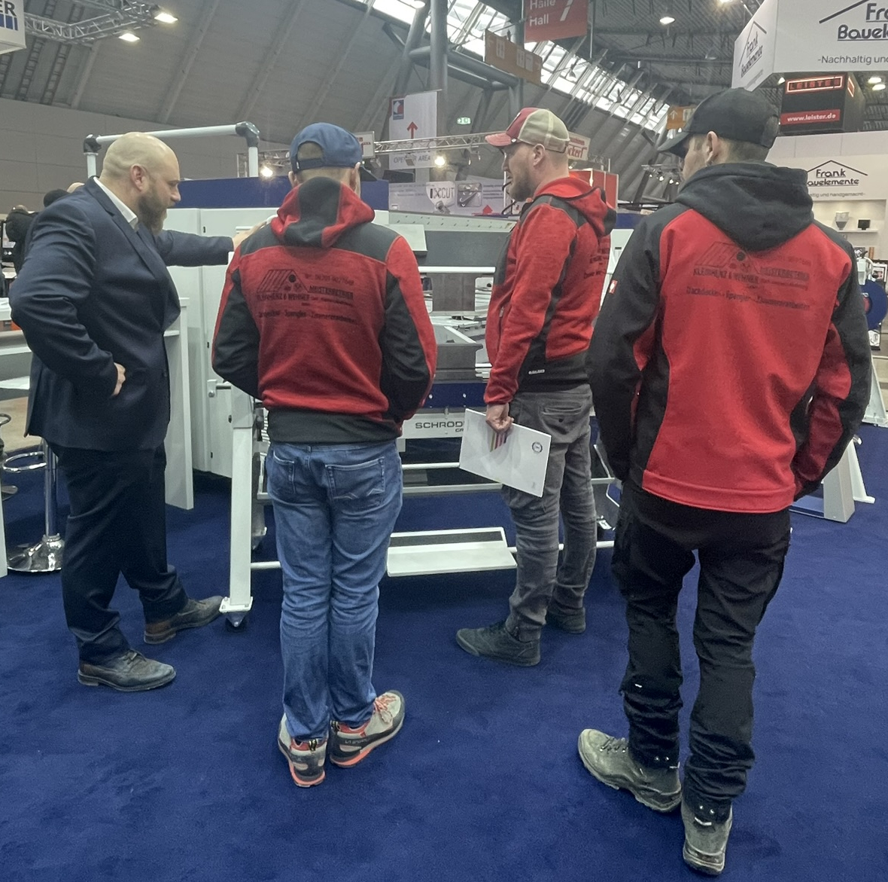  Image source: Schröder Group  Many companies came to Dach und Holz with several colleagues. These building fitters were shown the ASK 3, a manual folding machine with segmented tools on all beams.

About Schröder Group
The Schröder Group consists of Hans Schröder Maschinenbau GmbH, which is located in Wessobrunn-Forst, Germany, SCHRÖDER-FASTI Technologie GmbH, located in Wermelskirchen, Germany and the SMU GmbH, located in Leinburg-Weißenbrunn.
Founded in 1949, Hans Schröder Maschinenbau GmbH unifies traditional and modern approaches in machine building: Successfully managed as a quality and customer-oriented, family-owned company, Hans Schröder Maschinenbau is specialized in the development of modern machine concepts for bending and cutting sheet metal.
The successful integration of the Fasti Company in 2006 and its worldwide presence make the Schröder Group one of today‘s leading providers of machines for bending, cutting, beading, flanging, and circular bending all types of sheet metal. The company‘s precision machines range from proven solutions for craftsmen to innovative, high-performance machines for automatic industrial production processes. 2021 the Schröder Group was expanded by the tool manufacturer SMU GmbH. Overall, the Schröder Group currently employs more than 300 people at various locations at home and abroad.
Further information is available at www.schroedergroup.eu/en.

Press contact:
Schröder Group
Hans Schröder Maschinenbau GmbH
Janina Biró
Feuchten 2
82405 Wessobrunn-Forst
Germany
T: +49 8809 9220-68
E-mail: jj@schroedergroup.eu
Website: www.schroedergroup.eu

HighTech communications GmbH
Brigitte Basilio
Brunhamstraße 21
81249 München
Germany
T: +49 89 500778-20
E-mail: b.basilio@htcm.de
Website: www.htcm.de

