Press release
Schröder Group revises MHSU shear
Improved handling of the cut material
Wessobrunn-Forst (Germany), March 4, 2024 – The MHSU motorized shear is a proven classic from Hans Schröder Maschinenbau GmbH. The machine, which has already impressed generations of plumbers as an entry-level solution with numerous options, has now been redesigned. The most important new feature is a patented sheet holding device that increases handling flexibility. In addition, sheets can now be processed from coil.
Up to now, with the option of the sheet holding device, you had to decide how it should handle the cuttings. With the new patented sheet holding device of the MHSU, Schröder offers a versatile electronically controlled mechanism: The device can either guide sheet cuttings to the front into the sheet chute or to the rear onto a stacking cart. For particularly sensitive surfaces, the sheet holding device can also remain horizontal so that the cut material can be removed from the machine manually. This setting is also suitable for dividing sheets. The option of defining the forwarding of the cut material for each cut in the control system can be used as a scrap selector: For example, the trimming cut is fed to the sheet chute at the front, the good parts to the rear onto the stacking cart.
Further improvements
The geometry of the hold-down device has been modified to offer more operating freedom, and a small parts chute makes it easier to handle particularly narrow sections. Another new feature is the coil feed-through with safety package. The sheet holding device and back gauge are lowered to create space for feeding through sheets of any length.
The MHSU is still available in different versions, from 1,000 to 3,200 mm working length and for sheets thicknesses from 1.5 up to 4 mm. Various drive capacities are also available. In continuous operation, the MSHU achieves 34 strokes per minute.

Available images
The following images are available for download in printable format at:
https://kk.htcm.de/press-releases/schroeder/
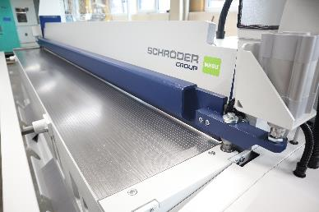  Image source: Schröder Group  The MHSU motorized shear has been revised. | 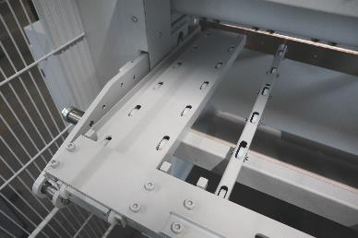  Image source: Schröder Group  With the new patented MHSU sheet holding device, Schröder offers a versatile electronically controlled mechanism.

About Schröder Group
The Schröder Group consists of Hans Schröder Maschinenbau GmbH, which is located in Wessobrunn-Forst, Germany, SCHRÖDER-FASTI Technologie GmbH, located in Wermelskirchen, Germany and the SMU GmbH, located in Leinburg-Weißenbrunn.
Founded in 1949, Hans Schröder Maschinenbau GmbH unifies traditional and modern approaches in machine building: Successfully managed as a quality and customer-oriented, family-owned company, Hans Schröder Maschinenbau is specialized in the development of modern machine concepts for bending and cutting sheet metal.
The successful integration of the Fasti Company in 2006 and its worldwide presence make the Schröder Group one of today‘s leading providers of machines for bending, cutting, beading, flanging, and circular bending all types of sheet metal. The company‘s precision machines range from proven solutions for craftsmen to innovative, high-performance machines for automatic industrial production processes. 2021 the Schröder Group was expanded by the tool manufacturer SMU GmbH. Overall, the Schröder Group currently employs more than 300 people at various locations at home and abroad.
Further information is available at www.schroedergroup.eu/en.

Press contact:
Schröder Group
Hans Schröder Maschinenbau GmbH
Janina Biró
Feuchten 2
82405 Wessobrunn-Forst
Germany
T: +49 8809 9220-68
E-mail: jj@schroedergroup.eu
Website: www.schroedergroup.eu

HighTech communications GmbH
Brigitte Basilio
Brunhamstrasse 21
81249 München
Germany
T: +49 89 500778-20
E-mail: b.basilio@htcm.de
Website: www.htcm.de

