PRESS RELEASE
ASMPT streamlines the entire material flow in the intelligent factory
WORKS Logistics
Suwanee (USA), February 29, 2024 – Providing the right material at the right time in the right place and in the right quantity while avoiding unnecessary material travel is the strength of the WORKS Logistics application. By controlling and optimizing the flow of materials in intelligent manufacturing, it prevents ‘precautionary’ stocks next to the line as well as excess movements to and from storage.
“That SMT manufacturers want to avoid machine downtimes at all cost makes a lot of sense,” says Alexander Nitzsche, Senior Product Manager Automation Solutions at market leader ASMPT. “Unfortunately, this often leads to far more material than necessary being stored next to the line ‘as a precaution’ so that valuable space on the shop floor gets blocked and material is no longer available to other lines. It is also not uncommon for a reel of material that has just been taken off the machine and returned to storage to be transported back to the setup preparation area after only a few minutes because it is needed again. With WORKS Logistics, things can be done much more easily and efficiently through automatic material requests and selective interim storage.”
Time slice-based material flow
WORKS Logistics continuously calculates the material demand based on freely definable time slices and interacts with Factory Material Manager software to ensure that the right material is available in the right quantity at the right time in the right place. Based on the planned demand and actual material consumption as well as the material stock on site, the material flow application calculates and updates the demand along the line continuously and dynamically. The resulting data forms the basis for the automatic control and optimization of material flows, demand messages to central and intermediate storage locations, and time-driven transport jobs.
Material gets re-used across upcoming orders
WORKS Logistics also organizes and optimizes the interim storage of material in the setup preparation area, thus avoiding unnecessary material travel between the warehouse and the shop floor. When reels are removed from the machine after a production run has been completed, the application checks automatically whether the material will be needed again for additional orders in the coming days. If this is the case, it instructs the staff to move the reel in question to the Active Feeder Rack in the setup preparation area. If additional material is needed, WORKS Logistics automatically sends a request to the warehouse via the Factory Material Manager.
Supply security and resource relief
“WORKS Logistics marks another important step on the road to the intelligent and integrative use of data for process optimization,” explains Nitzsche. “As an innovation and market leader in hardware and software for electronics manufacturing, we were able to pour our entire process know-how and many years of experience into the development of WORKS Logistics. Our customers get a practice-oriented application for their intelligent factory that gives them supply security and provides noticeable relief for their operators as well as for their transport and storage infrastructure.”

Illustrations for downloading
The following print-ready artwork is available on the internet for downloading:
https://kk.htcm.de/press-releases/asmpt/

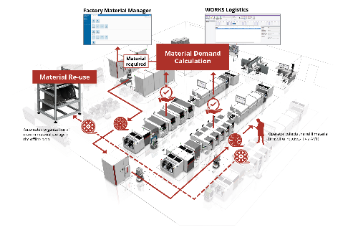 | 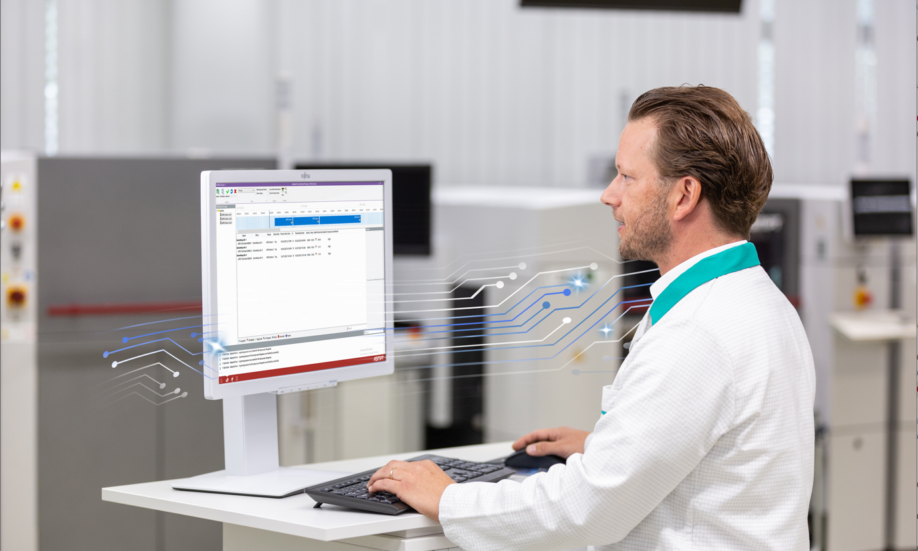
WORKS Logistics continuously calculates the material demand on the line during freely definable time slices and ensures resupplies in cooperation with the Factory Material Manager software.  Image credit: ASMPT | The Material Demand Calculation function automatically calculates the material requirements and thus realizes a just-in-time supply for the production line.  Image credit: ASMPT
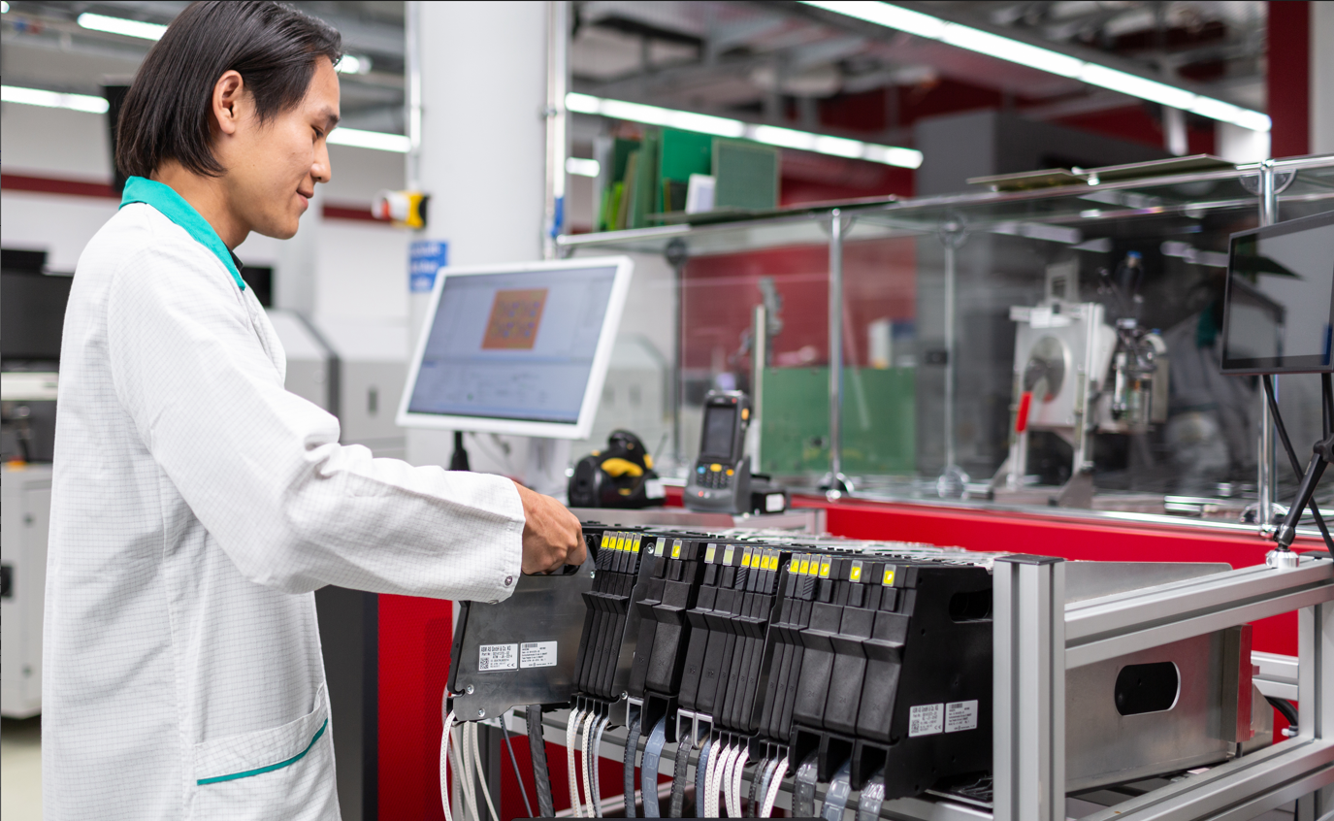 | 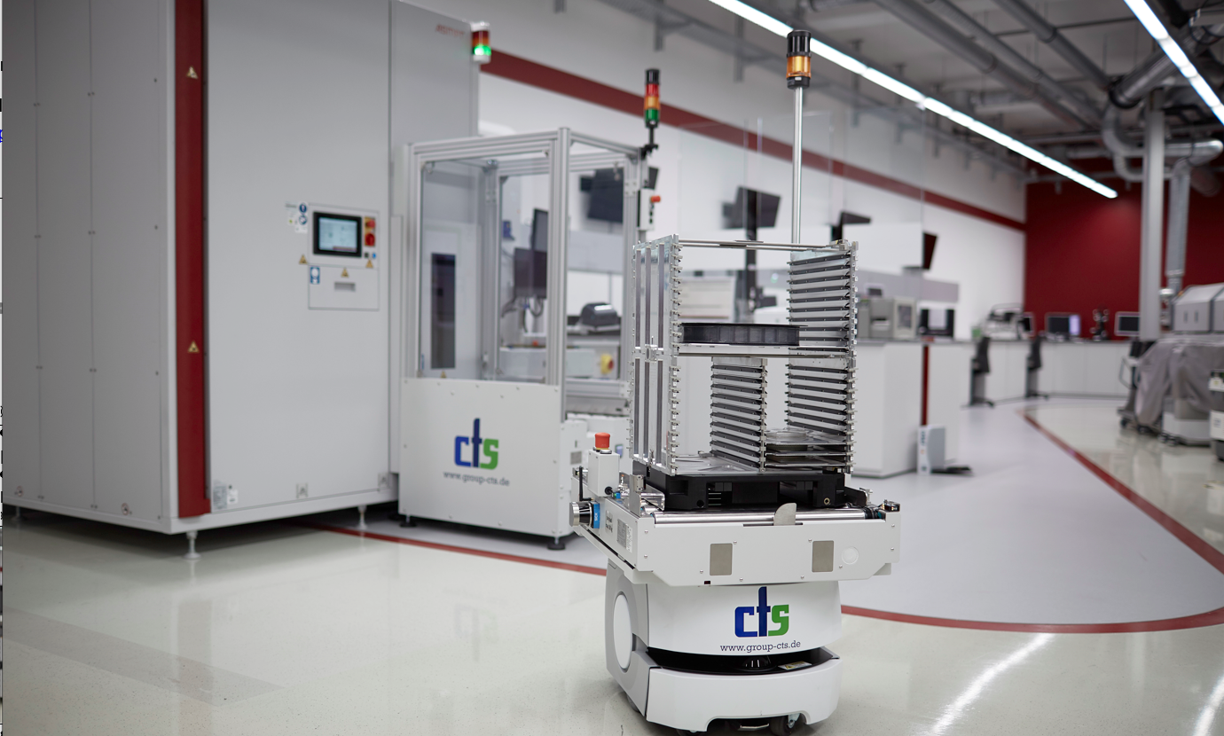
The Re-use function organizes and optimizes the interim storage of materials in an Active Feeder Rack located in the setup preparation area.  Image credit: ASMPT | With AMRs seamlessly integrated into the existing software and hardware landscape, the delivery of substrates to the lines is executed reliably and without operator intervention.  Image credit: ASMPT

About ASMPT Limited (“ASMPT”)
ASMPT Limited is a leading global supplier of hardware and software solutions for the manufacture of semiconductors and electronics. Headquartered in Singapore, ASMPT’s offerings encompass the semiconductor assembly & packaging, and SMT (surface mount technology) industries, ranging from wafer deposition to the various solutions that organize, assemble and package delicate electronic components into a vast range of end-user devices, which include electronics, mobile communications, computing, automotive, industrial and LED (displays). ASMPT partners with customers very closely, with continuous investment in R&D helping to provide cost-effective, industry-shaping solutions that achieve higher productivity, greater reliability, and enhanced quality.
ASMPT is listed on the Hong Kong Stock Exchange (HKEX stock code: 0522) and is one of the constituent stocks of the Hang Seng Composite MidCap Index under the Hang Seng Composite Size Indexes, the Hang Seng Composite Information Technology Industry Index under Hang Seng Composite Industry Indexes, and the Hang Seng HK 35 Index.
To learn more about ASMPT, visit www.asmpt.com.

The ASMPT SMT Solutions segment
The mission of the SMT Solutions segment within ASMPT is to implement and support the Intelligent Factory at electronics manufacturers worldwide.
ASMPT solutions support the networking, automation, and optimization of central workflows with hardware, software and services that enable electronics manufacturers to transition to the Intelligent Factory in stages and enjoy dramatic improvements in productivity, flexibility, and quality. With its integrated open automation concept, ASMPT opens the door for its customers to economically feasible automation, entirely in accordance with their individual requirements – modular, flexible, and vendor-independent.
The product range includes hardware and software such as SIPLACE placement solutions, DEK printing solutions, inspection and storage solutions, and the Software Suite WORKS. With WORKS, ASMPT offers electronics manufacturers high-quality software for planning, controlling, analyzing and optimizing all processes on the shop floor. Maintaining close relationships with customers and technology partners is a central component of ASMPT’s strategy.
For more information about ASMPT SMT Solutions visit smt.asmpt.com.

Media contacts:
AMCAS ASMPT Press Office
SMT Solutions
Mark Ogden
Tel.: +1 (770) 797 3189
E-mail: ogden.mark@asmpt.com
Website: smt.asmpt.com

Global ASMPT Press Office
ASMPT Ltd.
Susanne Oswald
Rupert-Mayer-Strasse 48
81379 Munich
Germany
Tel: +49 89 20800-26439
E-Mail: susanne.oswald@asmpt.com
Website: asmpt.com

