
PRESS RELEASE
Swissbit at Embedded World 2024
April 9-11, 2024
Hall 1 | Booth 1-534
PCIe high-end portfolio continues to grow +++ Highly efficient embedded solutions +++ New FIDO2 security key
Bronschhofen, Switzerland, February 29, 2024 – Storage and security specialist Swissbit will present selected innovations and product highlights at the Embedded World 2024 trade fair in Nuremberg, Germany (April 9-11, Booth 1-543). In the memory segment, Swissbit will focus on its PCIe high-performance portfolio, including the N5200 SSD, which stands out with its industry leading IOPS per watt ratio, as well as on versatile embedded solutions for industrial and IoT applications. In the security segment, the company will showcase its new iShield Key Pro with USB-C as well as CmReady-certified memory cards for efficient license protection.
High-End PCIe SSDs for edge computing and enterprise servers
Swissbit meets the constantly growing demands for storage solutions in the areas of edge computing, server environments, enterprise solutions, data centers and network routers with its expanded range of high-end PCIe SSDs. The portfolio is led by the N5200, which is characterized by its outstanding reliability, durability, and scalability. The product family consumes up to 30 percent less power compared to other PCIe Gen4 SSDs and sets standards in terms of performance per watt.
Another component of the high-end offering is the N3202, a member of the N3000 family. Developed for demanding applications in edge servers and network infrastructures, the SSD combines reliability and endurance with its robust design, the integrated Swissbit powersafe® PLP technology, and advanced security features. The N3202 uses eTLC flash memory with a DRAM-based controller architecture and offers an endurance rating of up to 1.5 DWPD (Drive Writes Per Day) over a period of five years.
Embedded storage solutions: Versatility for the IoT and more
Swissbit will also present in Nuremberg its embedded portfolio, which is designed for the challenges in automation, gateways, and green IoT applications. The products include the N2000 series, a DRAM-less PCIe SSD with host memory buffer support as an efficient solution for embedded applications that require lower power consumption and smaller form factors.
For applications with limited storage requirements in the green IoT area such as charging stations or smart meters, Swissbit will showcase e.MMCs and SD memory cards from the EM-30 and S-56(u) series with capacities ranging from 4 to 8 GB, which offer high reliability and endurance while also providing cost-efficient performance.
Featuring USB-C: New FIDO2 security key
Further expanding its range of hardware security keys, Swissbit will showcase the new iShield Key Pro with USB-C interface for the first time in Nuremberg. Like the USB-A version, the stick supports the FIDO2 standard as well as PIV (Personal Identity Verification) and HOTP (Hash-Based-One-Time-Password) and TOTP (Time-Based One-Time Password). The iShield Key Pro can also be used for physical access control, making it one of the most flexible security keys. In addition to USB-C, it also features an NFC interface.
License protection: Swissbit memory cards with CmReady label
The new PS-66(u) DP SD and microSD cards offer not only the usual robustness and industrial suitability but also a very special feature: they are certified for CmReady from WIBU, thus extending the CodeMeter technology to software protection and licensing. The use of Swissbit memory cards as an additional license container within the CodeMeter ecosystem offers manufacturers of embedded and IoT devices an efficient and cost-effective solution for license protection. Together with WIBU, Swissbit will showcase a demo of the CmReady functionality at the Swissbit booth.

Available images
The following images are available for download in printable format at: https://kk.htcm.de/press-releases/swissbit/
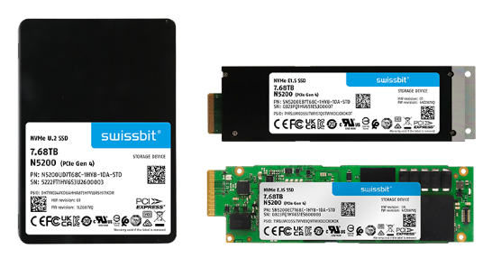  Image source: Swissbit  Enterprise SSD N5200 from Swissbit, available in U.2 and E1.S form factors. | 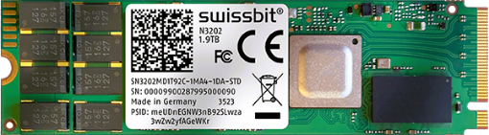  Image source: Swissbit  The N3202 from Swissbit: Robust, high-performance PCIe Gen4 SSD with high endurance.
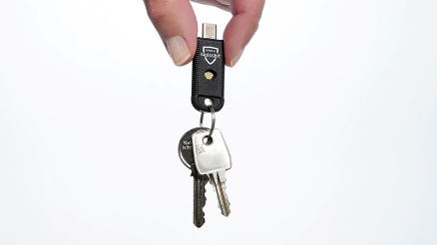  Image source: Swissbit  Swissbit further expands its range of FIDO2 tokens: New iShield Key Pro with USB-C interface. | 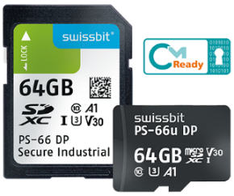  Image source: Swissbit  Efficient license protection: Swissbit PS-66(u) memory cards with CmReady label from WIBU.
About Swissbit
Swissbit AG is the leading European manufacturer of storage, security and embedded IoT solutions for demanding applications. Swissbit combines its unique competences in storage and embedded IoT technology with its advanced packaging know-how. This expertise allows our customers to reliably store and protect data in industrial, NetCom, automotive, medical, and fiscal applications as well as across the Internet of Things (IoT).
Swissbit develops and manufactures industrial-grade storage and security products “Made in Germany” with high reliability, long-term availability, and custom optimization.
Swissbit’s storage range includes SSDs with PCIe and SATA interface such as mSATA, Slim SATA, CFast™, M.2 and 2.5” as well as CompactFlash, USB flash drives, SD Memory Cards, micro-SD Memory Cards and managed NAND BGAs like e.MMC. Security products are available in various application specific editions as USB flash drives, SD Memory Cards, and micro-SD Memory Cards.
Swissbit was founded in 2001 and has offices in Switzerland, Germany, USA, Japan and Taiwan. Swissbit owns the registered trademarks Swissbit® and Hyperstone®. Since 2020, the independent investment firm Ardian is holding a majority stake in the company to support its growth.
For further information, please visit www.swissbit.com
Regional Headquarters:  Swissbit Germany AG  Bitterfelder Strasse 22  12681 Berlin  Germany  Tel: +49 30 936 954 0  Email: info@swissbit.com  www.swissbit.com | Headquarters:  Swissbit AG  Industriestrasse 4  9552 Bronschhofen  Switzerland  Tel: +41 71 913 03 03  Email: info@swissbit.com  www.swissbit.com
Contact:  Swissbit AG  Marian Weber  Industriestrasse 4  9552 Bronschhofen  Switzerland  Tel: +49 172 854 88 26  Email: marian.weber@swissbit.com  www.swissbit.com | Press Agency:  HighTech communications GmbH  Brigitte Basilio  Brunhamstrasse 21  81249 Munich  Germany  Tel: +49 89 500778-20  Email: b.basilio@htcm.de  www.htcm.de

