PRESS RELEASE

hyperMILL® 2024 To Arrive at MACH
15–19 April 2024
Hall 17, Stand 240
Wessling (Germany), February 28, 2024 – CAD/CAM developer OPEN MIND Technologies will be exhibiting at MACH 2024 with its biggest-ever stand at the UK’s showpiece manufacturing event. From the 15th to the 19th of April on Stand 240 in Hall 17, OPEN MIND Technologies UK will be presenting the innovative technologies of its hyperMILL® CAD/CAM suite with live demonstrations of the latest 2024 Version that is imminently set for release.
At MACH, OPEN MIND UK will highlight its pioneering technologies for digital process chains whilst showcasing its innovative advancements for connected manufacturing, automation, turning, Hummingbird MES and solutions for additive manufacturing.
One of the latest innovations that is gaining huge traction in the industry is the new Hummingbird Manufacturing Execution Systems (MES). The agile MES solution that enables users to improve and streamline the planning, control, automation and optimisation of processes across manufacturing operations will be presented for the first time at MACH 2024. Too often, the right information, data and materials are not in the right place at the right time. Hummingbird eases entry into the digitalised world of manufacturing for customers with a tailored solution that allows users to choose the modules they require to gain complete control of their processes - and then expand the system step by step as needed.
The OPEN MIND UK team will also present the latest hyperMILL® TURNING Solutions that have expanded exponentially since MACH 2022. The latest updates in hyperMILL® TURNING Solutions include technologies for turning, turn/mill and mill/turn machines – making the suite ideal for all corresponding machine configurations. In Version 2024, hyperMILL® TURNING developments will include CAD for CAM functions for rotary contours, finishing paths for grooving, a ‘remove rings’ function, a 2D stretch command and a snew tool turret support that via hyperMILL® VIRTUAL Machining can create a detailed map of all tools in a turret to create a seamless NC code simulation. The new enhancements will simplify the creation of chamfers, contours, radii and undercuts, create uniform allowances for finishing when grooving, reliably remove ring chips from components, quickly and easily adapt parametric 2D contours and much more. Furthermore, Heidenhain CNC systems as well as Siemens controls are now supported with the latest mill/turn modules whilst the ‘Connected Machining’ interface also supports FANUC control systems. These updates identify the exponential development rate and the associated compatibility of hyperMILL®’s TURNING suite with an ever-increasing range of machine tool types.
Bidirectional communication with machine tool controls is particularly important in networking with other systems along the process chain. At MACH, there will be demonstrations of hyperMILL® VIRTUAL Machining that closes the gap between the CAM system and the physical machine environment. If the CAM software can work with a digital twin of the physical machining process, then this opens up new options for generating, optimising and simulating the NC code safely. hyperMILL® BEST FIT is an impressive example of this. It is a new type of component alignment system for the subsequent processing of cast, welded or additively manufactured components. This sees the NC program adapt to what is physically happening in the workspace, rather than the clamping being adapted to the NC program, which has been standard practice until now.
As well as added functionality for 5-axis machining, mill/turn, Hummingbird MES, Connected Machining and hyperMILL® VIRTUAL Machining, OPEN MIND UK experts will be on hand to discuss hyperMILL® ADDITIVE Manufacturing. This technology opens up the flexible possibilities of highly complex 5-axis simultaneous machining to the Direct Energy Deposition (DED) and Wire Arc Additive Manufacturing (WAAM) processes. NC codes can be conveniently programmed and automatically simulated for collision avoidance and as an end-to-end software solution, this enables efficient hybrid machining with additive and subtractive machining on a single machine.
The OPEN MIND UK stand will have no fewer than 6 CAM workstations at MACH and here, our team of experts will be able to provide live demonstrations of the industry’s leading CAD/CAM system. So, if you are visiting MACH from the 15th to the 19th of April, please ensure you visit Stand 240 in Hall 17 to witness the evolution of CAM and how it is already being integrated into the machine shops of the future via the most advanced digital manufacturing platform in the industry.
-----ENDS-----

Available images
The following images are available for download in printable format at:
https://kk.htcm.de/press-releases/open-mind/
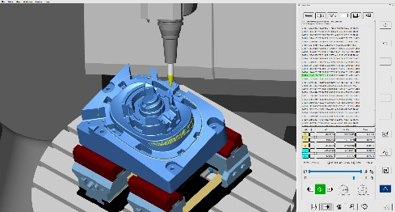
Source: OPEN MIND

The hyperMILL® VIRTUAL Machining Optimizer module automatically generates the optimal path between two operations.

Available videos
You can find the following videos on our YouTube channel: https://youtu.be/OVFOuYEKYCk?si=0LE1Xl3Mi8LCACh-
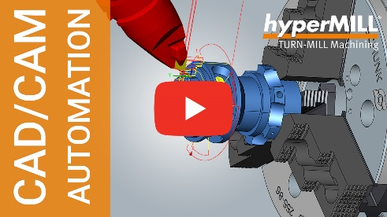
Source:: OPEN MIND
hyperMILL® TURNING Solutions

About OPEN MIND Technologies AG
OPEN MIND Technologies AG is one of the world’s leading developers of powerful CAD/CAM solutions for machine and controller-independent programming.
OPEN MIND develops optimized CAD/CAM solutions that include a large number of innovative and unique features that can deliver significantly higher performance in both programming and machining. hyperMILL® is a completely modular CAD/CAM solution that provides state-of-the-art CAM technologies on its own CAD platform: from 2.5D, 3D and 5-axis machining as well as turning strategies and solutions for additive manufacturing, HSC and HPC machining. Whether automation, simulation or virtual machine – trendsetting technologies expand the product range and enable continuous digital process chains. Special applications, the perfect interaction with all popular CAD solutions and a customer-oriented service complete the product range.
According to the "NC Market Analysis Report 2023" compiled by CIMdata, hyperMILL® is ranked in the top 4 CAD/CAM solutions worldwide. The innovative CAD/CAM technologies fulfil the highest demands in the automotive, tool and mold manufacturing, production machining, medical, job shops, energy, semiconductor and aerospace industries.
OPEN MIND's majority stake in manufacturing execution system (MES) developer Hummingbird expands the CAD/CAM manufacturer's product portfolio and enhances the range of connected digitalized manufacturing technologies.
OPEN MIND is a Mensch und Maschine company and has subsidiaries and qualified sales partners on all continents.
You can find more information at www.openmind-tech.com.

OPEN MIND Technologies UK Ltd., Oxford
Unit 3
Bicester Business Park
Telford Road
Bicester
Oxfordshire OX26 4LN
England
Phone: +44 1869 290 003
Fax: +44 1869 369 429
E-mail: Info.UK@openmind-tech.com

OPEN MIND Technologies USA, Inc.
1492 Highland Avenue, Unit 3
Needham MA 02492
USA
Phone: +1 339 225 4557 office
Phone: +1 888 516 1232 x0 toll-free
Fax: +1 270 912 5822
E-mail: Info.Americas@openmind-tech.com

Head office:
OPEN MIND Technologies AG, Argelsrieder Feld 5, 82234 Wessling, Germany
Tel.: (+49-8153) 933-500, Fax: (+49-8153) 933-501
E-mail: Info@openmind-tech.com, website: www.openmind-tech.com

Press contact:
HighTech communications GmbH
Brigitte Basilio
Brunhamstrasse 21
81249 Munich
Germany
Tel.: (+49-89) 500778-20
E-mail: b.basilio@htcm.de
Website: www.htcm.de

