Media information
Schröder Group patent: Squeezing function
Hemming function in only one working step
Wessobrunn-Forst (Germany), Februar 6, 2024 – The PowerBend Multi (PBM) is a versatile folding machine for thin sheet metal processing. Hans Schröder Maschinebau is now presenting a patented innovation that is available for the first time with the PBM. In combination with the option of the rotating clamping beam, it is possible to fold hems in just one working step with the folding beam.
The innovation was inspired by the following motto: "What can be bent can also be pressed shut." The clamping beam not only makes it possible to set up a second tool station in no time at all. It can also be set back so that it clamps the sheet metal further back. This creates space for the folding beam in order to fold hems. The folding beam first creates a sharp angle, the clamping beam is set back and clamps the sheet. The folding beam then moves up to 190° to create a fold and press it shut. Instead of the traditional pressing with the clamping beam, the much stronger and crownable folding beam is now used for this task. This makes it possible to to fold hems out of two millimetre thick sheet steel over the entire working length of 4000 mm.
Need a longer profile? Bend conically!
Another Schröder innovation is available on the PowerBend Multi: the electronically controlled two-axis back gauge. If profiles are required that are longer than the width of the machine, simply enter the required total length in the POS 2000 Professional control unit. This automatically calculates sections that have tapered edges with a precision in the tenth of a millimeter range. The result is form-fit, pluggable profiles.

Available images
The following images are available for download in printable format at:
https://kk.htcm.de/press-releases/schroeder/
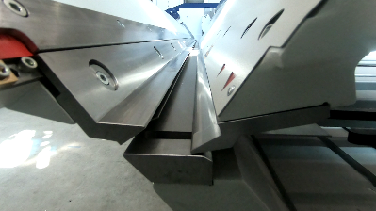  Image source: Schröder Group  Ingenious squeezing function: the PowerBend Multi can be used to fold hems in just one operation with the folding beam. | 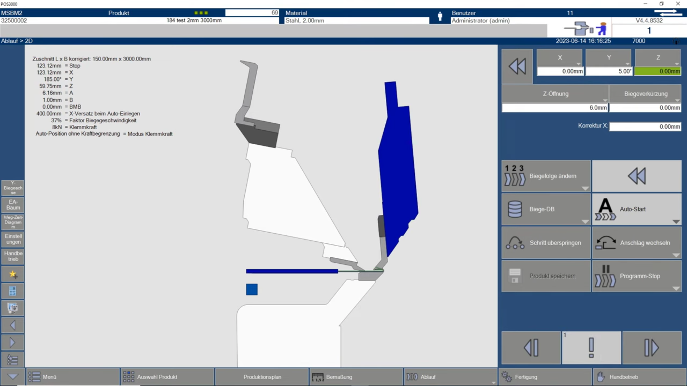  Image source: Schröder Group  The new function in the POS 2000 Professional control unit

Available videos
You can find the following video on our YouTube channel:
https://www.youtube.com/watch?v=0pb6ZUd6HxY
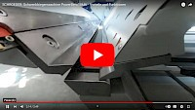Source: Schröder Group

The new squeeze function of the PowerBend Multi is shown on YouTube.

About Schröder Group
The Schröder Group consists of Hans Schröder Maschinenbau GmbH, which is located in Wessobrunn-Forst, Germany, SCHRÖDER-FASTI Technologie GmbH, located in Wermelskirchen, Germany and the SMU GmbH, located in Leinburg-Weißenbrunn.
Founded in 1949, Hans Schröder Maschinenbau GmbH unifies traditional and modern approaches in machine building: Successfully managed as a quality and customer-oriented, family-owned company, Hans Schröder Maschinenbau is specialized in the development of modern machine concepts for bending and cutting sheet metal.
The successful integration of the Fasti Company in 2006 and its worldwide presence make the Schröder Group one of today‘s leading providers of machines for bending, cutting, beading, flanging, and circular bending all types of sheet metal. The company‘s precision machines range from proven solutions for craftsmen to innovative, high-performance machines for automatic industrial production processes. 2021 the Schröder Group was expanded by the tool manufacturer SMU GmbH. Overall, the Schröder Group currently employs more than 300 people at various locations at home and abroad.
Further information is available at www.schroedergroup.eu/en.

Press contact:
Schröder Group
Hans Schröder Maschinenbau GmbH
Janina Biró
Feuchten 2
82405 Wessobrunn-Forst
Germany
T: +49 8809 9220-68
E-mail: jj@schroedergroup.eu
Website: www.schroedergroup.eu

HighTech communications GmbH
Brigitte Basilio
Brunhamstraße 21
81249 München
Germany
T: +49 89 500778-20
E-mail: b.basilio@htcm.de
Website: www.htcm.de

