PRESS RELEASE

Würth Elektronik at the DLD Conference: CTO presents cooperation in microalgae production
Spirulina: Superfood in a New Light
Waldenburg (Germany), January 23, 2024 – At Digital Life Design (DLD) in Munich, the international conference and innovation platform, Würth Elektronik announced a new cooperation with Agile Solutions: A highly efficient LED lighting system for microalgae production which has been developed together with the system partner.
Up to seven times more protein-rich than tofu, Spirulina is a real superfood, as well as being a very important raw material for the food and pharmaceutical industries. Optimal growth conditions are needed for efficient phototrophic algae production in Germany, and Würth Elektronik’s cooperation aims to achieve this, as promotion of new ideas and start-ups is an important pillar of the global player's successful business model.
LED lighting is crucial for yield
Alexander Gerfer, CTO at Würth Elektronik eiSos, and Martin Havers, founder of Agile Solutions, explained the concept: Algae cultivation in Germany takes place in closed indoor systems under controlled conditions. Plant-optimized lighting is crucial for yield. Agile Solutions – In cooperation with Würth Elektronik – has developed a special LED curtain using 700 mid-power LEDs to provide the algae cultures with the ideal lighting.
“LED lighting technology, in general, and plant-optimized lighting, in particular, is not new territory for us,” explains Alexander Gerfer. “With our Connected Vertical Farm prototype, we have already demonstrated, on a small scale, how plants grow and thrive excellently under the ideal LED lighting. And underwater, it works in a very similar way. Thanks to our targeted support, Agile Solutions was able to significantly shorten the development time and quickly bring a sophisticated lighting system to market with integrated self-diagnosis and optimized load distribution.”
Microalgae products are expected to see high market growth of 10.9% on average, particularly in Europe. Germany takes a leading role here. With 16 microalgae-producing companies, we are pioneers in Europe.
Dare to know
At DLD, renowned experts discussed the fundamental questions, problems, and opportunities currently affecting markets, media, culture and society in their transformation through the Internet and new digital business models. But lifestyle, design, music, and art are other important topics at Digital Life Design, because these areas are witnessing trendsetting changes visible to everyone. This year's DLD conference motto was “Dare to know.” Artificial intelligence is changing the world, and is predicted to grow exponentially. Where the journey is headed – that’s hard to say today.
“The same goes for every innovative idea”, Alexander Gerfer adds. “That's why we specifically support start-ups in turning their ideas into marketable products – even if success is a long way down the road. Today, circuit designs can be developed much faster with AI support. It’s important, however, that the components planned this way are also available in large quantities and in consistent quality. And that’s why we’re exactly the right partner, even in the AI era.”

Available images
The following images can be downloaded from the Internet in printable quality: https://kk.htcm.de/press-releases/wuerth/
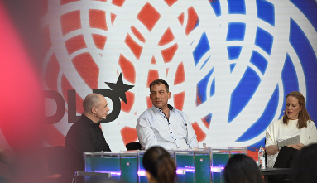Image source: Hubert Burda Media  Panel Talk at the DLD 2024 in Munich, on the topic of microalgae production: Alexander Gerfer, CTO at Würth Elektronik eiSos, and Martin Havers, founder of Agile Solutions, with Linda Hinz, moderator (from left to right). | 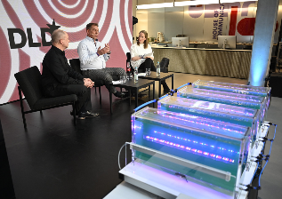  Image source: Hubert Burda Media  DLD Panel Talk on the future of food supply: Alexander Gerfer, CTO at Würth Elektronik eiSos, Martin Havers, founder of Agile Solutions, and Linda Hinz, moderator (from left to right). In the foreground: Experimental set-up for microalgae production under controlled conditions.

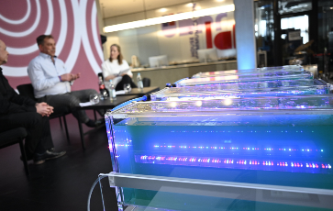  Image source: Hubert Burda Media  The future of food production: At DLD, Würth Elektronik and Agile Solutions presented their cooperation for controlled microalgae cultivation. | 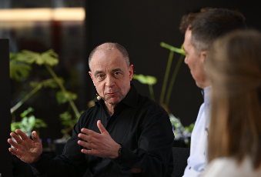  Image source: Hubert Burda Media  Alexander Gerfer, CTO at Würth Elektronik eiSos: “We help our cooperation partners, like Agile Solutions, turn ideas into marketable products.”
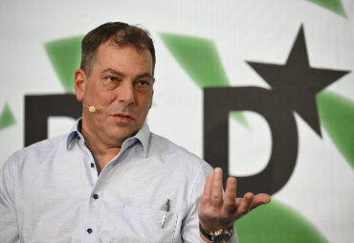  Image source: Hubert Burda Media  Martin Havers, founder of Agile Solutions: A highly efficient LED lighting system for microalgae production has been developed together with Würth Elektronik. | 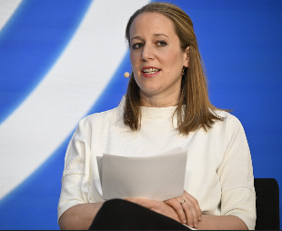  Image source: Hubert Burda Media  Competent moderator at the DLD Panel Talk: Linda Hinz, co-creator of the ‘News to be Good’ app and previously deputy editor-in-chief of Focus Online.

Available videos
A video is available for downloading at the following link:
https://kk.htcm.de/press-releases/wuerth/
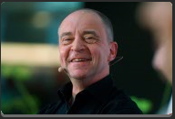
Source: Würth Elektronik
Statement from Alexander Gerfer, CTO at Würth Elektronik eiSos, on the cooperation with Agile Solutions.

About the Würth Elektronik eiSos Group
Würth Elektronik eiSos Group is a manufacturer of electronic and electromechanical components for the electronics industry and a technology company that spearheads pioneering electronic solutions. Würth Elektronik eiSos is one of the largest European manufacturers of passive components and is active in 50 countries. Production sites in Europe, Asia and North America supply a growing number of customers worldwide.
The product range includes EMC components, inductors, transformers, RF components, varistors, capacitors, resistors, quartz crystals, oscillators, power modules, Wireless Power Transfer, LEDs, sensors, radio modules, connectors, power supply elements, switches, push-buttons, connection technology, fuse holders and solutions for wireless data transmission. The portfolio is complemented by customized solutions.
The unrivaled service orientation of the company is characterized by the availability of all catalog components from stock without minimum order quantity, free samples and extensive support through technical sales staff and selection tools.
Würth Elektronik is part of the Würth Group, the global market leader in the development, production, and sale of fastening and assembly materials, and employs 8,200 people. In 2022, the Würth Elektronik Group generated sales of 1.33 Billion Euro.
Würth Elektronik: more than you expect!
Further information at www.we-online.com

Further information:  Würth Elektronik eiSos GmbH & Co. KG  Sarah Hurst  Clarita-Bernhard-Strasse 9  81249 Munich  Germany  Phone: +49 7942 945-5186  E-mail: sarah.hurst@we-online.de  www.we-online.com | Press contact:  HighTech communications GmbH  Brigitte Basilio  Brunhamstrasse 21  81249 Munich  Germany  Phone: +49 89 500778-20  E-mail: b.basilio@htcm.de  www.htcm.de

