PRESS RELEASE
ASMPT in the Semiconductor Climate Consortium
Committed to Net Zero
Singapore, January 18, 2024 – ASMPT, the innovation and market leader in surface-mount and semiconductor manufacturing technology and a Leadership Level founding member of the Semiconductor Climate Consortium (SCC), has officially announced its Net Zero 2035 strategy for climate neutrality. Its work within the SCC is an integral component of this strategy because reducing greenhouse gas emissions along the value chain requires cooperation between companies. As a market leader, ASMPT feels a special responsibility to lead the way and actively engage other companies in the semiconductor industry in their sustainability efforts.
“ASMPT is 100-percent supportive of the SCC’s mission to combat climate change and reduce harmful emissions through the combined resources and skills of its members,” said Richard Ooi, Global Head of ESG at ASMPT. “The SCC Scope 2 Emissions Working Group, for which I am in charge, focuses on the introduction of low-carbon energy in the semiconductor value chain and is working on defining a concrete set of actions. It has been extremely encouraging to support the industry in coming together and driving tangible, large-scale change.” The SCC was founded in cooperation with other companies in the semiconductor value chain and with SEMI, the global industry association representing the electronics manufacturing and design supply chain.

ASMPT Net Zero by 2035 Scope 1 and Scope 2
The strategic goal of CO₂ neutrality by 2035 applies to direct emissions from own sources (Scope 1) and indirect emissions from purchased energy (Scope 2). Scope 3 refers to indirect emissions caused by activities along the entire supply chain and requires even greater collaboration across sectors and industries than has previously been the case. Scope 3 includes pollutant emissions which result from purchased goods and services, from the use of products by customers, and from the shipping of goods. In order to enhance cooperation across industries, ASMPT was instrumental in launching the Semiconductor Climate Consortium as one of its Leadership Level founding members. Richard Ooi explains: “We are helping to develop a common roadmap for low-carbon energy concepts and support the value chain in accessing and deploying these systems to achieve a net zero Scope 2 target for all SCC members by 2050 or sooner. It is also a key component of ASMPT’s strategy to reduce Scope 3 emissions as we actively work to promote the use of low-carbon energy among our suppliers and customers.”
The E in ESG
ESG criteria are used to implement and evaluate sustainability in environmental, social and governance-related matters. ESG significantly influences ASMPT’s culture, human resources policies, business strategies, and workflows. Having already implemented many initiatives in the second and third categories, ASMPT is making a huge effort to tackle the environmental complex and has publicly committed itself to its Net Zero 2035 goal. “As innovation and market leader in the electronics manufacturing and semiconductor industry, we have the unique chance to lead the way in ESG and initiate positive change in cooperation with customers, partners, industry associations, and employees,” said Richard Ooi.

Illustrations for downloading
The following print-ready artwork is available on the internet for downloading:
https://kk.htcm.de/press-releases/asmpt/

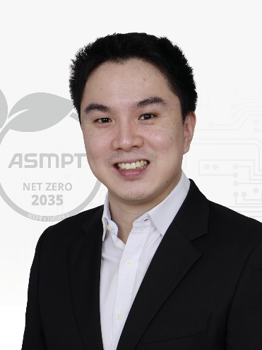 | 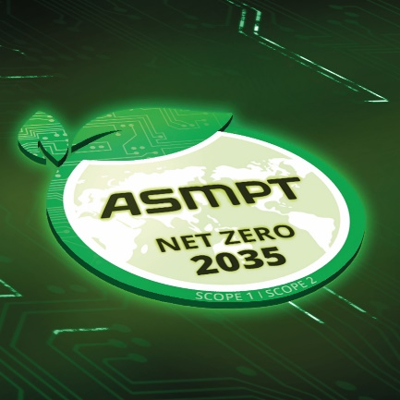
Richard Ooi, Global Head of ESG at ASMPT  Image credit: ASMPT | Climate neutrality is a central component of ASMPT’s comprehensive ESG strategy.  Image credit: ASMPT
ASMPT was instrumental in launching the Semiconductor Climate Consortium as is one of its Leadership Level founding members

Image credit: ASMPT

About ASMPT Limited (“ASMPT”)
ASMPT Limited is a leading global supplier of hardware and software solutions for the manufacture of semiconductors and electronics. Headquartered in Singapore, ASMPT’s offerings encompass the semiconductor assembly & packaging, and SMT (surface mount technology) industries, ranging from wafer deposition to the various solutions that organise, assemble and package delicate electronic components into a vast range of end-user devices, which include electronics, mobile communications, computing, automotive, industrial and LED (displays). ASMPT partners with customers very closely, with continuous investment in R&D helping to provide cost-effective, industry-shaping solutions that achieve higher productivity, greater reliability, and enhanced quality.
ASMPT is listed on the Stock Exchange of Hong Kong (HKEX stock code: 0522), and is one of the constituent stocks of the Hang Seng Composite MidCap Index under the Hang Seng Composite Size Indexes, the Hang Seng Composite Information Technology Industry Index under Hang Seng Composite Industry Indexes and the Hang Seng HK 35 Index.
To learn more about ASMPT, please visit us at asmpt.com.

The ASMPT SMT Solutions segment
The mission of the SMT Solutions segment within ASMPT is to implement and support the Intelligent Factory at electronics manufacturers worldwide.
ASMPT solutions support the networking, automation, and optimization of central workflows with hardware, software and services that enable electronics manufacturers to transition to the Intelligent Factory in stages and enjoy dramatic improvements in productivity, flexibility, and quality. With its integrated open automation concept, ASMPT opens the door for its customers to economically feasible automation, entirely in accordance with their individual requirements – modular, flexible, and vendor-independent.
The product range includes hardware and software such as SIPLACE placement solutions, DEK printing solutions, inspection and storage solutions, and the Software Suite WORKS. With WORKS, ASMPT offers electronics manufacturers high-quality software for planning, controlling, analyzing and optimizing all processes on the shop floor. Maintaining close relationships with customers and technology partners is a central component of ASMPT’s strategy.
For more information about ASMPT SMT Solutions visit smt.asmpt.com.

Media contacts:
ASMPT ROA Press Office
SMT Solutions
ASMPT SMT Singapore Pte. Ltd.
Janet Loh
Tel.: +65 6877 3948
E-mail: Janet.loh@asmpt.com
Website: smt.asmpt.com

Global ASMPT Press Office
ASMPT Ltd.
Susanne Oswald
Rupert-Mayer-Strasse 48
81379 Munich
Germany
Tel: +49 89 20800-26439
E-Mail: susanne.oswald@asmpt.com
Website: asmpt.com

