PRESS RELEASE
OPEN MIND presents machining example
Innovation meets tradition - CNC milled nutcracker
Wessling (Germany), December 11, 2023 - In keeping with the Christmas season and its traditions, OPEN MIND is showing how an exact replica of a famous nutcracker from the Erzgebirge a region in East Germany is milled from aluminum. The example demonstrates an end-to-end digital process chain and efficient 5-axis machining with hyperMILL®.
Together with EMUGE-FRANKEN, CAD/CAM developer OPEN MIND set itself a task: To digitally reproduce a 40 centimetre tall nutcracker as accurately as possible and mill it from aluminum as efficiently as possible. The traditional Seiffener Volkskunst provided the wooden figure, which was handcrafted in around 150 steps and consists of around thirty individual parts.
From scan to surface model
OPEN MIND turned to WESTCAM for the 3D scan of the nutcracker. The Austrian partner is not only characterized by its hyperMILL® expertise, but it also has extensive know-how in 3D measurement technology. The result of the scan was a high-resolution mesh model consisting of 1.2 million triangles. At OPEN MIND, a surface-based 3D model was created using the hyperMILL® CAD/CAM solution and designed completely parametrically. The advantage of the latter is that production-related changes to the model can be made very easily afterwards. For production, the nutcracker model was divided into the upper part, legs, arms and lever, which were pinned and glued together after completion.
Roughing and rest material machining
Production was carried out at FRANKEN's Rückersdorf application center on a Hermle C32 machining center in a single clamping operation using 5-axis and 5-axis simultaneous processes. This allowed the surfaces to be machined continuously without segmentation. The opening cut for the large central pocket of the upper body was efficiently achieved using 5-axis helical drilling, which enables a particularly high level of material removal and is also gentler on the tool than a helical plunging movement. Strategies from the hyperMILL® MAXX Machining high-performance package were used to optimize roughing operations. The 5-axis rest machining function then ensured that the roughing was completed safely and efficiently. The new EvoGrip centric clamp from EMUGE was used for workpiece clamping. With its modular and slim system design, reliable clamping was guaranteed.
Finishing with Circle Segment End Mill
The ‘high-precision surface’ mode was used for finishing, whereby hyperMILL® generates tool paths on the actual CAD surfaces and not on a calculation model. The large surfaces of the nutcracker that are curved in two directions, lent themselves to the use of FRANKEN's circle segment end mill in various shapes. For this application, taper and teardrop shape tools with cutting radii from 200mm to 1000mm were used. These tools, also known as barrel cutters, enable particularly efficient production of high-quality surfaces despite the large in-feeds or large step-over line increments. hyperMILL® offers optimum control of the cutting edge area of circle segment cutters.
Simulation and optimization in the virtual machine
"In the nutcracker machining example, we had the problem that the dimensions of the part were actually too large for the work area of the machine - a challenge that many manufacturers have already faced," explains Michael Förster, Senior Product Marketing Manager at OPEN MIND Technologies AG. "What would normally require many manual adjustments and individual simulations in order to avoid travel limitations and find safe tilt positions can now be implemented quickly and reliably thanks to the virtual machine and NC code-based simulation."
The hyperMILL® VIRTUAL Machining package includes an optimizer that perfectly adapts the connecting movements between the individual milling operations to the kinematics of the machine and can therefore solve limit switch problems. Communication between the milling center and the software, which contains a digital twin of the machine, allows precise machining based simulation of the actual NC code.
Another video for machining specialists
The machining videos from OPEN MIND and its partners are very popular. The nutcracker once again shows the advantages that can be gained from the optimum interaction of CAM, cutting tools and the machine.
"We would like to thank EMUGE-FRANKEN, WESTCAM and Seiffener Volkskunst for their cooperation. We are delighted that we were able to impress the artisans from the Erzgebirge with the detailed execution of this adaptation of their original design," says Förster.

Available images
The following images are available for download in printable format at:
https://kk.htcm.de/press-releases/open-mind/
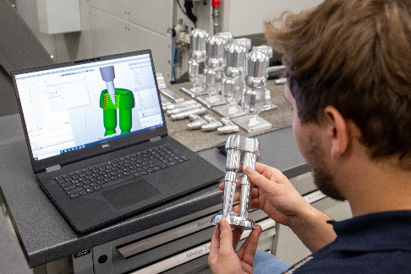  Source: OPEN MIND  CAD/CAM model and milled part: legs and body part of the aluminum nutcracker | 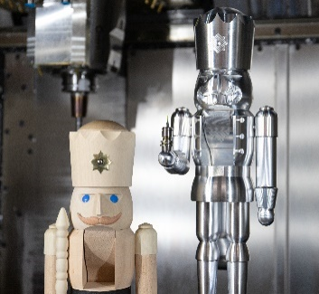  Source: OPEN MIND  Tradition meets innovation: the original wooden nutcracker from Seiffener Volkskunst and its milled aluminum counterpart

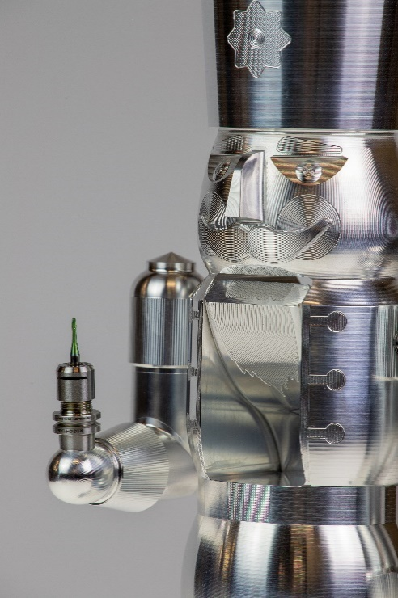  Source: OPEN MIND  Modern interpretation of the nutcracker with tool holder and tool | 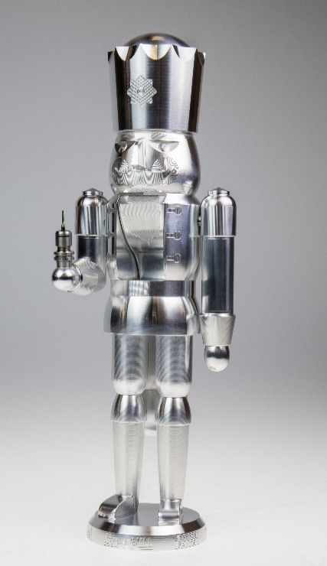  Source: OPEN MIND  The 40cm tall aluminum nutcracker is an exact replica of the original made of wood. The small difference: the new figure holds a tool

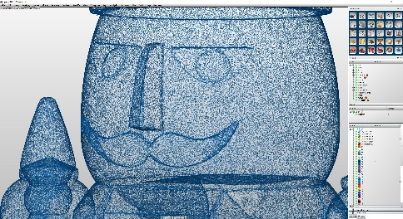  Source: OPEN MIND  Surface-based 3D model with many details | 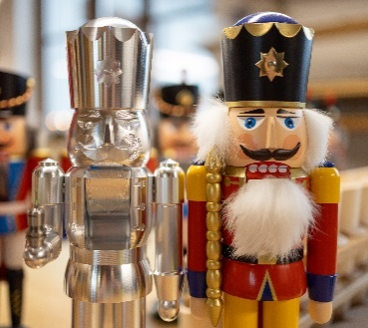  Source: OPEN MIND  CNC-milled aluminum nutcracker and its wooden counterpart

Available videos
You can find the following videos on our YouTube channel:
https://youtu.be/NVbI6YfBYPs?si=WTXg4_K4vPxSF1Qv
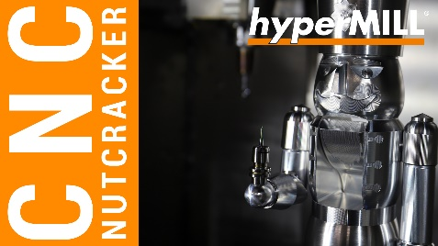
Source: OPEN MIND

Video: 5-axis machining of the nutcracker figure

About OPEN MIND Technologies AG
OPEN MIND Technologies AG is one of the world’s leading developers of powerful CAD/CAM solutions for machine and controller-independent programming.
OPEN MIND develops optimized CAD/CAM solutions that include a large number of innovative and unique features that can deliver significantly higher performance in both programming and machining. hyperMILL® is a completely modular CAD/CAM solution that provides state-of-the-art CAM technologies on its own CAD platform: from 2.5D, 3D and 5-axis machining as well as turning strategies and solutions for additive manufacturing, HSC and HPC machining. Whether automation, simulation or virtual machine – trendsetting technologies expand the product range and enable continuous digital process chains. Special applications, the perfect interaction with all popular CAD solutions and a customer-oriented service complete the product range.
According to the "NC Market Analysis Report 2023" compiled by CIMdata, hyperMILL® is ranked in the top 4 CAD/CAM solutions worldwide. The innovative CAD/CAM technologies fulfil the highest demands in the automotive, tool and mold manufacturing, production machining, medical, job shops, energy, semiconductor and aerospace industries.
OPEN MIND's majority stake in manufacturing execution system (MES) developer Hummingbird expands the CAD/CAM manufacturer's product portfolio and enhances the range of connected digitalized manufacturing technologies.
OPEN MIND is a Mensch und Maschine company and has subsidiaries and qualified sales partners on all continents.
You can find more information at www.openmind-tech.com.

OPEN MIND Technologies UK Ltd., Oxford
Unit 3
Bicester Business Park
Telford Road
Bicester
Oxfordshire OX26 4LN
England
Phone: +44 1869 290 003
Fax: +44 1869 369 429
E-mail: Info.UK@openmind-tech.com

OPEN MIND Technologies USA, Inc.
1492 Highland Avenue, Unit 3
Needham MA 02492
USA
Phone: +1 339 225 4557 office
Phone: +1 888 516 1232 x0 toll-free
Fax: +1 270 912 5822
E-mail: Info.Americas@openmind-tech.com

Head office:
OPEN MIND Technologies AG, Argelsrieder Feld 5, 82234 Wessling, Germany
Tel.: (+49-8153) 933-500, Fax: (+49-8153) 933-501
E-mail: Info@openmind-tech.com, website: www.openmind-tech.com

Press contact:
HighTech communications GmbH
Brigitte Basilio
Brunhamstrasse 21
81249 Munich
Germany
Tel.: (+49-89) 500778-20
E-mail: b.basilio@htcm.de
Website: www.htcm.de

