PRESS RELEASE
A strong team: Process Lens and
WORKS Process Expert from ASMPT
Process optimization along the entire line
Suwanee (USA), December 12, 2023 – Intelligent hardware and software solutions from technology and market leader ASMPT identify defective products in SMT manufacturing. Comprehensive monitoring of the entire production line reveals correlations that lead to rejects. This information forms the basis for continuous and integrative process optimization in the intelligent factory. The result: increased earnings, reduced workload for employees, and faster product launches.
“Zero DPMO is and will remain our ultimate goal,” affirms Jérôme Rousval, Product Manager Process Solutions at ASMPT. “On the other hand, careful quality assurance must not come at the expense of productivity. We present an inspection system that works extremely fast without compromising on measurement accuracy. We also demonstrated analytical software that stabilizes and optimizes processes across products and manufacturing lines.”
The hardware: Process Lens SPI system
The Process Lens system from ASMPT comes into play where statistically the most faults occur: during the solder paste printing process. The SPI system recognizes even the most minute deviations and trends. A DLP chip with up to 20 million individually controllable micro-mirrors checks each pad for volume, height, base area, shape, and position. The machine detects relevant areas on the PCB via a 2D scan before measuring them in 3D, all while operating up to 70 percent faster than conventional devices. And with a resolution of up to 10 microns, the Process Lens reports up to 80 percent fewer false positives.
The machine’s high performance also leaves more time for additional measurements without increasing the inspection time per unit – for example, to detect foreign objects or check glue dots. Another benefit: the Process Lens HD is one of the few SPI systems on the market where the measurement resolution can be controlled via software.
The software: WORKS Process Expert
While many of today’s inspection systems still focus on the individual product and manufacturing station, the intelligent inline system WORKS Process Expert looks at the operational whole. With the help of SPI and AOI systems, the printing and placement modules of the application include all printing and placement systems in the line in the error analysis via the standardized IPC-2591-CFX interface regardless of the machine’s manufacturer. This integrative cross-product and cross-line analysis and visualization of the data generated by SPI and AOI systems as well as the process data coming from the printers and assemblers help to identify and proactively eliminate the causes of defects, both in individual processes and in the overall context. This makes it possible to narrow down sporadic deviations that otherwise would remain undetected.
Based on AOI data, the Quality Viewer of WORKS Process Expert displays detailed fault statistics in the form of key performance indicators and freely selectable charts, thus helping operators on the line to find the causes of process errors. Reports from WORKS Process Expert can also be transferred to a pool of experts in accordance with their respective qualifications via the WORKS Command Center staff management application.
Autonomous printing process optimization
In combination with the Process Lens from ASMPT or a third-party SPI system, the printing process can run completely autonomously without any operator intervention. The system can also trigger an automatic offset correction or a cleaning cycle when needed. With virtual prints based on stencil data and ASMPT’s extensive process database, the printing module determines all relevant printing and process parameters, marks critical areas in the stencil layout, and recommends improvements before the first circuit board gets printed. With the help of “fractional experiments”, new products can be launched much faster because the software calculates all parameters for optimized stencil prints in minutes with just a few targeted test prints, making the whole process much more stable.
New: Placement process optimization
When SIPLACE pick-and-place machines are in use on the shop floor, WORKS Process Expert draws the operators’ attention to the sources of the largest process deviations and prioritizes the proposed solutions. Operators can easily see on the respective machine’s screen where they need to take action. This provides relief for skilled employees – who are quite scarce these days – and allows them to be deployed in a highly effective manner.
More productivity through integrative data utilization
“Automating ever more is not the panacea for increased productivity,” explains Rousval. “A lot of room for improvement remains in the way data is utilized, which still happens in a much too isolated manner in many factories. That’s why the kind of data integration we’ve achieved with WORKS Process Expert is the logical next step in intelligent factories for getting more speed, more yield, less waste, and more productivity.”

Illustrations for downloading
The following print-ready artwork is available on the internet for downloading:
https://kk.htcm.de/press-releases/asmpt/

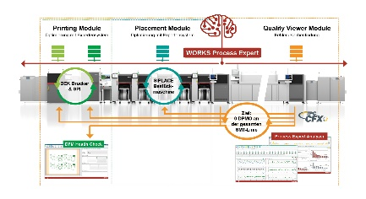 | 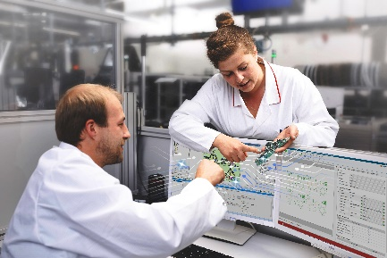
As an intelligent inline expert system, the WORKS Process Expert application optimizes the processes along the entire SMT line with one ambitious goal: zero DPMO.  Image credit: ASMPT | WORKS Process Expert makes the work of process and quality engineers much easier when it comes to identifying and troubleshooting problems along the entire SMT line.  Image credit: ASMPT

About ASMPT Limited (“ASMPT”)
ASMPT Limited is a leading global supplier of hardware and software solutions for the manufacture of semiconductors and electronics. Headquartered in Singapore, ASMPT’s offerings encompass the semiconductor assembly & packaging, and SMT (surface mount technology) industries, ranging from wafer deposition to the various solutions that organise, assemble and package delicate electronic components into a vast range of end-user devices, which include electronics, mobile communications, computing, automotive, industrial and LED (displays). ASMPT partners with customers very closely, with continuous investment in R&D helping to provide cost-effective, industry-shaping solutions that achieve higher productivity, greater reliability, and enhanced quality.
ASMPT is listed on the Stock Exchange of Hong Kong (HKEX stock code: 0522), and is one of the constituent stocks of the Hang Seng Composite MidCap Index under the Hang Seng Composite Size Indexes, the Hang Seng Composite Information Technology Industry Index under Hang Seng Composite Industry Indexes and the Hang Seng HK 35 Index.
To learn more about ASMPT, please visit us at asmpt.com.

The ASMPT SMT Solutions segment
The mission of the SMT Solutions segment within ASMPT is to implement and support the Intelligent Factory at electronics manufacturers worldwide.
ASMPT solutions support the networking, automation, and optimization of central workflows with hardware, software and services that enable electronics manufacturers to transition to the Intelligent Factory in stages and enjoy dramatic improvements in productivity, flexibility, and quality. With its integrated open automation concept, ASMPT opens the door for its customers to economically feasible automation, entirely in accordance with their individual requirements – modular, flexible, and vendor-independent.
The product range includes hardware and software such as SIPLACE placement solutions, DEK printing solutions, inspection and storage solutions, and the Software Suite WORKS. With WORKS, ASMPT offers electronics manufacturers high-quality software for planning, controlling, analyzing and optimizing all processes on the shop floor. Maintaining close relationships with customers and technology partners is a central component of ASMPT’s strategy.
For more information about ASMPT SMT Solutions visit smt.asmpt.com.

Media contacts:
AMCAS ASMPT Press Office
SMT Solutions
Mark Ogden
Tel.: +1 (770) 797 3189
E-mail: ogden.mark@asmpt.com
Website: smt.asmpt.com

Global ASMPT Press Office
ASMPT Ltd.
Susanne Oswald
Rupert-Mayer-Strasse 48
81379 Munich
Germany
Tel: +49 89 20800-26439
E-Mail: susanne.oswald@asmpt.com
Website: asmpt.com

