PRESS RELEASE
SIPLACE TX micron from ASMPT combines
SMT assembly and die processing
Speed and precision for SiPs
Suwanee (USA), November 30, 2023 – The SIPLACE TX micron is the answer to the challenges manufacturers face in SiP (system-in-package) production. The flexible platform combines the speed of SMT assembly with the complexity of die processing. The new version of the pick-and-place machine has been significantly improved by market and innovation leader ASMPT in terms of speed and placement accuracy as well as transport and processing options. The hybrid system offers electronics manufacturers greater flexibility and thus significant competitive advantages for their Intelligent Factory.
A SiP (system-in-package) combines active and passive electronic components into compact functional groups for things like radio modules in smartphones, wireless earphones or smartwatches. The advanced packaging technology required for this assembles dies, bare semiconductor chips, as well as classic SMT components. The high demand for such modules can only be satisfied with machines that process dies with the same high speed that is common in the SMT world and with the level of precision that is common in die processing. It involves the placement of passive SMD components, which must often be positioned very close to each other, with exceptional precision.
Two worlds and three precision classes in one machine
The SIPLACE TX micron from ASMPT fully meets these tough industrial requirements of the industry. After a further increase in the machine’s precision, three accuracy classes are now available for advanced packaging applications in a single machine: 10, 15 and 20 microns, each with a process stability of 3 sigma. Despite its improved basic accuracy from 25 to 20 microns, the machine achieves a placement speed of 93,000 cph – an increase of 14 percent compared to the previous 20-micron class of the SIPLACE TX micron. With its maximum placement accuracy of 10 microns, the machine can process an unprecedented 62,000 components per hour even in mixed SiP applications.
Larger components and boards
Thanks to its larger vacuum tooling, the SIPLACE TX micron can now process substrates measuring up to 300 by 240 millimeters with an accuracy of 15 microns @ 3 σ. New as well is the high-resolution SST54 circuit board camera with improved lighting performance for smaller structures, fiducials, and barcodes.
With the Long Board Option, the SIPLACE TX micron can process PCBs measuring up to 590 by 460 millimeters (23.2 by 18.1 inches). Also new is an optional multi-purpose conveyor system that allows regular PCBs, PCBs with carriers up to 20.5 mm high or curvatures as well as J-boats and JEDEC trays to be used as carriers. And customers who manufacture for highly demanding customers like those in the automobile industry will appreciate the optional level of traceability directly from the tape.
Now compatible with SIPLACE Tray Unit
As an added benefit for fast and uninterrupted production, the SIPLACE TX micron can now also be operated with the SIPLACE Tray Unit, which accommodates carriers that can each hold two JEDEC trays. Depending on the size of the components, up to 82 JEDEC trays or 41 wide trays measuring up to 355 by 275 millimeters fit into the unit. As a special feature, new trays can be added without having to interrupt the production because the magazine is split into a buffer zone for the continuous supply and the main storage area, which can be refilled with new trays.
Proven quality
Unchanged in the new version are established features such as the cost-saving detection of damaged or unusable components and the high-resolution component vision system with blue light that improves the image contrast for especially fine structures and balls. The SIPLACE TX micron is also certified in accordance with ISO Class 7 cleanroom requirements and Semi S2/S8.
A safe investment
“ASMPT’s product portfolio covers a wide range of areas for processing dies as well as SMT components,” explains Sylvester Demmel, Senior Product Manager at ASMPT. “To meet the changing market requirements, it was only logical for us to combine these two worlds in one machine, thus giving electronics manufacturers the opportunity to benefit from more flexibility and economic advantages for their Intelligent Factory. With its high precision and maximum placement speeds, the new SIPLACE TX micron is a future-proof investment that is profitable.”

Illustrations for downloading
The following print-ready artwork is available on the internet for downloading:
https://kk.htcm.de/press-releases/asmpt/

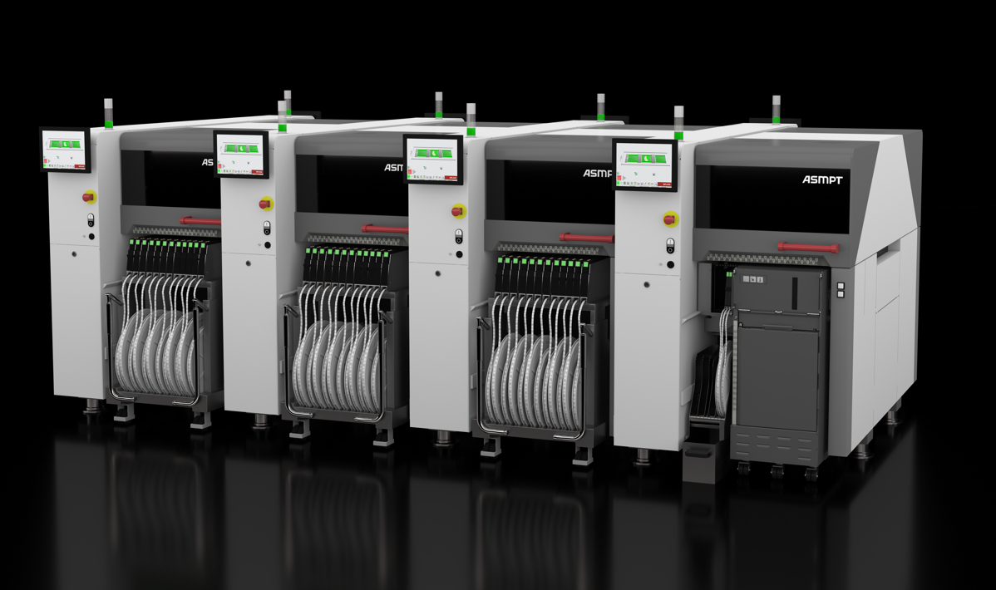

As an added benefit, the SIPLACE TX micron can now also be operated with the SIPLACE Tray Unit. New trays can be refilled without having to interrupt the production run.

Image credit: ASMPT

About ASMPT Limited (“ASMPT”)
ASMPT Limited is a leading global supplier of hardware and software solutions for the manufacture of semiconductors and electronics. Headquartered in Singapore, ASMPT’s offerings encompass the semiconductor assembly & packaging, and SMT (surface mount technology) industries, ranging from wafer deposition to the various solutions that organise, assemble and package delicate electronic components into a vast range of end-user devices, which include electronics, mobile communications, computing, automotive, industrial and LED (displays). ASMPT partners with customers very closely, with continuous investment in R&D helping to provide cost-effective, industry-shaping solutions that achieve higher productivity, greater reliability, and enhanced quality.
ASMPT is listed on the Stock Exchange of Hong Kong (HKEX stock code: 0522), and is one of the constituent stocks of the Hang Seng Composite MidCap Index under the Hang Seng Composite Size Indexes, the Hang Seng Composite Information Technology Industry Index under Hang Seng Composite Industry Indexes and the Hang Seng HK 35 Index.
To learn more about ASMPT, please visit us at asmpt.com.

The ASMPT SMT Solutions segment
The mission of the SMT Solutions segment within ASMPT is to implement and support the Intelligent Factory at electronics manufacturers worldwide.
ASMPT solutions support the networking, automation, and optimization of central workflows with hardware, software and services that enable electronics manufacturers to transition to the Intelligent Factory in stages and enjoy dramatic improvements in productivity, flexibility, and quality. With its integrated open automation concept, ASMPT opens the door for its customers to economically feasible automation, entirely in accordance with their individual requirements – modular, flexible, and vendor-independent.
The product range includes hardware and software such as SIPLACE placement solutions, DEK printing solutions, inspection and storage solutions, and the Software Suite WORKS. With WORKS, ASMPT offers electronics manufacturers high-quality software for planning, controlling, analyzing and optimizing all processes on the shop floor. Maintaining close relationships with customers and technology partners is a central component of ASMPT’s strategy.
For more information about ASMPT SMT Solutions visit smt.asmpt.com.

Media contacts:
AMCAS ASMPT Press Office
SMT Solutions
Mark Ogden
Tel.: +1 (770) 797 3189
E-mail: ogden.mark@asmpt.com
Website: smt.asmpt.com

Global ASMPT Press Office
ASMPT Ltd.
Susanne Oswald
Rupert-Mayer-Strasse 48
81379 Munich
Germany
Tel: +49 89 20800-26439
E-Mail: susanne.oswald@asmpt.com
Website: asmpt.com

