PRESS RELEASE
ASMPT is upbeat on the results of
productronica 2023
The impressive fusion of innovation and integration
Munich, November 20, 2023 – ASMPT, the global innovation and market leader in SMT and semiconductor assembly & packaging solutions, calls its extensive presence at the world’s leading trade fair productronica for electronics development and manufacturing in Munich a complete success. All its businesses – ASMPT Semiconductor Solutions, ASMPT SMT Solutions, and Critical Manufacturing – presented themselves as an innovative and integrated whole.
“What belongs together in the semiconductor industry is coming together,” said Guenter Lauber, EVP & Chief Strategy and Digitalization Officer at ASMPT. “Innovative developments such as system-in-package components, but also increasing cost pressures, require us to overcome the boundaries between SMT and die processing, and to think and act across lines, products and manufacturing facilities when it comes to data use.”
Industry visitors were able to see what this looks like in practice at the joint ASMPT booth, where ASMPT Semiconductor Solutions presented new innovative machines that are particularly interesting for automotive applications in the areas of ADAS, connectivity and electrification that require maximum precision and unique speeds. With an SMT production line that was fully optimized for volume production and a flexible SMT line for small-batch production, ASMPT demonstrated once again that the innovation and market leader is able to cover the entire hardware spectrum for modern electronics manufacturing. The hybrid pick-and-place machine SIPLACE CA marks the successful synthesis between chip assembly and SMT processing, and the industry audience’s interest was correspondingly high.
ASMPT’s software products were all about its new Intelligent Factory concept, which focuses on the smart use of data and connects all production levels from the machines to the enterprise into a functional and productive whole. As a result, skilled workers are deployed more efficiently, materials are scheduled more effectively, and errors and production impediments are detected and rectified more quickly. Also trend-setting was ASMPT’s Critical Manufacturing software business, which presented its modern, integrated manufacturing execution system (MES) designed specifically for electronics manufacturing at the trade fair.
“Frequent feedback from our customers was: “What I would otherwise have to put together from many different sources, the market leader is now offering from a single source”,” said Guenter Lauber. “This means ASMPT features a hardware and software concept that is as coherent as it is comprehensive while incorporating existing third-party solutions and combining the performance and precision of proven hardware with future-oriented software.”
“Lively interest by the public and extremely positive customer feedback at the fair are both a confirmation of our work and an incentive,” says Guenter Lauber, about his company’s endeavors. “In 2024, we will continue to consistently advance our integrative strategy in all divisions. Achieving the greatest return on investment for our customers, however, is and continues to be our overarching goal in everything we do.”

Illustrations for downloading
The following print-ready artwork is available on the internet for downloading:
https://kk.htcm.de/press-releases/asmpt/

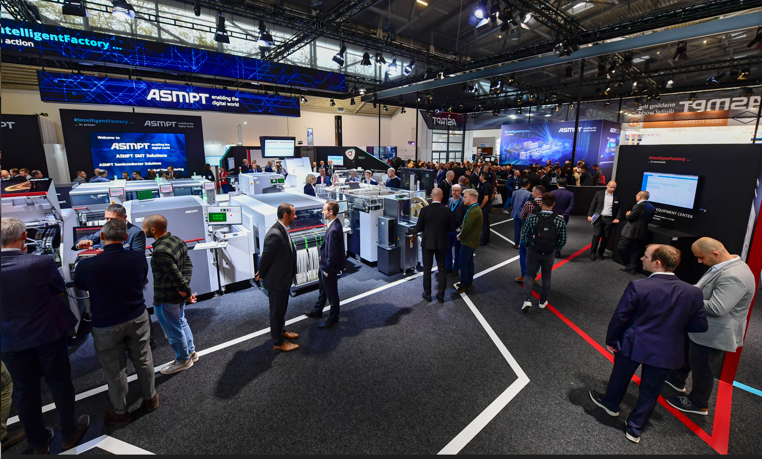

The concept of the Intelligent Factory presented by ASMPT – a software-oriented, integrative approach that draws maximum value from existing hardware and enables enterprise-wide big data processing in electronics manufacturing – met with great interest among the numerous visitors.  Image credit: ASMPT | Guenter Lauber, EVP & Chief Strategy and Digitalization Officer at ASMPT  Image credit: ASMPT

About ASMPT Limited (“ASMPT”)
ASMPT Limited is a leading global supplier of hardware and software solutions for the manufacture of semiconductors and electronics. Headquartered in Singapore, ASMPT’s offerings encompass the semiconductor assembly & packaging, and SMT (surface mount technology) industries, ranging from wafer deposition to the various solutions that organise, assemble and package delicate electronic components into a vast range of end-user devices, which include electronics, mobile communications, computing, automotive, industrial and LED (displays). ASMPT partners with customers very closely, with continuous investment in R&D helping to provide cost-effective, industry-shaping solutions that achieve higher productivity, greater reliability, and enhanced quality.
ASMPT is listed on the Stock Exchange of Hong Kong (HKEX stock code: 0522), and is one of the constituent stocks of the Hang Seng Composite MidCap Index under the Hang Seng Composite Size Indexes, the Hang Seng Composite Information Technology Industry Index under Hang Seng Composite Industry Indexes and the Hang Seng HK 35 Index.
To learn more about ASMPT, visit www.asmpt.com.
Media contacts:
Global ASMPT Press Office
ASMPT Ltd.
Susanne Oswald
Rupert-Mayer-Str. 48
81379 Munich
Germany
Tel: +49 89 20800-26439
E-mail: susanne.oswald@asmpt.com
Website: asmpt.com

HighTech communications GmbH
Barbara Ostermeier
Brunhamstr. 21
81249 Munich
Germany
Tel.: +49-89 500778-10
Fax: +49-89 500778-78
E-mail: b.ostermeier@htcm.de
Website: www.htcm.de

