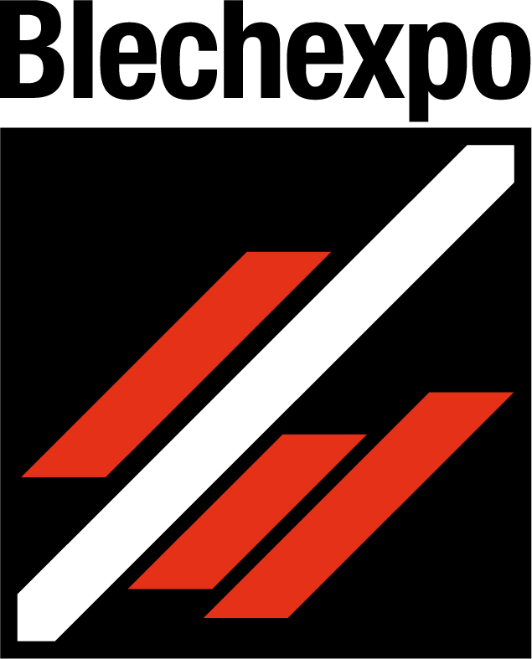
Press release
Schröder Group at Blechexpo
More freedom, more flexibility
7–10 November 2023
Hall 1, Booth 1805
Wessobrunn-Forst (Germany), 18 October 2023 – The Schröder Group will be exhibiting a wide range of sheet metal working machines at the booth 1805 in Hall 1 at Blechexpo from November 7 to 10, 2023. The presentation will focus on folding machines for all sheet thicknesses and automation solutions for a wide range of sheet metal applications. Highlights are the MAK 4 Evolution UD, which bends 6 mm thick sheets on 3200 mm working length, the PowerBend Multi with the option of conical bending and the brand-new EVO DuoBend, a folding machine with two folding beams.
The top model in the range of industrial folding machines is the MAK 4 Evolution UD for up to 6 mm thick sheets. The equipment of the machine with its generous clamping beam stroke of 1090 mm includes an up-and-down folding beam and a back gauge with suction cups. Radius Step Bending will be shown as a special function of the POS 3000 3D graphic control.
The EVO DuoBend makes its first public appearance at Blechexpo. This brand-new motorized folding machine (working length 4000 mm, sheet thickness 4.0 mm) works with two independently operating folding beams. After the up-and-down folding beam, Schröder thus introduces a second option for manufacturing large-format products with counter bends without having to turn the sheet. A negative bend is carried out by the top folding beam and a positive bend by the bottom folding beam. This eliminates the need to bypass already bent product sides, which means that there are no longer any restrictions due to the maximum bypass radius of less than 200 mm. The EVO DuoBend will appear at Blechexpo with a fully automatic tool changer which has proven itself as a great support many times on the MAK 4 Evolution UD with up to 500 mm high tools. With the EVO DuoBend Hans Schröder Maschinenbau GmbH is nominated for the innovation award "Blechexpo best-Award 2023“.
Rotating clamping beam
With the option of a rotating clamping beam, the Schröder Group offers the possibility to quickly switch between tool stations and geometries with different clearances. Both the PowerBend Professional and the PowerBend Multi will be shown at the exhibition with improved rotating clamping beams. The PowerBend Multi also has a new squeeze function that allows folding hems entirely by bending with the folding beam. The swivel range of the folding beam has been extended to 190° for this purpose. Moreover, the following gauge option has quickly become an insider's tip among the machine options of the PowerBend Multi: conical bending. With the unique two-axis back gauge, pluggable profiles can be produced quickly and easily with precision in the tenth of a millimeter range. This eliminates the need for manual reworking in applications where edges are not parallel, such as parapet or wall copings, roof edge trim, verge plates, and cladding that is to have a slope.
Perfect radii
Also on display at Blechexpo are the slip bending rolls of the Schröder-Fasti brand. These are especially appreciated for their roll geometry with a crowning that allows particularly uniform radii. Beading and flanging machines will also be on the booth, as well as the ASK 3 segmented manual folding machine and the two powerful motorized shears MHSU and PDC with a NC positioning gauge.

Available images
The following images are available for download in printable format at:
https://kk.htcm.de/press-releases/schroeder/
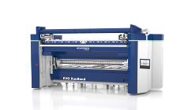  Image source: Schröder Group  This is what it will look like, the new folding machine of the Schröder Group at Blechexpo: EVO DuoBend with two independently operated folding beams. | 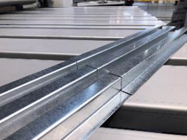  Image source: Schröder Group  The " conical bending " option of the PowerBend Multi enables pluggable profiles.

About Schröder Group
The Schröder Group consists of Hans Schröder Maschinenbau GmbH, which is located in Wessobrunn-Forst, Germany, SCHRÖDER-FASTI Technologie GmbH, located in Wermelskirchen, Germany and the SMU GmbH, located in Leinburg-Weißenbrunn.
Founded in 1949, Hans Schröder Maschinenbau GmbH unifies traditional and modern approaches in machine building: Successfully managed as a quality and customer-oriented, family-owned company, Hans Schröder Maschinenbau is specialized in the development of modern machine concepts for bending and cutting sheet metal.
The successful integration of the Fasti Company in 2006 and its worldwide presence make the Schröder Group one of today‘s leading providers of machines for bending, cutting, beading, flanging, and circular bending all types of sheet metal. The company‘s precision machines range from proven solutions for craftsmen to innovative, high-performance machines for automatic industrial production processes. 2021 the Schröder Group was expanded by the tool manufacturer SMU GmbH. Overall, the Schröder Group currently employs more than 300 people at various locations at home and abroad.
Further information is available at www.schroedergroup.eu/en.

Press contact:
Schröder Group
Hans Schröder Maschinenbau GmbH
Janina Biró
Feuchten 2
82405 Wessobrunn-Forst
Germany
T: +49 8809 9220-68
E-mail: jj@schroedergroup.eu
Website: www.schroedergroup.eu

HighTech communications GmbH
Brigitte Basilio
Brunhamstraße 21
81249 München
Germany
T: +49 89 500778-20
E-mail: b.basilio@htcm.de
Website: www.htcm.de

