PRESS RELEASE
OPEN MIND with hyperMILL® at EMO 2023
Interest in digital twins is growing
Wessling (Germany), October 16, 2023 – EMO 2023 ended on a thoroughly successful note for OPEN MIND. As expected, hyperMILL® TURNING Solutions for turning, turn-milling and mill-turning attracted significant interest. This was emphasized by live demonstrations on a GROB G350T mill-turn machine. The topic of simulation also played a major role in the exhibition. Many trade show visitors were interested in the virtual machine technology that resides in the hyperMILL® CAM system, with which a digital twin of the machining situation can be realized.
"Users are showing themselves to be open and interested in topics that can be summarized under the heading of digitalization," says Claudio Jorio, Sales Director DACH & Global Reseller at OPEN MIND Technologies AG. He continues: "People are increasingly thinking in terms of process chains, and our path from CAD via CAM to the CNC machines already represents the starting point for digitalization in the sense of networked production, which obviously makes sense. Users are looking for ways to become even more efficient. This fits with the great demand for the Hummingbird MES that we have seen."

Available images
The following images are available for download in printable format at:
https://kk.htcm.de/press-releases/open-mind/

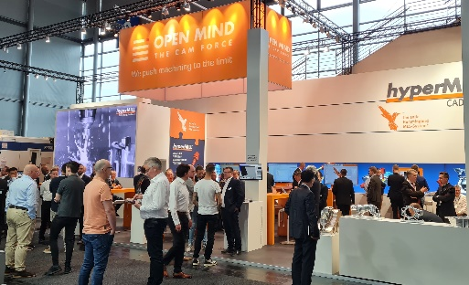Source: OPEN MIND  Successful EMO trade show appearance for OPEN MIND with its CAD/CAM and MES solutions | 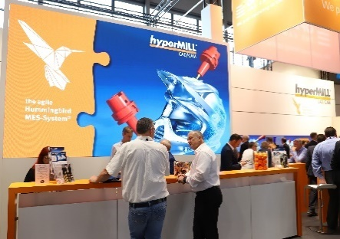  Source: OPEN MIND  Trade show visitors learned about implementing networked processes with hyperMILL® and Hummingbird MES.
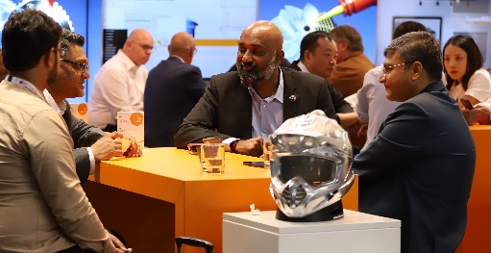
Source: OPEN MIND

Many international visitors were also interested in hyperMILL®.

About OPEN MIND Technologies AG
OPEN MIND Technologies AG is one of the world’s leading developers of powerful CAD/CAM solutions for machine and controller-independent programming.
OPEN MIND develops optimized CAD/CAM solutions that include a large number of innovative and unique features that can deliver significantly higher performance in both programming and machining. hyperMILL® is a completely modular CAD/CAM solution that provides state-of-the-art CAM technologies on its own CAD platform: from 2.5D, 3D and 5-axis machining as well as turning strategies and solutions for additive manufacturing, HSC and HPC machining. Whether automation, simulation or virtual machine – trendsetting technologies expand the product range and enable continuous digital process chains. Special applications, the perfect interaction with all popular CAD solutions and a customer-oriented service complete the product range.
According to the "NC Market Analysis Report 2023" compiled by CIMdata, hyperMILL® is ranked in the top 4 CAD/CAM solutions worldwide. The innovative CAD/CAM technologies fulfil the highest demands in the automotive, tool and mold manufacturing, production machining, medical, job shops, energy, semiconductor and aerospace industries.
OPEN MIND's majority stake in manufacturing execution system (MES) developer Hummingbird expands the CAD/CAM manufacturer's product portfolio and enhances the range of connected digitalized manufacturing technologies.
OPEN MIND is a Mensch und Maschine company and has subsidiaries and qualified sales partners on all continents.
You can find more information at www.openmind-tech.com.

OPEN MIND Technologies UK Ltd., Oxford
Unit 3
Bicester Business Park
Telford Road
Bicester
Oxfordshire OX26 4LN
England
Phone: +44 1869 290 003
Fax: +44 1869 369 429
E-mail: Info.UK@openmind-tech.com

OPEN MIND Technologies USA, Inc.
1492 Highland Avenue, Unit 3
Needham MA 02492
USA
Phone: +1 339 225 4557 office
Phone: +1 888 516 1232 x0 toll-free
Fax: +1 270 912 5822
E-mail: Info.Americas@openmind-tech.com

Head office:
OPEN MIND Technologies AG, Argelsrieder Feld 5, 82234 Wessling, Germany
Tel.: (+49-8153) 933-500, Fax: (+49-8153) 933-501
E-mail: Info@openmind-tech.com, website: www.openmind-tech.com

Press contact:
HighTech communications GmbH
Brigitte Basilio
Brunhamstrasse 21
81249 Munich
Germany
Tel.: (+49-89) 500778-20
E-mail: b.basilio@htcm.de
Website: www.htcm.de

