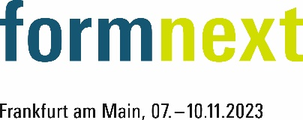
PRESS RELEASE
OPEN MIND at Formnext Expo 2023
hyperMILL® brings additive and subtractive manufacturing together
Hall A39, Booth 12.0
Wessling (Germany), October 12, 2023 – OPEN MIND will be presenting the benefits of the hyperMILL® CAD/CAM system for users of additive manufacturing processes at formnext exhibition from November 7th to 10th, 2023. At booth 12.0 in hall A39 at Messe Frankfurt, examples of additive workpieces programmed with hyperMILL® will be shown and the BEST FIT concept, an innovative technique for reducing the effort involved in post-processing will be explained.
hyperMILL® ADDITIVE Manufacturing opens up the flexible possibilities of highly complex 5-axis simultaneous machining to the Direct Energy Deposition (DED) process and Wire Arc Additive Manufacturing (WAAM) process. NC codes can be conveniently programmed and automatically simulated for collision avoidance. As an end-to-end software solution, this enables efficient hybrid machining with additive and subtractive machining on one machine.
No 3D printing without finishing
Support structures and surfaces that can be seen to be built up layer by layer make a finish machining operation necessary for additively manufactured workpieces. Post-processing of printed parts requires the alignment of near-finished parts with low stock allowance in the machine tool unless using hybrid machines. With hyperMILL® BEST FIT, OPEN MIND replaces time-consuming and error-prone manual alignment with an automated process. Instead of positioning additively generated parts for post-processing in the milling machine so that the zero point and axes match the NC code, BEST FIT adjusts the code to the real position of the workpiece in the machines’ workspace that is imported via measurement and simulation as a digital twin.
"With the hyperMILL® BEST FIT function, we are offering an innovative answer to the challenge of part alignment for post-processing and thus achieving an unprecedented level of process reliability," explains Manfred Guggemos, Product Manager at OPEN MIND Technologies AG.

Available images
The following images are available for download in printable format at:
https://kk.htcm.de/press-releases/open-mind/
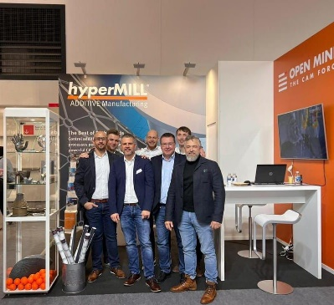  Source: OPEN MIND  The OPEN MIND team is looking forward to meeting other 3D printing experts at formnext | 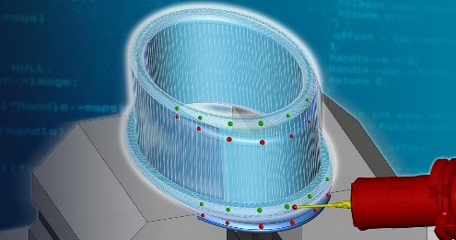  Source: OPEN MIND  hyperMILL® BEST FIT: Intelligent part alignment at the push of a button

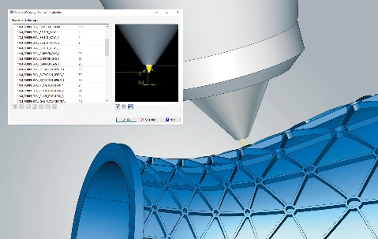  Source: OPEN MIND  Detailed mapping of the laser machining head in the machining simulation in hyperMILL® | 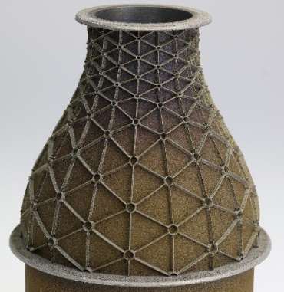  Source: OPEN MIND  Part manufactured with hyperMILL® ADDITIVE Manufacturing Aerospace turbine nozzle

Available videos
You can find the following videos on our YouTube channel:
https://youtu.be/OIZIoQvBob8
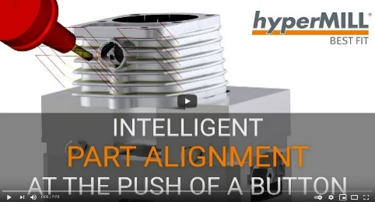
Source: OPEN MIND

Video about intelligent part alignment in CAM with hyperMILL® BEST FIT

About OPEN MIND Technologies AG
OPEN MIND Technologies AG is one of the world’s leading developers of powerful CAD/CAM solutions for machine and controller-independent programming.
OPEN MIND develops optimized CAD/CAM solutions that include a large number of innovative and unique features that can deliver significantly higher performance in both programming and machining. hyperMILL® is a completely modular CAD/CAM solution that provides state-of-the-art CAM technologies on its own CAD platform: from 2.5D, 3D and 5-axis machining as well as turning strategies and solutions for additive manufacturing, HSC and HPC machining. Whether automation, simulation or virtual machine – trendsetting technologies expand the product range and enable continuous digital process chains. Special applications, the perfect interaction with all popular CAD solutions and a customer-oriented service complete the product range.
According to the "NC Market Analysis Report 2023" compiled by CIMdata, hyperMILL® is ranked in the top 4 CAD/CAM solutions worldwide. The innovative CAD/CAM technologies fulfil the highest demands in the automotive, tool and mold manufacturing, production machining, medical, job shops, energy, semiconductor and aerospace industries.
OPEN MIND's majority stake in manufacturing execution system (MES) developer Hummingbird expands the CAD/CAM manufacturer's product portfolio and enhances the range of connected digitalized manufacturing technologies.
OPEN MIND is a Mensch und Maschine company and has subsidiaries and qualified sales partners on all continents.
You can find more information at www.openmind-tech.com.

OPEN MIND Technologies UK Ltd., Oxford
Unit 3
Bicester Business Park
Telford Road
Bicester
Oxfordshire OX26 4LN
England
Phone: +44 1869 290 003
Fax: +44 1869 369 429
E-mail: Info.UK@openmind-tech.com

OPEN MIND Technologies USA, Inc.
1492 Highland Avenue, Unit 3
Needham MA 02492
USA
Phone: +1 339 225 4557 office
Phone: +1 888 516 1232 x0 toll-free
Fax: +1 270 912 5822
E-mail: Info.Americas@openmind-tech.com

Head office:
OPEN MIND Technologies AG, Argelsrieder Feld 5, 82234 Wessling, Germany
Tel.: (+49-8153) 933-500, Fax: (+49-8153) 933-501
E-mail: Info@openmind-tech.com, website: www.openmind-tech.com

Press contact:
HighTech communications GmbH
Brigitte Basilio
Brunhamstrasse 21
81249 Munich
Germany
Tel.: (+49-89) 500778-20
E-mail: b.basilio@htcm.de
Website: www.htcm.de

