PRESS RELEASE
Swissbit Unveils New Portfolio of Real Industrial-Grade SATA SSDs with highly reliable 3D NAND Technology

Bronschhofen, Switzerland. October 12, 2023 – Swissbit, a leading manufacturer of industrial-grade flash memory solutions, today announced the release of its new product line of SATA SSDs. The series X-73, X-75 and X-78 are powered by cutting-edge industrial 112-layer 3D NAND technology, bringing unprecedented reliability and extended lifespan to the world’s most crucial networks. The latest portfolio is built with Swissbit’s dedication to quality and innovation. The new portfolio not only offers reduced Total Cost of Ownership (TCO) thanks to its extended product life cycle, but also comes with powersafeTM SSDs – Swissbit’s industry-leading power loss protection feature.
The expanded SSD product line includes M.2 2242, M.2 2280, Slim SATA MO-297, and 2.5” form factors, and offers a wide capacity range from 40 GB up to 1.92 TB. With an industry-leading 100k P/E cycles, the high endurance versions in pSLC mode are aimed at addressing the increasing market demand for durable and reliable data storage solutions.
“Our new generation of SATA SSDs underlines the industrial long-term strategy in providing highly reliable, secure, industrial-grade NAND flash memory solutions for our customers,” said Roger Griesemer, General Manager Memory Solutions at Swissbit. “We have specifically designed these drives to meet the needs of the most demanding applications, especially in mission-critical sectors such as embedded systems, IPC, IoT, networking and communication equipment, and industrial automation.”
Further enhancing data integrity, selected series come with Swissbit’s powersafeTM PLP feature, which guarantees end-to-end data security in the event of sudden power loss. The incorporation of powersafeTM technology in the new X-75 (2.5”) and X-75m2 2280 series ensures that SSDs operate safely under any circumstances, preventing drive corruption and loss of critical data.
For added data security, all the products in the portfolio are self-encrypting-drives (SEDs) equipped with AES-256 encryption and TCG Opal 2.0, providing a robust and efficient method of encrypting stored data. This design enables advanced user management options, thereby enhancing system data sharing on a strictly need-to-know basis.
The new Swissbit SATA SSDs are designed to perform optimally in a wide range of applications, such as 5G networks, edge computing, servers, smart surveillance, smart medical devices, POS, factory/industrial automation, routers, switches, security appliances, and Internet of Things applications.
Swissbit’s commitment to serving its customers with high-quality, innovative products is exemplified in the launch of this new portfolio. With customization available on a project basis, Swissbit is set to continue driving the future of industrial-grade flash memory solutions.
For more information about Swissbit’s new SATA SSDs with real industrial-grade 112-layer TLC NAND, visit www.swissbit.com.

Available images
The following images are available for download in printable format at: https://kk.htcm.de/press-releases/swissbit/
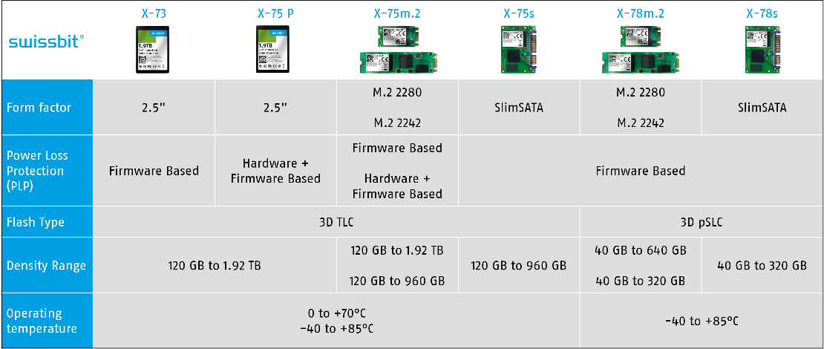
Image source: Swissbit
Overview of the new SATA SSD series X-73, X-75 and X-78 from Swissbit.
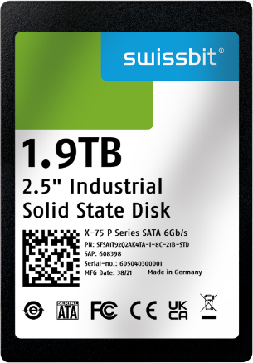
Image source: Swissbit
Part of Swissbit’s new SATA SSD portfolio: The X-75 P including Swissbit powersafeTM technology for advanced PLP protection.

About Swissbit
Swissbit AG is the leading European manufacturer of storage, security and embedded IoT solutions for demanding applications. Swissbit combines its unique competences in storage and embedded IoT technology with its advanced packaging know-how. This expertise allows our customers to reliably store and protect data in industrial, NetCom, automotive, medical, and fiscal applications as well as across the Internet of Things (IoT).
Swissbit develops and manufactures industrial-grade storage and security products “Made in Germany” with high reliability, long-term availability, and custom optimization.
Swissbit’s storage range includes SSDs with PCIe and SATA interface such as mSATA, Slim SATA, CFast™, M.2 and 2.5” as well as CompactFlash, USB flash drives, SD Memory Cards, micro-SD Memory Cards and managed NAND BGAs like e.MMC. Security products are available in various application specific editions as USB flash drives, SD Memory Cards, and micro-SD Memory Cards.
Swissbit was founded in 2001 and has offices in Switzerland, Germany, USA, Japan and Taiwan. Swissbit owns the registered trademarks Swissbit® and Hyperstone®. Since 2020, the independent investment firm Ardian is holding a majority stake in the company to support its growth.
For further information, please visit www.swissbit.com

Regional Headquarters:
Swissbit Germany AG
Bitterfelder Strasse 22
12681 Berlin
Germany
Tel: +49 30 936 954 0
Email: info@swissbit.com
www.swissbit.com
Headquarters:
Swissbit AG
Industriestrasse 4
9552 Bronschhofen
Switzerland
Tel: +41 71 913 03 03
Email: info@swissbit.com
www.swissbit.com
Contact:  Swissbit AG  Marian Weber  Industriestrasse 4  9552 Bronschhofen  Switzerland  Tel: +49 172 854 88 26  Email: marian.weber@swissbit.com  www.swissbit.com | Press Agency:  HighTech communications GmbH  Brigitte Basilio  Brunhamstrasse 21  81249 Munich  Germany  Tel: +49 89 500778-20  Email: b.basilio@htcm.de  www.htcm.de

