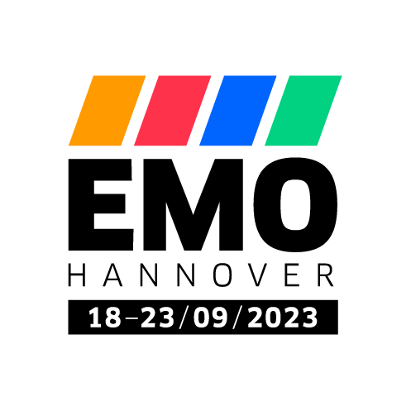PRESS RELEASE

*hyper*MILL® TURNING Solutions at EMO 2023

Mill turning: OPEN MIND boosts efficiency and process reliability

Wessling (Germany), September 18, 2023 - *hyper*MILL® TURNING Solutions are the hot topic for OPEN MIND at this year’s EMO. Live demonstrations on a GROB G350T mill-turn machine will be performed at the booth to display what the milling-turning technologies of the *hyper*MILL® CAD/CAM solution can do. The demos will also include milling, drilling and angle head support.

**Exhibition Hall 9,   
Booth A05**

[*hyper*MILL® TURNING Solutions](https://www.openmind-tech.com/en/cam/turning-solutions/) include technologies for turning, turn-milling, and mill-turning, meaning they can be used for all corresponding machine configurations. OPEN MIND has chosen a housing component made using high-strength EN AW 7075 aluminum to demonstrate the capabilities of *hyper*MILL® in practice. The component is 372mm in diameter and 200mm high and engages in turning operations on the outer and inner contours. It also features various milled geometries inspired by typical requirements in different industries. These include housing elements from plant engineering for the semiconductor industry, surfaces such as those used in mold making, as well as reverse counterboring and angular head support functions – demonstrated live for the first time – which is in particular demand in mechanical engineering.

Tool-friendly turning

When roughing and finishing the external and internal contours, the benefit of simultaneous machining is impressively demonstrated alongside standard machining. Two areas that would otherwise have to be finished individually can be machined in one step with simultaneous turning and without a visible edge. Among the high-performance strategies shown will be trochoidal roughing. A high material removal rate is achieved quickly and gently without any major lifting movements.

The advantage of 3-axis simultaneous turning is also clear from the undercuts when machining the inner contour. Without this technique, these areas would be difficult to manufacture. Trade show visitors can see how easy it is to program 3-axis simultaneous turning. For even better performance, simultaneous roughing can also be used with the HPC option.

Milling rates

The live machining demonstration at EMO contains an example of a 5-axis halfpipe with finishing operations. OPEN MIND shows how quickly optimized tool paths can be programmed for grooves and tubes that produce the highest quality surface finishes. Perfect surfaces are also shown in another geometry. To minimize the effort required for grinding and polishing steps, *hyper*MILL® offers a machining strategy with gentle overlapping, creating perfect transitions that are barely measurable.

Secure programming

As an example of the safe programming of machining operations with a high risk of collision, a reverse counterboring task has been integrated into the demonstration, i.e. the control of a tool for deburring and milling cylinder countersinks on the inaccessible rear side of a bore.

**Available images**

The following images are available for download in printable format at:   
<https://kk.htcm.de/press-releases/open-mind/>

|  |  |
| --- | --- |
| Source: OPEN MIND  **The demo part for live machining at EMO 2023 combines a wealth of challenging turning and milling tasks** | Source: OPEN MIND  **Trochoidal roughing and simultaneous machining – the high-performance turning strategies of *hyper*MILL® TURNING Solutions are fast and tool-friendly at the same time** |
| Source: OPEN MIND  **Without 3-axis simultaneous turning, undercuts like these wouldn’t be possible** |

About OPEN MIND Technologies AG

OPEN MIND Technologies AG is one of the world’s leading developers of powerful CAD/CAM solutions for machine and controller-independent programming.

OPEN MIND develops optimized CAD/CAM solutions that include a large number of innovative and unique features that can deliver significantly higher performance in both programming and machining. *hyper*MILL® is a completely modular CAD/CAM solution that provides state-of-the-art CAM technologies on its own CAD platform: from 2.5D, 3D and 5-axis machining as well as turning strategies and solutions for additive manufacturing, HSC and HPC machining. Whether automation, simulation or virtual machine – trendsetting technologies expand the product range and enable continuous digital process chains. Special applications, the perfect interaction with all popular CAD solutions and a customer-oriented service complete the product range.

According to the "NC Market Analysis Report 2023" compiled by CIMdata, *hyper*MILL® is ranked in the top 4 CAD/CAM solutions worldwide. The innovative CAD/CAM technologies fulfil the highest demands in the automotive, tool and mold manufacturing, production machining, medical, job shops, energy, semiconductor and aerospace industries.

OPEN MIND's majority stake in manufacturing execution system (MES) developer Hummingbird expands the CAD/CAM manufacturer's product portfolio and enhances the range of connected digitalized manufacturing technologies.

OPEN MIND is a Mensch und Maschine company and has subsidiaries and qualified sales partners on all continents.

You can find more information at [www.openmind-tech.com](http://www.openmind-tech.com).

OPEN MIND Technologies UK Ltd., Oxford

Unit 3

Bicester Business Park

Telford Road

Bicester

Oxfordshire OX26 4LN

England

Phone: +44  1869  290 003

Fax: +44  1869  369 429

E-mail: Info.UK@openmind-tech.com

OPEN MIND Technologies USA, Inc.

1492 Highland Avenue, Unit 3

Needham MA 02492

USA

Phone: +1  339  225  4557 office

Phone: +1  888  516 1232 x0 toll-free

Fax: +1  270  912 5822

E-mail: Info.Americas@openmind-tech.com

Head office:   
OPEN MIND Technologies AG, Argelsrieder Feld 5, 82234 Wessling, Germany  
Tel.: (+49-8153) 933-500, Fax: (+49-8153) 933-501  
E-mail: Info@openmind-tech.com, website: www.openmind-tech.com

**Press contact:**

HighTech communications GmbH  
Brigitte Basilio  
Brunhamstrasse 21  
81249 Munich  
Germany  
Tel.: (+49-89) 500778-20  
E-mail: b.basilio@htcm.de  
Website: www.htcm.de