PRESS RELEASE
Swissbit introduces iShield Archive memory card that protects sensitive information
microSD card with encryption function offers reliable access protection for video and image data

Bronschhofen, Switzerland. September 12, 2023 – With ‘iShield Archive’, the storage and security expert Swissbit introduces a new microSD card designed for encryption and access protection of video and image records, expanding the Swissbit iShield product line for plug-and-play security solutions. The card is intended particularly for manufacturers and users for whom sensitive data confidentiality and data protection in line with GDPR legislation are top priorities. It can be used host-independently with all common camera types. The plug-and-play system offers insurance firms, governments, or security organizations an effective solution to guarantee that recordings are never viewed, copied, or erased by unauthorized people under any circumstances. The data is AES-256-bit hardware encrypted by iShield Archive and can also be used in WORM (Write Once, Read Many) scenarios. The microSD comes in storage sizes ranging from 16 to 64 GB and is UHS-I U3 and V30 rated for 4K video recordings.
Securely storing sensitive video and image data is, in many cases, essential to ensure data protection, confidentiality, or the integrity of crucial evidence. After all, data breaches can have significant repercussions, particularly for public safety but also for the insurance or healthcare industries. This is where Swissbit's iShield Archive offers a reliable solution. Manufacturers, system integrators, businesses or authorities can easily equip drones, body cams and many other types of cameras with an extra layer of security using the microSD card.
Functionality and operation
The PC-based "iShield Archive Tool" (iAT) software is used to set up the card. Both the security parameters and user PIN are configured here. Following the initial configuration, iShield Archive securely stores data in the end device and uses hardware AES-256-bit encryption to protect it.
Any previously recorded data is no longer viewable on iShield Archive once the camera is turned off or the microSD card is removed, and can only be accessed and downloaded using iAT together with a correct password. Up until the card's capacity is reached, this procedure can be repeated. To release storage capacity, data must first be deleted from iShield Archive, which is only possible through authentication with the correct password.

Optionally, deletion can be further safeguarded by an admin PIN, which allows iShield Archive to be used for role-based access control. Here, only a defined group of individuals have the required rights to permanently delete recordings or data. In the so-called WORM mode, regular users have read-only access with a user PIN, but are not authorized to edit or delete data. WORM mode is commonly used for data that needs to be stored in a safe and unalterable manner for legal reasons.
Technical specification and availability
The 16, 32, and 64 GB storage capacity options for iShield Archive feature Speed Class UHS-I U3 and Video Speed Class V30 for capturing 4K video. The microSD cards are based on 3D-pSLC NAND and designed for use in the industrial temperature range of -40 to +85 °C. The iAT software is available for Windows, macOS, and Linux operating systems and can be downloaded for free from www.swissbit.com.
The following sales channels sell iShield Archive: Allnet, Digikey, Distrelec, Farnell, Mouser, and Rutronik 24. Individual inquiries can also be directed at any time to sales@swissbit.com.

Available images
The following images are available for download in printable format at: https://kk.htcm.de/press-releases/swissbit/
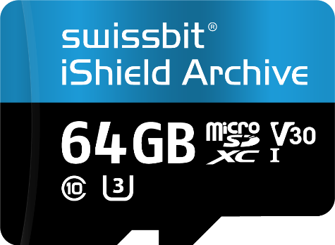  Image source: Swissbit  iShield Archive from Swissbit is a microSD card with an encryption function for effective access protection of video and photo data. | 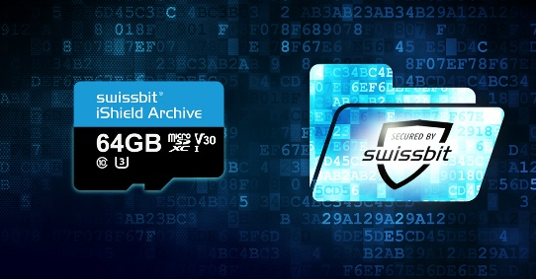  Image source: Swissbit  The new iShield Archive memory card from Swissbit protects sensitive information and is available in capacities ranging from 16 to 64 GB.

About Swissbit
Swissbit AG is the leading European manufacturer of storage, security and embedded IoT solutions for demanding applications. Swissbit combines its unique competences in storage and embedded IoT technology with its advanced packaging know-how. This expertise allows our customers to reliably store and protect data in industrial, NetCom, automotive, medical, and fiscal applications as well as across the Internet of Things (IoT).
Swissbit develops and manufactures industrial-grade storage and security products “Made in Germany” with high reliability, long-term availability, and custom optimization.
Swissbit’s storage range includes SSDs with PCIe and SATA interface such as mSATA, Slim SATA, CFast™, M.2 and 2.5” as well as CompactFlash, USB flash drives, SD Memory Cards, micro-SD Memory Cards and managed NAND BGAs like e.MMC. Security products are available in various application specific editions as USB flash drives, SD Memory Cards, and micro-SD Memory Cards.
Swissbit was founded in 2001 and has offices in Switzerland, Germany, USA, Japan and Taiwan. Swissbit owns the registered trademarks Swissbit® and Hyperstone®. Since 2020, the independent investment firm Ardian is holding a majority stake in the company to support its growth.
For further information, please visit www.swissbit.com

Regional Headquarters:
Swissbit Germany AG
Bitterfelder Strasse 22
12681 Berlin
Germany
Tel: +49 30 936 954 0
Email: info@swissbit.com
www.swissbit.com
Headquarters:
Swissbit AG
Industriestrasse 4
9552 Bronschhofen
Switzerland
Tel: +41 71 913 03 03
Email: info@swissbit.com
www.swissbit.com
Contact:  Swissbit AG  Marian Weber  Industriestrasse 4  9552 Bronschhofen  Switzerland  Tel: +49 172 854 88 26  Email: marian.weber@swissbit.com  www.swissbit.com | Press Agency:  HighTech communications GmbH  Brigitte Basilio  Brunhamstrasse 21  81249 Munich  Germany  Tel: +49 89 500778-20  Email: b.basilio@htcm.de  www.htcm.de

