PRESS RELEASE
Guaranteed High Performance: Swissbit Launches D1200 Datacenter SSD
PCIe Gen4 SSD with up to 1.6 million IOPS outperforms mainstream solutions and offers industry's highest system performance

Bronschhofen, Switzerland. August 29, 2023 – Swissbit announces the launch of its latest PCIe SSD specifically designed for data center applications. The new D1200 SSD is optimized for workloads demanded by applications including databases, cloud computing, media streaming or artificial intelligence (AI). It combines outstanding performance values, reliability and an extended NVMe feature set, including security functions for demanding cloud applications. Compared to existing mainstream data center SSDs, which are prone to significant performance degradation, D1200 delivers the highest sustained system performance over its lifetime. In addition, features including Full Data Path Protection, NVMe-MI for out-of-band-management and Secure Boot are available to protect critical data and guarantee system security. Swissbit’s D1200 SSD is immediately available with storage capacities of 7.68 TB and 15.4 TB.
"Our new D1200 SSD offers superior and, most importantly, consistently high system performance that can handle even the most demanding workloads, making performance degradation a thing of the past," said Roger Griesemer, General Manager Memory Solutions at Swissbit. "In this way, providers and data center operators can lower the cost of maintenance or SSD replacement while enabling their customers to achieve consistently high service levels. Latest NAND technology and optimized hardware design also help reduce power consumption and thus lower energy costs."
The U.3 SSD is based on enterprise-grade 3D-TLC-NAND (eTLC), is backwards compatible with U.2, and has both a 4-lane PCIe and NVMe 1.4 interface. As a result, it achieves bandwidths of up to 6,900 MB/s for sequential reads and 7,000 MB/s for sequential writes. Up to 1.6 million IOPS for reads and 900,000 IOPS for writes are possible with Random Access. With support for up to 128 namespaces, D1200 provides high flexibility and efficiency for virtualizing cloud applications and managing data in data centers. Its endurance values are at least 1.5 DWPD (Drive Writes Per Day), when measured against a standardized workload (JEDEC Enterprise Workload) over a 5-year period.
The SSD also includes many more features that enhance data security even further. These include Full Data Path Protection, NVMe-MI for out-of-band-management, telemetry, Persistent Event Log and AES-data-encryption. By verifying firmware integrity and encryption before loading, Secure Boot adds an additional layer of security.
Distribution and Availability
The D1200 data center SSD is readily available. For project and sales inquiries, please contact the Swissbit Datacenter team at sales@swissbit.com.

Available images
The following images are available for download in printable format at: https://kk.htcm.de/press-releases/swissbit/
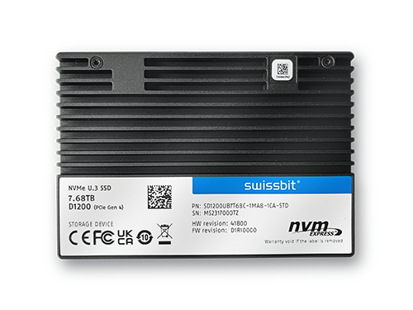
Image source: Swissbit
New PCIe Gen4 Data Center SSD: the D1200 from Swissbit

About Swissbit
Swissbit AG is the leading European manufacturer of storage, security and embedded IoT solutions for demanding applications. Swissbit combines its unique competences in storage and embedded IoT technology with its advanced packaging know-how. This expertise allows our customers to reliably store and protect data in industrial, NetCom, automotive, medical, and fiscal applications as well as across the Internet of Things (IoT).
Swissbit develops and manufactures industrial-grade storage and security products “Made in Germany” with high reliability, long-term availability, and custom optimization.
Swissbit’s storage range includes SSDs with PCIe and SATA interface such as mSATA, Slim SATA, CFast™, M.2 and 2.5” as well as CompactFlash, USB flash drives, SD Memory Cards, micro-SD Memory Cards and managed NAND BGAs like e.MMC. Security products are available in various application specific editions as USB flash drives, SD Memory Cards, and micro-SD Memory Cards.
Swissbit was founded in 2001 and has offices in Switzerland, Germany, USA, Japan and Taiwan. Swissbit owns the registered trademarks Swissbit® and Hyperstone®. Since 2020, the independent investment firm Ardian is holding a majority stake in the company to support its growth.
For further information, please visit www.swissbit.com

Regional Headquarters:
Swissbit Germany AG
Bitterfelder Strasse 22
12681 Berlin
Germany
Tel: +49 30 936 954 0
Email: info@swissbit.com
www.swissbit.com
Headquarters:
Swissbit AG
Industriestrasse 4
9552 Bronschhofen
Switzerland
Tel: +41 71 913 03 03
Email: info@swissbit.com
www.swissbit.com
Contact:  Swissbit AG  Marian Weber  Industriestrasse 4  9552 Bronschhofen  Switzerland  Tel: +49 172 854 88 26  Email: marian.weber@swissbit.com  www.swissbit.com | Press Agency:  HighTech communications GmbH  Brigitte Basilio  Brunhamstrasse 21  81249 Munich  Germany  Tel: +49 89 500778-20  Fax: +49 89 500778-77  Email: b.basilio@htcm.de  www.htcm.de

