Fifteen years of professional friendship – OPEN MIND Technologies and DAISHIN SEIKI CORPORATION
The hyperMILL User That Provided OPEN MIND’s Key Visual
Wessling (Germany), August 9, 2023 – DAISHIN SEIKI CORPORATION and OPEN MIND Technologies have enjoyed a fruitful relationship for 15 years, working together to solve machining challenges. A motorcycle helmet programmed and milled by DAISHIN acts as OPEN MIND’s central image motif in its marketing materials (key visual). The helmet was a demonstration of the Japanese contract manufacturer’s expertise in using the 5-axis technologies that the hyperMILL CAD/CAM suite can offer. This year, the motorcycle helmet – which has now become a YouTube celebrity in its own right (https://youtu.be/RnIvhlKT7SY)with more than 5.2 million views – is being redesigned. The helmet will continue to be the reference component people associate with hyperMILL.
“CEO of DAISHIN SEIKI CORPORATION Ryosuke Omachi’s ingenious idea to mill a motorcycle helmet from a solid to demonstrate his company’s 5-axis machining expertise has been attracting tech-savvy visitors to our booths for years. They even have their picture taken with the YouTube star,” reveals Volker Nesenhöner, CEO of OPEN MIND Technologies AG. “We are delighted to be able to use this and other demonstration parts from DAISHIN, and our marketing team has now given this famous eye-catcher a modern redesign to mark our 15-year collaboration. DAISHIN is a true power user and our development department is greatly appreciative of the valuable feedback this customer provides.”
Manufacturer for the motorsport industry
DAISHIN is a leading supplier of prototypes for the motorsport industry, among others. The company has also sworn by the CAD/CAM solution and its world-leading 5-axis technology ever since it acquired a customer business that used hyperMILL for programming back in 2008. Motorsports enthusiast Ryosuke Omachi came up with the enduro helmet idea while looking for an almost spherical object to push his new 5-axis milling center from DMG MORI to the limit. The popular YouTube video shows how a 3.6 kg helmet was milled from a 120 kg aluminum block (A7N01-T6).
Always keeping up with the times
OPEN MIND is staying true to the showcase for 5-axis machining and has modernized how the helmet is depicted. The key visual now shows CAD mesh, CAM toolpaths, and the finished component in one image composition.
“Generating the NC code with hyperMILL was a key factor in creating this unique reference component. hyperMILL is easy to use and has great depth with excellent collision avoidance thanks to its powerful strategies. A machining video getting more than five million views is sensational and a testament to the technical achievement that comes from the collaboration between DAISHIN and OPEN MIND,” says Omachi. “The milled helmet still endures as a shining example, and I’m happy that this symbol is now getting a fresh, modern redesign. The world of manufacturing is changing faster and faster, but the relationship between DAISHIN and OPEN MIND, which today can be described as familial, remains unchanged and will continue into the future.”
You can find more spectacular processing patterns programmed with hyperMILL, including a crown, an electric guitar, and a Japanese Nō theater mask, on DAISHIN’s YouTube channel.

Available images
The following images can be downloaded in a printable format at:
https://kk.htcm.de/press-releases/open-mind/
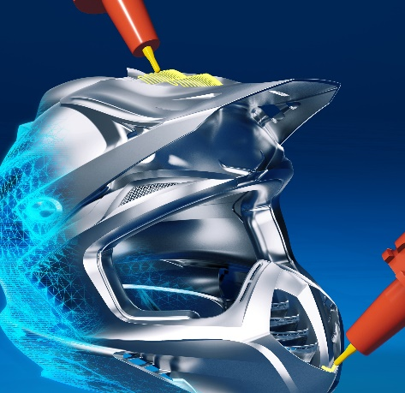  Source: OPEN MIND  The helmet in its fresh, new design | 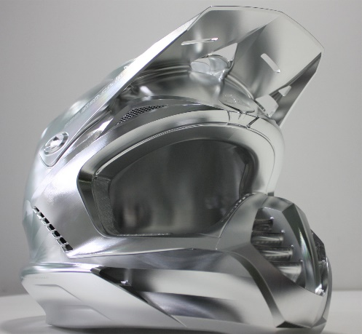  Source: OPEN MIND  The helmet programmed and milled from solid by DAISHIN almost always catches the eye when OPEN MIND appears at trade fairs

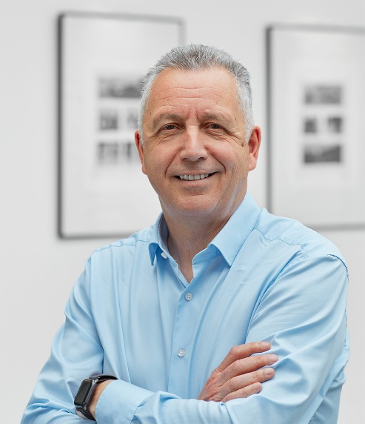  Source: OPEN MIND  Volker Nesenhöner, CEO of  OPEN MIND Technologies AG | 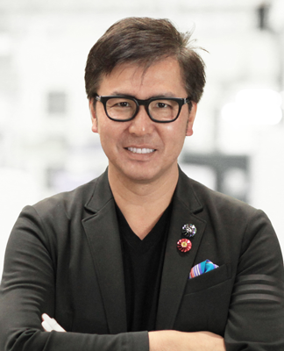  Source: DAISHIN  Ryosuke Omachi, CEO of DAISHIN SEIKI CORPORATION

Available videos
You can find the following videos on our YouTube channel:
https://youtu.be/RnIvhlKT7SY
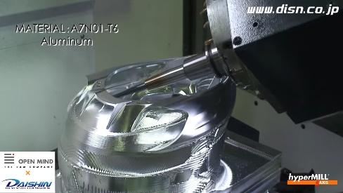
Source: OPEN MIND

More than 5.2 million views for a machining video – the DAISHIN helmet is admired by machining experts around the world.

About DAISHIN
The origin of DAISHIN-Seiki (DAISHIN) dates back to 1960.
The founder, Minoru Omachi, established Omachi Seisakusho, a lathe machining company that mass-produced shutter parts. From there, DAISHIN has been a metalworking company for three generations.
The current chairman, Yukio Omachi, converted the company from a mass production company to a prototype development and small lot parts machining company.
In 2005, a new factory was opened, and at the same time, the current president Ryosuke Omachi, took over the company.
With the installation of 5-axis milling machine and hyperMILL in 2008, DAISHIN began pushing the limits of milling in order to expand the possibilities of milling and improving its own technology.
Since then, DAISHIN has challenged and achieved in various themes such as the limit of complex machining, the limit of lightweight machining, the limit of precision geometric tolerance, and the limit of Integral structure parts machining using 5-axis milling technology.
As a result, many first and special grade technicians, and prefectural master craftsmen are currently engaged in high-precision, high-value-added machining intended for industries of MotoGP & F1, aerospace, defense related equipment, Marine equipment and semiconductor.
Since 2009, DAISHIN has been also posting videos on YouTube and SNS to spread the attraction of milling to the world, garnering attention from many DAISHIN fans and accelerating recruiting campaign as well.
In 2010, DAISHIN established the design division DDS, which is developing and designing cabinets, tool wagons and custom-made products for engineers going for higher.

For more information : www.disn.co.jp
DAISHIN SEIKI CORPORATION
4-8-45, Hizaori-cho, Asaka-shi, Saitama, JAPAN 3510014
TEL : +81-48-462-0832
Email : info@disn.co.jp

About OPEN MIND Technologies AG
OPEN MIND Technologies AG is one of the world’s leading developers of powerful CAD/CAM solutions for machine and controller-independent programming.
OPEN MIND develops optimized CAD/CAM solutions that include a large number of innovative and unique features that can deliver significantly higher performance in both programming and machining. hyperMILL® is a completely modular CAD/CAM solution that provides state-of-the-art CAM technologies on its own CAD platform: from 2.5D, 3D and 5-axis machining as well as turning strategies and solutions for additive manufacturing, HSC and HPC machining. Whether automation, simulation or virtual machine – trendsetting technologies expand the product range and enable continuous digital process chains. Special applications, the perfect interaction with all popular CAD solutions and a customer-oriented service complete the product range.
According to the "NC Market Analysis Report 2023" compiled by CIMdata, hyperMILL® is ranked in the top 4 CAD/CAM solutions worldwide. The innovative CAD/CAM technologies fulfil the highest demands in the automotive, tool and mold manufacturing, production machining, medical, job shops, energy, semiconductor and aerospace industries.
OPEN MIND's majority stake in manufacturing execution system (MES) developer Hummingbird expands the CAD/CAM manufacturer's product portfolio and enhances the range of connected digitalized manufacturing technologies.
OPEN MIND is a Mensch und Maschine company and has subsidiaries and qualified sales partners on all continents.
You can find more information at www.openmind-tech.com.

OPEN MIND Technologies UK Ltd., Oxford
Unit 3
Bicester Business Park
Telford Road
Bicester
Oxfordshire OX26 4LN
England
Phone: +44 1869 290 003
Fax: +44 1869 369 429
E-mail: Info.UK@openmind-tech.com

OPEN MIND Technologies USA, Inc.
1492 Highland Avenue, Unit 3
Needham MA 02492
USA
Phone: +1 339 225 4557 office
Phone: +1 888 516 1232 x0 toll-free
Fax: +1 270 912 5822
E-mail: Info.Americas@openmind-tech.com

Head office:
OPEN MIND Technologies AG, Argelsrieder Feld 5, 82234 Wessling, Germany
Tel.: (+49-8153) 933-500, Fax: (+49-8153) 933-501
E-mail: Info@openmind-tech.com, website: www.openmind-tech.com

