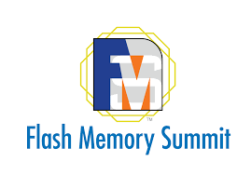
PRESS RELEASE
Swissbit to highlight Data Center SSD solutions at Flash Memory Summit 2023
Booth #515
Westford, MA USA. July 18, 2023 – Swissbit will be returning to the Flash Memory Summit (FMS) in Santa Clara, California from August 08 to 10, 2023. Swissbit will be introducing its latest Data Center SSD for cloud applications to the North American market. As a US-show exclusive, FMS-visitors will also be treated to a special sneak preview of unique solutions for the Enterprise market. With its broad range of optimized flash memory and security solutions designed for high reliability, long-term availability, custom optimization, and low total-cost-of-ownership, Swissbit will once again join the Flash Memory Summit as a Platinum Sponsor. Visitors to booth #515 will experience the company’s newest innovations up-close, including its latest breakthroughs in the realm of Data Center storage.
The new D1200 PCIe/NVMe SSD represents a significant leap forward in high-performance flash storage solutions. The DC-SSD offers high reliability, ultimate performance, and low power consumption for I/O-intensive data center applications such as databases, data storage, cloud computing, and artificial intelligence. With an extended feature set that increases sequential and random write performance, peak efficiency of data center operations is ensured.
Exclusive Preview: NVMe SSD Enterprise Solution
First details of Swissbit’s latest NVMe SSD for demanding enterprise applications will be unveiled. Setting new standards in Quality of Service (QoS), the upcoming N5200 is optimized to serve the increasing demand of enterprise and edge data centers. By delivering a high IOPS/watt performance with less power consumption and twice the speed as other Gen4 SSDs, it is the ideal choice for high-performance and mission-critical applications where reliability, durability, and scalability are essential.
"The North American market is increasingly demanding sophisticated solutions for reliably storing and protecting data for netcom, industrial, security and IoT applications," said Grady Lambert, General Manager Swissbit NA Inc. "The Flash Memory Summit offers the perfect platform to showcase our trusted and proven memory and security solutions. Together with my team, I’m even more excited to be able to exclusively preview our exciting new Enterprise solutions to visitors of the show."

Available images
The following images are available for download in printable format at: https://kk.htcm.de/press-releases/swissbit/
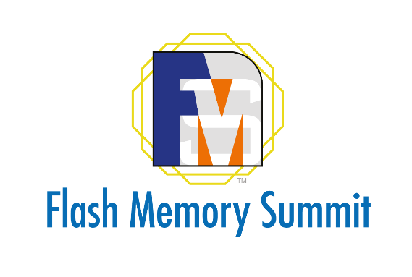  Image source: Swissbit  Swissbit returns to the Flash Memory Summit (FMS) in Santa Clara, California. | 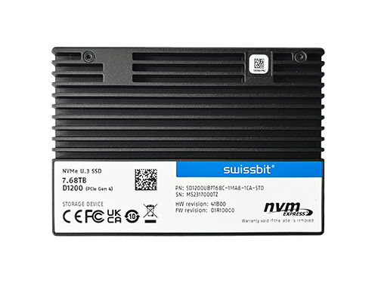  Image source: Swissbit  Premiere at the FMS: New Data Center SSD D1200 from Swissbit.

About Swissbit
Swissbit AG is the leading European manufacturer of storage, security and embedded IoT solutions for demanding applications. Swissbit combines its unique competences in storage and embedded IoT technology with its advanced packaging know-how. This expertise allows our customers to reliably store and protect data in industrial, NetCom, automotive, medical, and fiscal applications as well as across the Internet of Things (IoT).
Swissbit develops and manufactures industrial-grade storage and security products “Made in Germany” with high reliability, long-term availability, and custom optimization.
Swissbit’s storage range includes SSDs with PCIe and SATA interface such as mSATA, Slim SATA, CFast™, M.2 and 2.5” as well as CompactFlash, USB flash drives, SD Memory Cards, micro-SD Memory Cards and managed NAND BGAs like e.MMC. Security products are available in various application specific editions as USB flash drives, SD Memory Cards, and micro-SD Memory Cards.
Swissbit was founded in 2001 and has offices in Switzerland, Germany, USA, Japan and Taiwan. Swissbit owns the registered trademarks Swissbit® and Hyperstone®. Since 2020, the independent investment firm Ardian is holding a majority stake in the company to support its growth.
For further information, please visit www.swissbit.com
Contact Headquarters:  Swissbit AG  Marian Weber  Industriestrasse 4  9552 Bronschhofen  Switzerland  Tel: +49 172 854 88 26  Email: marian.weber@swissbit.com  www.swissbit.com | Press Agency:  miXim Ltd.  Kim Sauer (Mr)  Tel: +44 7906 019 022  Email: kim@miXimPR.com

