PRESS RELEASE
OPEN MIND Achieves Success with Suppliers to the Semiconductor Industry
hyperMILL® in Plant Engineering for Chip Producers
Wessling (Germany), July 13, 2023 – OPEN MIND is experiencing strong demand for its hyperMILL® CAD/CAM suite from suppliers to the semiconductor industry. The industry is known for its very high quality requirements with high-mix, low volume production. Users therefore rely on innovative high-end solutions for reliable generation and simulation of NC programs. Plant designers, special machinery builders, and their specialized manufacturers stress to OPEN MIND that high-precision surfaces, programming automations, and reliable postprocessor technology are the key decisive factors for choosing hyperMILL®.
Internationally active companies in the semiconductor industry have been relying on the CAD/CAM technologies of hyperMILL® for some time now. Examples of this positive and trusting cooperation can be found on the OPEN MIND website: BKB Precision, AAE, NDK Paragon, and RE Thompson are just a small selection of the software developer’s customers that are suppliers to the semiconductor industry.
The machines and devices used in modern chip manufacturing can be divided into three main categories: wafer production, assembly equipment, and testing equipment. The variety of parts is enormous and ranges from prototype construction to small series and series production. Components such as vacuum chambers, wafer handling components, or distributors made of special plastic place the most varied demands on the CAM system in terms of material and geometry diversity. Being able to act with maximum flexibility, but at the same time reliably in production, is enormously important for many manufacturers in the industry.
Perfect Surfaces
Similar to the medical technology and aerospace industry, cleanliness, accuracy, and perfect surfaces in high gloss quality are the most obvious requirements in the semiconductor industry. The components are often complex, for example, prismatic and with many holes and pockets. Here, feature and macro technology make programming easier, and OPEN MIND’s leading role in 5-axis machining also plays a part. “hyperMILL® allows us to generate 5-axis NC programs quickly and easily. We like the fact that the software offers different tilt strategies for 3+2 and 5-axis simultaneous machining – and also a range of options with the 5-axis rework machining strategy. In addition, hyperMILL® enables set-ups for milling and turning on multitasking machines,” says Hein Raaijmakers, CAM programmer at AAE B.V.
Berrie van de Burgt, Sales Director at BKB Precision and a specialist in machining high-performance plastics, explains: “Offline programming and simulation are critical for our “right-first-time” principle, especially when we’re machining expensive materials such as PEEK. The milling strategies are also very easy to adapt to the different materials. This helps us reduce errors and scrap.”
Simulation with Virtual Machine
The capabilities of hyperMILL® and the virtual machine in the area of simulation with digital twins and the related postprocessor technology are particularly appreciated in the industry. NC codes must be generated quickly and reliably, especially in the high-mix, low-volume production environment. This reliability of the NC code is a decisive criterion when choosing the right CAM system. Berrie van de Burgt explains: “hyperMILL® is so well integrated into our production process that we don’t even think about the benefits anymore. The fact that we produce 24/7 with only one day shift always impresses our customers. We have so much confidence in hyperMILL® that we integrate new production series directly into our 24/7 production cycle, whereas other manufacturers tend to limit initial production to manned shifts.”

Available images
The following images are available for download in printable format at:
https://kk.htcm.de/press-releases/open-mind/

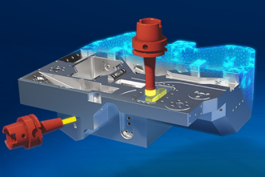
Source: OPEN MIND

hyperMILL® for suppliers to the semiconductor industry – versatile, reliable, and safe.

Available video footage
The following video footage is available on our YouTube channel:
https://youtu.be/10fHYi46dPg
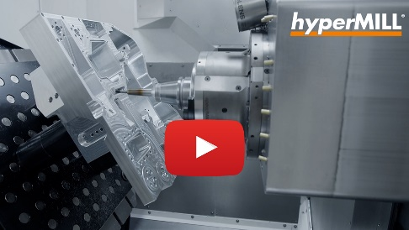
Source: OPEN MIND

Machining a housing demo part for semiconductor manufacturing equipment

About OPEN MIND Technologies AG
OPEN MIND is one of the world’s most sought-after developers of powerful CAM solutions for machine and controller-independent programming.
OPEN MIND develops optimized CAM solutions that include a high number of innovative features not available elsewhere to deliver significantly higher performance in both programming and machining. Strategies such as 2.5D, 3D as well as 5-axis milling/mill turning, and machining operations like HSC and HPC are efficiently built into the hyperMILL® CAM system. hyperMILL® provides the maximum possible benefits to customers thanks to its full compatibility with all current CAD solutions and extensive programming automation.
OPEN MIND strives to be the best and most innovative CAD/CAM manufacturer in the world, helping it become one of the top five in the CAM industry according to the “NC Market Analysis Report 2022” compiled by CIMdata. The CAD/CAM solutions of OPEN MIND fulfil the highest demands in the automotive, tool and mold manufacturing, production machining, medical, job shops, energy and aerospace industries. OPEN MIND is represented in all key markets in Asia, Europe and America, and is a Mensch und Maschine company.

You can find more information at www.openmind-tech.com.

OPEN MIND Technologies UK Ltd., Oxford
Unit 3
Bicester Business Park
Telford Road
Bicester
Oxfordshire OX26 4LN
England
Phone: +44 1869 290 003
Fax: +44 1869 369 429
E-mail: Info.UK@openmind-tech.com

OPEN MIND Technologies USA, Inc.
1492 Highland Avenue, Unit 3
Needham MA 02492
USA
Phone: +1 339 225 4557 office
Phone: +1 888 516 1232 x0 toll-free
Fax: +1 270 912 5822
E-mail: Info.Americas@openmind-tech.com

Head office:
OPEN MIND Technologies AG, Argelsrieder Feld 5, 82234 Wessling, Germany
Tel.: (+49-8153) 933-500, Fax: (+49-8153) 933-501
E-mail: Info@openmind-tech.com, website: www.openmind-tech.com

Press contact:
HighTech communications GmbH
Brigitte Basilio
Brunhamstrasse 21
81249 Munich
Germany
Tel.: (+49-89) 500778-20
E-mail: b.basilio@htcm.de
Website: www.htcm.de

