PRESS RELEASE

WR-NTYPE – another coax product group from Würth Elektronik
High-quality Antenna Connectors for Harsh Conditions
Waldenburg (Germany), July 5, 2023 – Würth Elektronik has expanded its range of coaxial cables and connectors to include comprehensive portfolio of N-type cable connectors to satisfy MIL-STD-348 requirements with 50 Ω impedance. Jacks for connecting to the application PCB are available in straight and angled THT versions, or as 4-hole flanged panel connectors with round post or solder cup. Besides pre-assembled cables, individual cable connections are also available for field assembly.
The Würth Elektronik coax connectors are suitable for use outdoors or in harsh environments like those in radio base stations, signal distributors, GPS systems or ship antennas – just the application for which the N-type was thought to have been originally developed. Both the screw connections of the THT jacks as well as those for mounting packages are therefore available in protection class IP67. The gold-plated THT contacts have enhanced corrosion resistance compared to the standard tin-plated connectors, and the gold-plated phosphor-bronze center contact material even reduce component costs compared to the beryllium-copper otherwise used.
High-quality high frequency cables
Würth Elektronik offers various assembled cables including double-shielded Low Loss 195 and Low Loss 200, which are compatible with LMR195/200 or CFD195/200. The RG316 cable with FEP sheathing, for instance, is resistant to oil, chemicals and weathering and can be used at operating temperatures from -55 to +165°C. The various N-Type cable connectors are designed for quick installation of cable assemblies in small quantities and for assembly in the field. The secure screw connection is achieved without tools using a knurled union nut. Both the IP67 and RG178 bulkhead jack are also suitable for microcoaxial cables (1.3, 1.32 and 1.37). The new coaxial products also include N-type to SMA adapters, as required for connection expansion and for adapting RF interfaces or for test equipment.
The new coax connectors, like all products in the Würth Elektronik Electromechanics catalog 2023, are available from stock. Free samples can be requested.

Available images
The following images can be downloaded from the Internet in printable quality: https://kk.htcm.de/press-releases/wuerth/
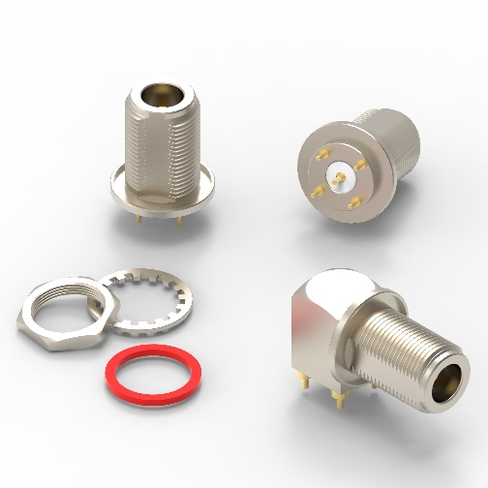  Image source: Würth Elektronik  WR-NTYPE N-type PCB connectors | 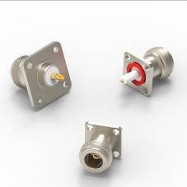Image source: Würth Elektronik  WR-NTYPE N-type panel connectors
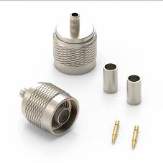  Image source: Würth Elektronik  WR-NTYPE N-type cable connectors | 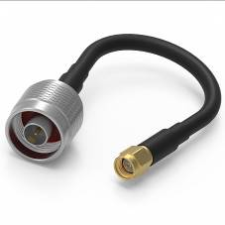  Image source: Würth Elektronik  WR-CXASY N-type-to-SMA adapter

About the Würth Elektronik eiSos Group
Würth Elektronik eiSos Group is a manufacturer of electronic and electromechanical components for the electronics industry and a technology company that spearheads pioneering electronic solutions. Würth Elektronik eiSos is one of the largest European manufacturers of passive components and is active in 50 countries. Production sites in Europe, Asia and North America supply a growing number of customers worldwide.
The product range includes EMC components, inductors, transformers, RF components, varistors, capacitors, resistors, quartz crystals, oscillators, power modules, Wireless Power Transfer, LEDs, sensors, connectors, power supply elements, switches, push-buttons, connection technology, fuse holders and solutions for wireless data transmission.
The unrivaled service orientation of the company is characterized by the availability of all catalog components from stock without minimum order quantity, free samples and extensive support through technical sales staff and selection tools.
Würth Elektronik is part of the Würth Group, the global market leader in the development, production, and sale of fastening and assembly materials, and employs 8,200 people. In 2022, the Würth Elektronik Group generated sales of 1.33 Billion Euro.
Würth Elektronik: more than you expect!
Further information at www.we-online.com

Further information:  Würth Elektronik eiSos GmbH & Co. KG  Sarah Hurst  Max-Eyth-Strasse 1  74638 Waldenburg  Germany  Phone: +49 7942 945-5186  E-mail: sarah.hurst@we-online.de  www.we-online.com | Press contact:  HighTech communications GmbH  Brigitte Basilio  Brunhamstrasse 21  81249 Munich  Germany  Phone: +49 89 500778-20  E-mail: b.basilio@htcm.de  www.htcm.de

