PRESS RELEASE
OPEN MIND repositions hyperMILL®
Modern Manufacturing: Digitalization Starts with CAM

Wessling (Germany), July 3, 2023 – The CAM system is set to play an increasingly centralized role in digitalization strategies at manufacturing companies in the future. This is the point that OPEN MIND Technologies AG is emphasizing at the moment. Connecting the systems used throughout the production process is a core requirement for CAM systems to take on this role. The company behind the hyperMILL® CAD/CAM suite further underscored this point through its acquisition of MES specialist Hummingbird Systems GmbH in early 2022. Integration of CAM and MES is just one example of the communication capacities that will be required by CAM systems in the future.
“Everyone is talking about digitalization, Industry 4.0, and the Internet of Things. Small to medium-sized enterprises with machining operations want to know how they can keep up,” says Michael Förster, Senior Product Marketing Manager at OPEN MIND Technologies AG. “With NC code generated from CAD data, each of these companies has a digital process already in place. This can serve as a starting point, with connectivity having a key role to play.”
Based on OPEN MIND’s experience, the comprehensive digitalization strategies of large companies are in many cases too broad for SMEs. A more suitable approach would be to seek out digitalization solutions in steps, starting with the CAD/CAM system. There are different strategies available based on the company’s IT landscape: linking the process in and around CAD, CAM, and NC data to a product lifecycle management (PLM) system or manufacturing execution system (MES). This enables the integration of a tool management system, making CAD data accessible company-wide, and using bidirectional communication with the machine controls.
Advanced processes
According to OPEN MIND, the flow of data from design to production can help optimize the process through better networking. Simulations based on real NC codes and advanced optimization processes are made possible based on bidirectional communication between the CAM system and machine controller.
Accompanying e-paper on the topic
In an e-paper, OPEN MIND provides answers to the question of “what role the CAD/CAM system will play in an increasingly connected world.” The e-paper is available for download on the CAD/CAM manufacturer’s website.
https://www.openmind-tech.com/en/cam/connected-manufacturing/

Available images
The following images are available for download in printable format at:
https://kk.htcm.de/press-releases/open-mind/
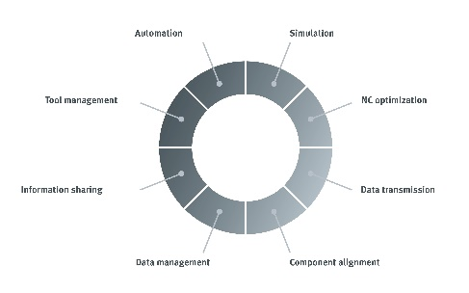
Source: OPEN MIND

Digital production environment: networking with hyperMILL® delivers benefits in many areas

About OPEN MIND Technologies AG
OPEN MIND is one of the world’s most sought-after developers of powerful CAM solutions for machine and controller-independent programming.
OPEN MIND develops optimized CAM solutions that include a high number of innovative features not available elsewhere to deliver significantly higher performance in both programming and machining. Strategies such as 2.5D, 3D as well as 5-axis milling/mill turning, and machining operations like HSC and HPC are efficiently built into the hyperMILL® CAM system. hyperMILL® provides the maximum possible benefits to customers thanks to its full compatibility with all current CAD solutions and extensive programming automation.
OPEN MIND strives to be the best and most innovative CAD/CAM manufacturer in the world, helping it become one of the top five in the CAM industry according to the “NC Market Analysis Report 2022” compiled by CIMdata. The CAD/CAM solutions of OPEN MIND fulfil the highest demands in the automotive, tool and mold manufacturing, production machining, medical, job shops, energy and aerospace industries. OPEN MIND is represented in all key markets in Asia, Europe and America, and is a Mensch und Maschine company.

You can find more information at www.openmind-tech.com.

OPEN MIND Technologies UK Ltd., Oxford
Unit 3
Bicester Business Park
Telford Road
Bicester
Oxfordshire OX26 4LN
England
Phone: +44 1869 290 003
Fax: +44 1869 369 429
E-mail: Info.UK@openmind-tech.com

OPEN MIND Technologies USA, Inc.
1492 Highland Avenue, Unit 3
Needham MA 02492
USA
Phone: +1 339 225 4557 office
Phone: +1 888 516 1232 x0 toll-free
Fax: +1 270 912 5822
E-mail: Info.Americas@openmind-tech.com

Head office:
OPEN MIND Technologies AG, Argelsrieder Feld 5, 82234 Wessling, Germany
Tel.: (+49-8153) 933-500, Fax: (+49-8153) 933-501
E-mail: Info@openmind-tech.com, website: www.openmind-tech.com

Press contact:
HighTech communications GmbH
Brigitte Basilio
Brunhamstrasse 21
81249 Munich
Germany
Tel.: (+49-89) 500778-20
Fax: (+49-89) 500778-78
E-mail: b.basilio@htcm.de
Website: www.htcm.de

