PRESS RELEASE
Cost-efficient, small-capacity memory for IIoT and smart city applications

Swissbit introduces e.MMCs and SD memory cards with capacities starting from 4 GB

Bronschhofen, Switzerland. June 27, 2023 – The industry is vying for ever-increasing gigabyte capacities. And yet there are countless applications that only require a fraction of this storage space. Typical applications include green IIoT technologies like charging stations, smart meters, and PV inverters, for which only a small amount of memory is required to run boot software or to communicate with cloud applications. In response to these demands, Swissbit is expanding its range of memory solutions with the introduction of e.MMC and SD memory cards with small capacities ranging from 4 to 8 GB. They are based on 3D-TLC-NAND and optimized for power failure protection, industrial reliability, and high endurance. Consequently, they rival the performance of more expensive SLC models and outperform corresponding MLC variants.
The proliferation of IIoT technologies is particularly evident in smart cities. Key factors here include smart meters, controllers for intelligent building management, or generating and using sustainable energy through charging stations.
For the most efficient operation of these green IoT applications, Swissbit now offers targeted small-capacity storage media. With capacities ranging from 4 to 8 GB, these are ideally suited as boot media or for data logging of small amounts of data, without sacrificing performance or durability. The models of the EM-30 and S-56(u) series, which are available as an embedded component in the form of an e.MMC or as flexible, interchangeable SD memory cards, offer maximum reliability due to proven firmware architecture. They also guarantee 100% data security.
Swissbit EM-30 and S-56(u) Series
The EM-30 product series (153 ball BGA) complies with e.MMC-5.1 specifications and is fully backward compatible. It is designed for an extended temperature range of -40°C to 85°C and is suitable for use in harsh environmental conditions. Based on durable industrial-grade 3D-TLC-NAND and with storage capacities ranging from 4GB to 8GB, the range offers sequential data rates of up to 280MB/s read and 120MB/s write, as well as 11k IOPS random read and 16k IOPS random write.
The S-56(u) SD and microSD memory cards attain sequential read and write data rates of 95 MB/s and 74 MB/s, respectively. The cards are optimized for high-performance applications with random read IOPS of 2,200 and random write IOPS of 1,300. With advanced over-provisioning and pSLC technology, the S-56 series offers the highest endurance for write-intensive workloads. Combined with up to 100,000 PE cycles, its endurance for small data logging even surpasses that of an SLC card for the first time.
Other typical applications for small-capacity flash memory include white goods, payment devices and point-of-sale systems, industrial control systems, and medical diagnostic and patient monitoring devices.

Available images
The following images are available for download in printable format at: https://kk.htcm.de/press-releases/swissbit/
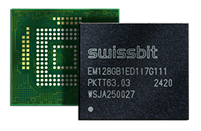  Image source: Swissbit  Embedded solution: The e.MMC EM-30 range from Swissbit is now available with storage capacities ranging from 4 to 8 GB. | 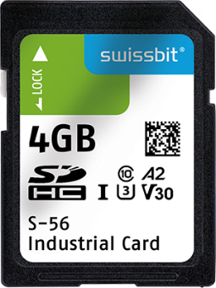  Image source: Swissbit  Up to 100,000 PE-cycles are reached: The SD-card S-56 uses pSLC technology and expanded over-provisioning.
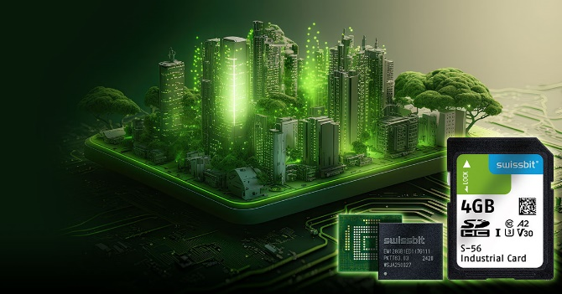
Cost-effective, small-capacity storage solutions for IIoT and smart city applications
Image source: Swissbit

About Swissbit
Swissbit AG is the leading European manufacturer of storage, security and embedded IoT solutions for demanding applications. Swissbit combines its unique competences in storage and embedded IoT technology with its advanced packaging know-how. This expertise allows our customers to reliably store and protect data in industrial, NetCom, automotive, medical, and fiscal applications as well as across the Internet of Things (IoT).
Swissbit develops and manufactures industrial-grade storage and security products “Made in Germany” with high reliability, long-term availability, and custom optimization.
Swissbit’s storage range includes SSDs with PCIe and SATA interface such as mSATA, Slim SATA, CFast™, M.2 and 2.5” as well as CompactFlash, USB flash drives, SD Memory Cards, micro-SD Memory Cards and managed NAND BGAs like e.MMC. Security products are available in various application specific editions as USB flash drives, SD Memory Cards, and micro-SD Memory Cards.
Swissbit was founded in 2001 and has offices in Switzerland, Germany, USA, Japan and Taiwan. Swissbit owns the registered trademarks Swissbit® and Hyperstone®. Since 2020, the independent investment firm Ardian is holding a majority stake in the company to support its growth.
For further information, please visit www.swissbit.com
Regional Headquarters:
Swissbit Germany AG
Bitterfelder Strasse 22
12681 Berlin
Germany
Tel: +49 30 936 954 0
Email: info@swissbit.com
www.swissbit.com
Headquarters:
Swissbit AG
Industriestrasse 4
9552 Bronschhofen
Switzerland
Tel: +41 71 913 03 03
Email: info@swissbit.com
www.swissbit.com
Contact:  Swissbit AG  Marian Weber  Industriestrasse 4  9552 Bronschhofen  Switzerland  Tel: +49 172 854 88 26  Email: marian.weber@swissbit.com  www.swissbit.com | Press Agency:  HighTech communications GmbH  Brigitte Basilio  Brunhamstrasse 21  81249 Munich  Germany  Tel: +49 89 500778-20  Fax: +49 89 500778-77  Email: b.basilio@htcm.de  www.htcm.de

