PRESS RELEASE

Würth Elektronik presents its WE-HEPC SMT Power Inductor series
Highest saturation current in a tiny space
Waldenburg (Germany), June 26, 2023 – Würth Elektronik presents WE-HEPC, its smallest NiZn-ferrite based self-shielded power inductor to date. Thanks to a new and completely automated manufacturing process, these inductors provide consistent very high quality and a higher saturation current than any previous own or known competitive product. In all, there are 15 models available with different attributes (L: 3.3 ~ 100 μH; I_{SAT}: 1.3 ~ 3.3 A) and in package sizes 5030 (4.8 x 4.8 x 1.8 mm) and 6030 (5.9 x 5.9 x 2.85 mm).
WE-HEPC is suitable for DC/DC converters, filter applications, embedded computers, and other compact design applications. Due to its AEC Q-200 Grade 1 rating, it can also be used for some automobile applications. The operating temperature range spans -40°C to +125°C. The land pattern is compatible with older WE-SPC and WE-TPC inductors, giving customers a maximum amount of design flexibility.
Like all products in the Electronic Components 2022/2023, WE-HEPC is immediately available from stock in any quantities. Developers are welcome to request free samples.

Available images
The following images can be downloaded from the Internet in printable quality: https://kk.htcm.de/press-releases/wuerth/

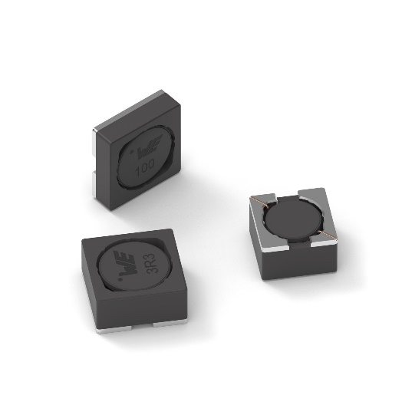
Image source: Würth Elektronik
Würth Elektronik’s SMT Power Inductor WE-HEPC features high saturation current values.

About the Würth Elektronik eiSos Group
Würth Elektronik eiSos Group is a manufacturer of electronic and electromechanical components for the electronics industry and a technology company that spearheads pioneering electronic solutions. Würth Elektronik eiSos is one of the largest European manufacturers of passive components and is active in 50 countries. Production sites in Europe, Asia and North America supply a growing number of customers worldwide.
The product range includes EMC components, inductors, transformers, RF components, varistors, capacitors, resistors, quartz crystals, oscillators, power modules, Wireless Power Transfer, LEDs, sensors, connectors, power supply elements, switches, push-buttons, connection technology, fuse holders and solutions for wireless data transmission.
The unrivaled service orientation of the company is characterized by the availability of all catalog components from stock without minimum order quantity, free samples and extensive support through technical sales staff and selection tools.
Würth Elektronik is part of the Würth Group, the global market leader in the development, production, and sale of fastening and assembly materials, and employs 8,200 people. In 2022, the Würth Elektronik Group generated sales of 1.33 Billion Euro.
Würth Elektronik: more than you expect!
Further information at www.we-online.com

Further information:  Würth Elektronik eiSos GmbH & Co. KG  Sarah Hurst  Max-Eyth-Strasse 1  74638 Waldenburg  Germany  Phone: +49 7942 945-5186  E-mail: sarah.hurst@we-online.de  www.we-online.com | Press contact:  HighTech communications GmbH  Brigitte Basilio  Brunhamstrasse 21  81249 Munich  Germany  Phone: +49 89 500778-20  E-mail: b.basilio@htcm.de  www.htcm.de

