PRESS RELEASE
Würth Elektronik presents IoT concept at the Greentech Festival
Control plant growth from the cloud
Waldenburg (Germany), June 20, 2023 - At the Greentech Festival in Berlin, Würth Elektronik demonstrated how wireless connectivity with an IoT-networked prototype of a digital greenhouse, can contribute to feeding a rapidly growing world population. In the innovative cultivation system, lighting, irrigation, fertilization and air conditioning can be monitored, controlled and dynamically optimized remotely and automatically for maximum crop yields and the best food quality.
The world's population is growing inexorably, while available resources are becoming ever scarcer. Here, vertical farming with LEDs in multi-story high-tech greenhouses offers promising solutions to the pressing issues of global food security. In this pioneering farming method, plants are grown under artificial light and controlled conditions, and their growth and nutrient content are optimized. By using wireless connectivity technology, the efficiency, monitoring and control of these cultivation systems can be significantly improved.
Real-time monitoring of parameters, such as temperature, air and soil moisture, light intensity, as well as CO2 content of the air, allows the environmental conditions to be precisely adapted to the needs of the plants. If abnormal values are measured or unexpected changes are detected, the digital greenhouse automatically sends notifications to the operators. This allows errors to be detected at an early stage, potential problems to be rectified quickly, and possible crop failures to be avoided. Efficient remote control and automation also enable optimal plant growth and maximize crop yields while reducing manual effort and conserving resources such as water and energy.
"Smart farming, today, means above all: smooth digital IoT networking," emphasizes Alexander Gerfer, CTO of Würth Elektronik eiSos, a manufacturer and supplier of electronic and electromechanical components. "Measurement data, for example on the PH value and salt content of the recycled irrigation water, the soil moisture or the CO2 content of the air, must be reliably transferred to the cloud so that they are available to the control system in real time. Its control commands must arrive just as reliably at the actuators. Then, irrigation pumps can be started selectively or the color temperature of the LED lighting can be adjusted so that the plant can be provided with the optimum light recipe in every growth phase."
Connected Vertical Farming with LED
In the age of digitalization, electronics has a decisive influence on sustainability. Many future-forward products contain electronic and electromechanical components, printed circuit boards, intelligent power and control systems, services and solutions from Würth Elektronik. Greentech Festival visitors were able to see what this all looks like in practice at the joint stand of Berlin Partner. There, Würth Elektronik presented the IoT-networked Connected Vertical Farm prototype, an innovative horticulture rack that impressively integrates plant-optimized LED lighting as well as real-time monitoring and remote control of sensors and actuators via wireless connectivity. "For both wireless connectivity and energy-efficient lighting in vertical farming with LED, Würth Elektronik offers components and sophisticated solutions, such as our Horticulture LED Panel, our Lighting Development Kit or the energy-saving Adrastea-I cellular module, which is used to bridge the longer distances in IoT applications," explains Oliver Opitz, Vice President Wireless Connectivity & Sensors at Würth Elektronik eiSos GmbH & Co. KG.
"Würth Elektronik makes innovations possible - quickly and easily," promises Alexander Gerfer. "Through quality, long-term availability and intensive customer support, we develop sustainable, resource and energy-saving solutions together with our customers and suppliers. In doing so, we see ourselves by no means only as a supplier, but also as a technology enabler. We support developers with free component samples and know-how transfer, and this also and especially applies to innovative startups. We also work closely with universities and colleges, promoting our own developments as well as the customers and employees of tomorrow. What opportunities there are, what we offer and what we do, is what our team talked about at the booth with many interested people."
About the Greentech Festival
The Greentech Festival is a meeting place for people, organizations and companies from all over the world to discuss and advance ways out of the climate crisis together. The festival provides a space for mutual exchange and inspiration and, under the same name, a global platform.
"This is the only way we can bring the enormous potential of green technologies to life. We need to inspire and captivate as many people as possible. We need to massively accelerate positive change," says festival founder and ex-Formula 1 driver Nico Rosberg.
This year's Greentech Festival featured more than 190 exhibitors, 150 speakers and around 15,000 visitors.

Available images
The following images can be downloaded from the Internet in printable quality: https://kk.htcm.de/press-releases/wuerth/

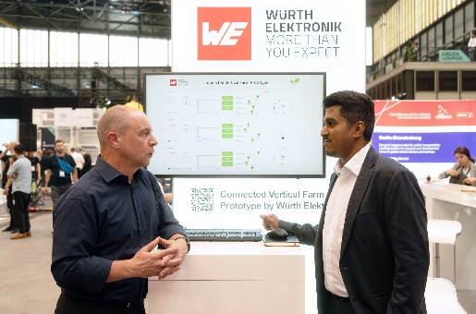Image source: Würth Elektronik  Würth Elektronik at the Greentech Festival 2023: The components manufacturer presents a pioneering vertical farming technology. | 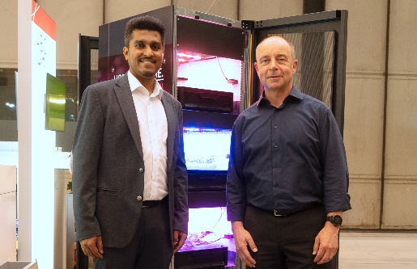  Image source: Würth Elektronik  Adithya Madanahalli, IoT Engineer at Würth Elektronik eiSos (left) and Alexander Gerfer, CTO at Würth Elektronik eiSos, in front of the IoT-networked prototype of a digital greenhouse.
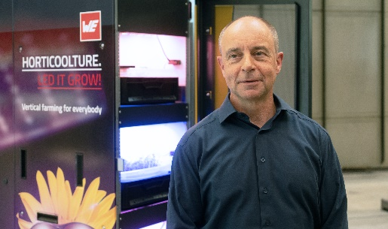Image source: Würth Elektronik
Alexander Gerfer, CTO at Würth Elektronik eiSos: "Würth Elektronik makes innovations possible - quickly and easily."

About the Würth Elektronik eiSos Group
Würth Elektronik eiSos Group is a manufacturer of electronic and electromechanical components for the electronics industry and a technology company that spearheads pioneering electronic solutions. Würth Elektronik eiSos is one of the largest European manufacturers of passive components and is active in 50 countries. Production sites in Europe, Asia and North America supply a growing number of customers worldwide.
The product range includes EMC components, inductors, transformers, RF components, varistors, capacitors, resistors, quartz crystals, oscillators, power modules, Wireless Power Transfer, LEDs, sensors, connectors, power supply elements, switches, push-buttons, connection technology, fuse holders and solutions for wireless data transmission.

The unrivaled service orientation of the company is characterized by the availability of all catalog components from stock without minimum order quantity, free samples and extensive support through technical sales staff and selection tools.
Würth Elektronik is part of the Würth Group, the global market leader in the development, production, and sale of fastening and assembly materials, and employs 8,200 people. In 2022, the Würth Elektronik Group generated sales of 1.33 Billion Euro.
Würth Elektronik: more than you expect!
Further information at www.we-online.com

Further information:  Würth Elektronik eiSos GmbH & Co. KG  Sarah Hurst  Max-Eyth-Strasse 1  74638 Waldenburg  Germany  Phone: +49 7942 945-5186  E-mail: sarah.hurst@we-online.de  www.we-online.com | Press contact:  HighTech communications GmbH  Brigitte Basilio  Brunhamstrasse 21  81249 Munich  Germany  Phone: +49 89 500778-20  E-mail: b.basilio@htcm.de  www.htcm.de

