PRESS RELEASE
ASMPT at Nepcon China 2023
Accelerate! Open Automation in the integrated smart factory
Munich, June 19, 2023 – ASMPT, the global technology and market leader in the areas of semiconductor and SMT manufacturing, will present groundbreaking solutions for the integrated smart factory at the NEPCON China trade fair, booth 1F60. With products and exhibits ranging from powerful line and factory software to ASMPT’s Open Automation concept, a fully automated production line, an SMT line designed especially for the needs of the automobile sector and advanced packaging solutions, ASMPT will present everything that’s needed to advance the transition to future-oriented intelligent electronics manufacturing.
The NEPCON China trade fair will be held from July 19 to 21 at the Shanghai World Expo Exhibition & Convention Center. Under the motto “Accelerate! OPEN AUTOMATION by ASMPT”, the company will present innovative hardware and software solutions for the integrated smart factory at the renowned trade fair for electronics manufacturing and surface mount technology.
Smart operations in intelligent SMT factories
At booth 1F60, visitors will gain insights into ASMPT’s comprehensive and steadily growing portfolio of coordinated software solutions. With its smart shop floor management suite WORKS and its Factory Automation software for connecting AMR fleets as well as its Critical Manufacturing MES solution, ASMPT is the only supplier that can link the worlds of hardware and software across the board. The company’s intelligent applications enable users to deploy staff more effectively, ensure maximum equipment availability, establish an effective and transparent material management system, and perfect their quality management in a closed-loop system.
Future-oriented and seamlessly integrated: The Open Automation line
With its Open Automation line featuring fully automated setup changeovers via autonomous mobile robots, ASMPT will demonstrate a modern, highly automated SMT line that delivers maximum production speeds and volumes. It features a new-generation DEK TQ printer with Smart Pin Support, a Process Lens HD SPI system and SIPLACE TX placement machines with a Smart Tray Unit, all of which work together without operator assists. An IPC-Hermes-9852-compatible PCB loader and conveyor ensures fully automatic product movements. By defining standardized data formats and communication protocols, this open industry standard allows equipment from multiple manufacturers to work together and exchange board data with each other. The result: continuous production with maximum quality.
Automotive line: SMT assembly that meets the most demanding standards
Another highlight that was specially designed for the automobile industry this time is the combination of a DEK TQ L printing platform and a SIPLACE SX placement machine. Both systems feature numerous automation options and unique levels of precision and flexibility for demanding SMT production requirements. The DEK TQ L, for example, processes up to 244 circuit boards per hour that can measure up to 600 × 510 millimeters. Equipped with the OSC Package, Clinching Option and CPP Gripper, the accurate and flexible SIPLACE SX placement machine impresses with demand-oriented scalability and expanded feeding and transport options. Three innovative placement heads ensure maximum precision and reliability, particularly for industry-typical requirements such as LED centering, snap-ins and THT placements. And thanks to standardized interfaces, even third-party feeders can be seamlessly integrated into the production line.
SIPLACE CA2: New dimensions in advanced packaging
With its multi-wafer system, the SIPLACE CA2 is another machine that sets new standards in terms of performance, precision, and flexibility. The innovative placement system from global market and technology leader ASMPT combines the high-speed assembly of chips taken directly off the sawed wafer with SMT placement technology, thus integrating the production of SiPs directly into the high-speed SMT line – a highly attractive option for electronics manufacturers in the smartphone and tablet segments. Its changer holds up to 25 wafers and swaps them out in only 5.6 seconds. The SIPLACE CA2’s placement accuracy of up to 10 microns @ ±3 sigma is also trendsetting.
Tailor-made automation
“We will show at our booth what system integration and automation can achieve today,” explains Eric Zhao, Head of Marketing at ASMPT SMT Solutions China. “This does not mean, however, that a fully automated line without operators would be the best solution for every customer. With its modular structure and maximum compatibility, our Open Automation concept allows our customers to decide for themselves at any time what they want to automate and to what extent. The best way for them to find out which solution works best for them is to talk directly with our experts at the fair.”

Illustrations for downloading
The following print-ready artwork is available on the internet for downloading:
https://kk.htcm.de/press-releases/asmpt/

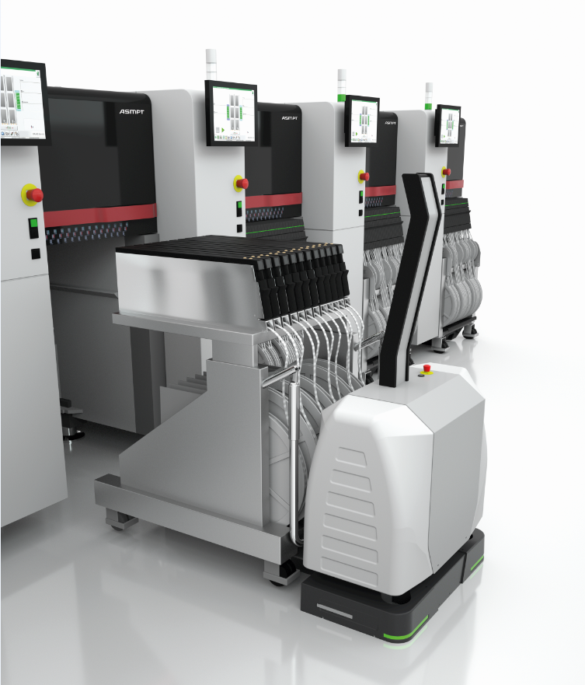 | 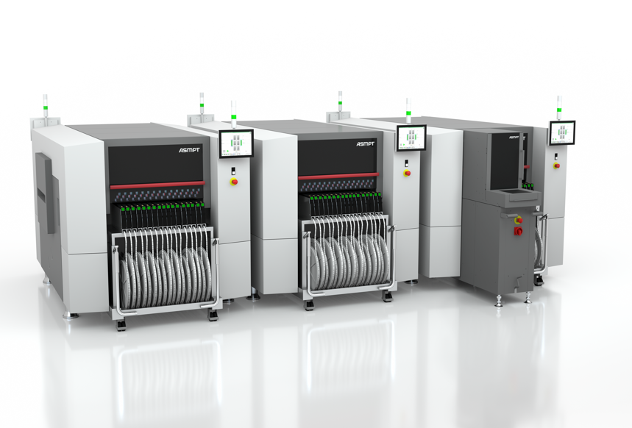
The SIPLACE TX features maximum automation options for high-speed and high-volume production environments.  Image credit: ASMPT | With the OSC Package, the flexible SIPLACE SX placement platform can even handle odd-shaped, large and  heavy components. It also features full THT capabilities for automotive and industrial applications.  Image credit: ASMPT
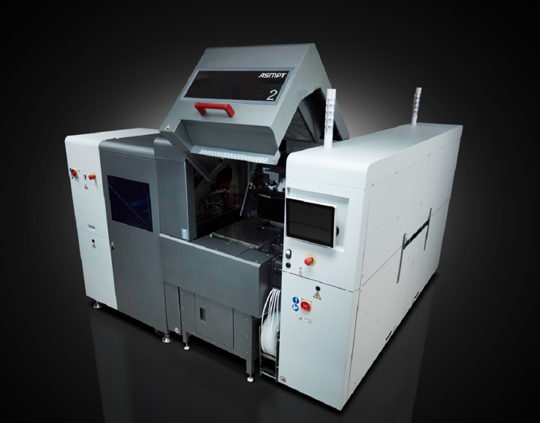

The SIPLACE CA2 can handle both taped components and dies taken directly off the wafer.

Image credit: ASMPT

About ASMPT Limited (“ASMPT”)
ASMPT Limited is a leading global supplier of hardware and software solutions for the manufacture of semiconductors and electronics. Headquartered in Singapore, ASMPT’s offerings encompass the semiconductor assembly & packaging, and SMT (surface mount technology) industries, ranging from wafer deposition to the various solutions that organize, assemble and package delicate electronic components into a vast range of end-user devices, which include electronics, mobile communications, computing, automotive, industrial and LED (displays). ASMPT partners with customers very closely, with continuous investment in R&D helping to provide cost-effective, industry-shaping solutions that achieve higher productivity, greater reliability, and enhanced quality.
ASMPT is listed on the Hong Kong Stock Exchange (HKEX stock code: 0522) and is one of the constituent stocks of the Hang Seng Composite MidCap Index under the Hang Seng Composite Size Indexes, the Hang Seng Composite Information Technology Industry Index under Hang Seng Composite Industry Indexes, and the Hang Seng HK 35 Index.
To learn more about ASMPT, visit www.asmpt.com.

The ASMPT SMT Solutions segment
The mission of the SMT Solutions segment within ASMPT is to implement and support the Integrated Smart Factory at electronics manufacturers worldwide.
ASMPT solutions support the networking, automation and optimization of central workflows with hardware, software and services that enable electronics manufacturers to transition to the Integrated Smart Factory in stages and enjoy dramatic improvements in productivity, flexibility and quality. With its integrated “Open Automation” concept, ASMPT opens the door for its customers to economically feasible automation, entirely in accordance with their individual requirements – modular, flexible, and vendor-independent.
The product range includes hardware and software such as SIPLACE placement solutions, DEK printing solutions, inspection and storage solutions, and the Smart Shop Floor Management Suite WORKS. With WORKS, ASMPT offers electronics manufacturers high-quality software for planning, controlling, analyzing and optimizing all processes on the shop floor.
Since maintaining close relationships with customers and partners is a central component of ASMPT’s strategy, the company has established the SMT Smart Network as a global forum for the active exchange of information between and with smart manufacturing champions.
For more information about ASMPT SMT Solutions, visit smt.asmpt.com.

Media contacts:
Global ASMPT Press Office
SMT Solutions
ASMPT GmbH & Co. KG
Susanne Oswald
Rupert-Mayer-Strasse 48
81379 Munich
Germany
Tel: +49 89 20800-26439
E-Mail: susanne.oswald@asmpt.com
Website: smt.asmpt.com

HighTech communications GmbH
Barbara Ostermeier
Brunhamstrasse 21
81249 Munich
Germany
Tel.: +49-89 500778-10
E-Mail: b.ostermeier@htcm.de
Website: www.htcm.de

