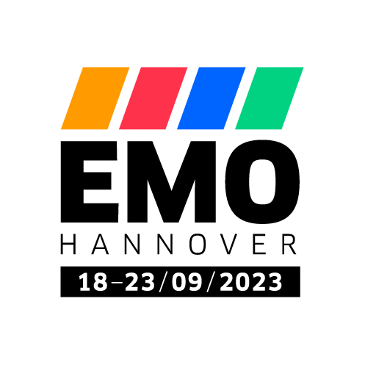PRESS RELEASE

OPEN MIND at EMO 2023

Major Appearance for *hyper*MILL®

Wessling (Germany), 19 June 2023 – OPEN MIND will focus on turning, milling, and the importance of CAM software and MES in connected manufacturing environments at EMO 2023. The CAD/CAM manufacturer is more than aware of the importance of the world’s leading trade fair for manufacturing technology, which is why this year’s booth has been upgraded to be larger and feature better media tech than ever before. Located in Exhibition Hall 9 at the Hanover Exhibition Grounds, Booth A05 covers 150 square meters and will be where visitors will get the chance to learn everything there is to know about the *hyper*MILL® CAD/CAM suite from 18 to 23 September 2023.

**Exhibition Hall 9, Booth A05**

Live demonstrations on a GROB G350T mill-turn machine will be held at the booth to display what the milling-turning technologies of *hyper*MILL® TURNING Solutions can do. The live demos will also include milling, drilling, and angle head support, as well as how to use a virtual machine to simulate machining of finished NC code. [*hyper*MILL® TURNING Solutions](https://www.openmind-tech.com/en/cam/turning-solutions/) include technologies for turning, turn-milling, and mill-turning, meaning they can be used for all corresponding machine configurations. Last but not least, OPEN MIND’s demonstrations will also feature automation solutions to help make creating error-free NC programs simpler and faster.

Connected manufacturing

OPEN MIND has been positioning *hyper*MILL® as a vital building block in the digitalization of process chains since the acquisition of MES manufacturer Hummingbird in early 2022. [Connected manufacturing](https://www.openmind-tech.com/en/cam/connected-manufacturing/) will also be on the agenda at EMO – under the motto “Create the future of manufacturing together” – to highlight the important role of the CAM system in a connected manufacturing environment.

Examples from multiple industries

OPEN MIND will again have a large number of show parts at its booth to help visitors truly understand what optimized machining looks like. The examples of industries in which *hyper*MILL® is particularly valued range from tool and mold making to aerospace and medical technology. There will also be components for equipment in the semiconductor industry on display. These components have to meet particularly high requirements in terms of dimensional accuracy and surface quality.

Special education show

OPEN MIND will take part in the Nachwuchsstiftung Maschinenbau’s special education show as a cooperation partner, which will be held in Hall 8 at EMO. The show is expected to attract over 3,500 students and around 1,500 trainers and teachers have been invited to attend. The new generation will have the opportunity to get a firsthand look at the *hyper*MILL® CAM system and understand its practical importance for the process chain.

**Available images**

The following images are available for download in printable format at:   
<https://kk.htcm.de/press-releases/open-mind/>

|  |
| --- |
| Source: OPEN MIND  **Turning and milling in one CAM software** |

About OPEN MIND Technologies AG

OPEN MIND is one of the world’s most sought-after developers of powerful CAM solutions for machine and controller-independent programming.

OPEN MIND develops optimized CAM solutions that include a high number of innovative features not available elsewhere to deliver significantly higher performance in both programming and machining. Strategies such as 2.5D, 3D as well as 5-axis milling/mill turning, and machining operations like HSC and HPC are efficiently built into the *hyper*MILL® CAM system. *hyper*MILL® provides the maximum possible benefits to customers thanks to its full compatibility with all current CAD solutions and extensive programming automation.

OPEN MIND strives to be the best and most innovative CAD/CAM manufacturer in the world, helping it become one of the top five in the CAM industry according to the “NC Market Analysis Report 2022” compiled by CIMdata. The CAD/CAM solutions of OPEN MIND fulfil the highest demands in the automotive, tool and mold manufacturing, production machining, medical, job shops, energy and aerospace industries. OPEN MIND is represented in all key markets in Asia, Europe and America, and is a Mensch und Maschine company.

You can find more information at [www.openmind-tech.com](http://www.openmind-tech.com).

OPEN MIND Technologies UK Ltd., Oxford

Unit 3

Bicester Business Park

Telford Road

Bicester

Oxfordshire OX26 4LN

England

Phone: +44  1869  290 003

Fax: +44  1869  369 429

E-mail: Info.UK@openmind-tech.com

OPEN MIND Technologies USA, Inc.

1492 Highland Avenue, Unit 3

Needham MA 02492

USA

Phone: +1  339  225  4557 office

Phone: +1  888  516 1232 x0 toll-free

Fax: +1  270  912 5822

E-mail: Info.Americas@openmind-tech.com

Head office:   
OPEN MIND Technologies AG, Argelsrieder Feld 5, 82234 Wessling, Germany  
Tel.: (+49-8153) 933-500, Fax: (+49-8153) 933-501  
E-mail: Info@openmind-tech.com, website: www.openmind-tech.com

**Press contact:**

HighTech communications GmbH  
Brigitte Basilio  
Brunhamstrasse 21  
81249 Munich  
Germany  
Tel.: (+49-89) 500778-20  
E-mail: b.basilio@htcm.de  
Website: www.htcm.de