

NEWS RELEASE

For Release: IMMEDIATELY With Art: Digital Image
Editorial Michael McCue OPEN MIND Alan Levine
Contact: McCue & Associates LLC Contact: OPEN MIND Technologies USA, Inc.
978-733-1353 339-225-4557 mmccue@mccueassociates.com alan.levine@openmind-tech.com

OPEN MIND Announces hyperMILL® CAM Ultrasonic Knife Cutting Strategy
for Composites, Honeycomb Structures, Foams

Leveraging CAM for Ultrasonic Knife Cutting Explained during May 18th Webinar
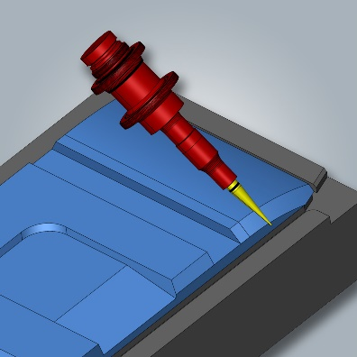
NEEDHAM, MA U.S.A. (April 17, 2023) – OPEN MIND Technologies, a leading developer of CAD/CAM software solutions worldwide, offers a precise, highly productive ultrasonic knife cutting strategy via its hyperMILL® CAM software. Ultrasonic knife cutting represents an ideal solution for the efficient cutting of advanced materials including honeycomb structures, composites, and foams often found in aerospace, automotive and wind turbine applications. Using a single interface, users can benefit from the comprehensive programming capabilities of the hyperMILL® CAD/CAM software suite ranging from 2.5D machining to 5-axis milling, as well as easily program ultrasonic cutting with oscillating cutting blades.
Ultrasonic Knife Cutting via hyperMILL® VIRTUAL Machining Optimizer

hyperMILL® provides NC code simulation to reliably bring challenging 6-axis output to the machine. Using hyperMILL’s VIRTUAL Machining Optimizer to control the orientation of the spindle, as the sixth axis, the cutting blade is aligned to the workpiece. The Optimizer keeps toolpaths within limits for demanding machining processes with limited rotation axes, such as a fork-head style milling machine (with the machine head having two rotary axes).

“Creating the required 6-axis NC programs for knife cutting applications, including five machine axes plus a programmable spindle orientation, has historically proven to be a challenge,” said Mr. Alan Levine, Managing Director of OPEN MIND Technologies USA, Inc. “However, hyperMILL® provides users with a productive, accurate, safe and smooth cutting solution which prevents hazardous rotations and retract movements.”

Manufacturers are welcome to attend a 30-minute webinar at 12:00 p.m. ET on May 18th this year when OPEN MIND Technologies Account Manager Kevin Lewis will present how CAM software can be leveraged for ultrasonic knife cutting. Visit here for more information and to register for the webinar.

For more information and to watch a video about knife cutting with hyperMILL®, visit here.

About OPEN MIND Technologies AG
Headquartered in Wessling, Germany, OPEN MIND is one of the world's leading developers of powerful CAM solutions for machine and controller-independent programming. The company develops optimized CAM solutions that include many innovative features unavailable elsewhere, to deliver significantly higher performance in both programming and machining. Strategies such as 2.5D, 3D, as well as 5-axis milling, mill/ turning, and machining operations like HSC and HPC, are efficiently designed into the hyperMILL® CAM system, providing maximum user benefit and compatibility with all current CAD solutions and extensive programming automation. OPEN MIND strives to be the best, most innovative CAD/ CAM developer in the world, and has earned the top five ranking in the CAD/ CAM industry according to the 2022 NC Market Analysis Report by CIMdata. OPEN MIND CAD/ CAM solutions meet and exceed the requirements of the most demanding industries such as automotive, tool and mold manufacturing, production machining, medical, job shops, energy and aerospace industries, and is represented in all key markets of Asia, Europe and the Americas. OPEN MIND is a Mensch und Maschine Company. http://www.mum.de/ For more information visit https://www.openmind-tech.com/en-us.html.
# # # # #

