PRESS RELEASE
Swissbit introduces management tool for storage devices
Swissbit Device Manager offers comprehensive monitoring and is enabled for firmware updates

Westford, MA USA. May 24, 2023 – Swissbit Device Manager (SBDM) is the latest edition of the Swiss storage and security specialist’s software tool for storage devices. The most recent version of SBDM allows customers to initiate firmware updates in addition to giving comprehensive insight into the lifecycle status of Swissbit storage solutions. As a result, the software supports Swissbit customers who are currently in the design-in stages, giving them complete flexibility for extensive testing and customization. A user-friendly app presents all the captured data. It serves as a main interface for all Swissbit storage products. The Swissbit website offers a free download of the tool, which is available for both Windows and Linux.
Swissbit's software tool is designed to minimize machine downtime and outage costs while increasing system reliability. Additionally, the need for maintenance and service can be accurately determined. Customers and Swissbit's FAE team may now communicate even more effectively thanks to the newly introduced feature of performing firmware updates using locally stored firmware packages, especially during the design-in stage. Customers can easily install and test product-specific firmware adjustments.
The Swissbit Device Manager is the systematic further development of the successful Swissbit Lifetime Monitoring Tool, whose feature set and ease of use have now been expanded even further. All the benefits of a complete monitoring and system tool are provided by the SBDM. This includes both the standard S.M.A.R.T. parameters (Self-Monitoring, Analysis and Reporting Technology) as well as the utilization of the individual flash blocks. Important telemetry data, general device information like serial number or firmware version, utilization statistics like NAND flash erase cycles, and ECC/CRC counters are all visualized using SBDM. The history of all these values is recorded for each memory device.
Compatibility, use and potential future applications.
For Linux and Windows, there is a direct executable version of the Swissbit Device Manager. The Command Line Interface (CLI) is another method of using the SBDM in addition to the app.
The SBDM supports the CompactFlash, SSD SATA, CFast, CFexpress, USB, SD, microSD, e.MMC, and NVMe product lines from Swissbit.
The Swissbit Device Manager Library/API is now also available as a free download. Customers can use this to integrate SBDM features into their own tools or software programs.
Visit https://www.swissbit.com/en/support/swissbit-device-manager/ for further information.

Available images
The following images are available for download in printable format at: https://kk.htcm.de/press-releases/swissbit/
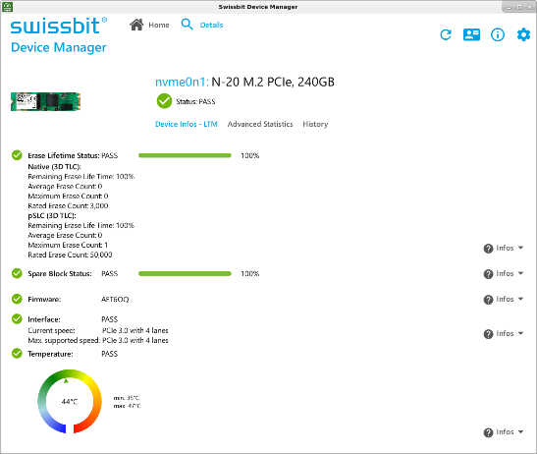  Image source: Swissbit  The Swissbit Device Manager's user interface. | 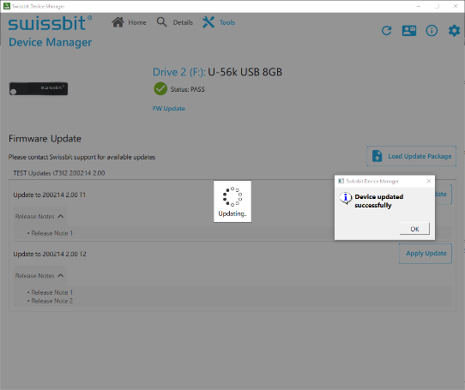  Image source: Swissbit  Firmware updates can now be uploaded via the new Swissbit Device Manager.

Image source: Swissbit
Management-Tool for storage devices: Swissbit Device Manager

About Swissbit
Swissbit AG is the leading European manufacturer of storage, security and embedded IoT solutions for demanding applications. Swissbit combines its unique competences in storage and embedded IoT technology with its advanced packaging know-how. This expertise allows our customers to reliably store and protect data in industrial, NetCom, automotive, medical, and fiscal applications as well as across the Internet of Things (IoT).
Swissbit develops and manufactures industrial-grade storage and security products “Made in Germany” with high reliability, long-term availability, and custom optimization.
Swissbit’s storage range includes SSDs with PCIe and SATA interface such as mSATA, Slim SATA, CFast™, M.2 and 2.5” as well as CompactFlash, USB flash drives, SD Memory Cards, micro-SD Memory Cards and managed NAND BGAs like e.MMC. Security products are available in various application specific editions as USB flash drives, SD Memory Cards, and micro-SD Memory Cards.
Swissbit was founded in 2001 and has offices in Switzerland, Germany, USA, Japan and Taiwan. Swissbit owns the registered trademarks Swissbit® and Hyperstone®. Since 2020, the independent investment firm Ardian is holding a majority stake in the company to support its growth.
For further information, please visit www.swissbit.com

Regional Headquarters:
Swissbit Germany AG
Bitterfelder Strasse 22
12681 Berlin
Germany
Tel: +49 30 936 954 0
Email: info@swissbit.com
www.swissbit.com
Headquarters:
Swissbit AG
Industriestrasse 4
9552 Bronschhofen
Switzerland
Tel: +41 71 913 03 03
Email: info@swissbit.com
www.swissbit.com
Contact:  Swissbit AG  Marian Weber  Industriestrasse 4  9552 Bronschhofen  Switzerland  Tel: +49 172 854 88 26  Email: marian.weber@swissbit.com  www.swissbit.com | Press Agency:  HighTech communications GmbH  Brigitte Basilio  Brunhamstrasse 21  81249 Munich  Germany  Tel: +49 89 500778-20  Fax: +49 89 500778-77  Email: b.basilio@htcm.de  www.htcm.de

