Press Release
Symeo at TOC Europe 2023
Precise Position Determination in Ports and Terminals
Neubiberg, Germany, 23 May 2023 – Symeo will once again be at TOC Europe, the world’s largest trade exhibition for port, marine, and terminal technology. From 13 to 15 June 2023, Symeo will present industrial radar technology for reliably determining positions in all weather conditions at booth G26 in hall 5 of the Ahoy Rotterdam event center. This technology mainly focuses on measuring distances on cranes using extremely robust radar sensors which do not require maintenance.
Symeo’s maintenance-free and wear-free sensors are based on patented LPR technology (local positioning radar) and can be fully relied on even when faced with dirt, extreme dust, vibrations, high solar radiation, fog, or precipitation. The LPR-1D24 sensor system has been providing collision avoidance and reliable position determination in many seaports and container terminals around the world for years.
With the LPR-1DHP-291, Symeo is introducing a new robust sensor system for accurately measuring distances up to 50 meters in real time with a single sensor. Combining multiple LPR-1DHP-291 sensors increases this range to 500 meters. The industrial radar system with integrated directional antenna measures with accuracy in the millimeter range and is suitable for the development of crane positioning, collision avoidance, goods tracking, and process automation applications. Used as radar barriers, the sensors can detect objects and help secure areas.
New compact solution
With the LPR-1DHP-350, Symeo is primarily looking to replace laser or ultrasonic sensors, as these are sensitive to environmental influences. However, the fact the new sensor is just 90 x 90 x 35 mm in size means it is also particularly suitable for installations in places where radar systems have not previously fit before. The compact LPR-1DHP-350, for example, is perfect for use on trolleys. The sensor uses the 120 GHz frequency range for distance measurements at distances up to 40 meters with its high degree of accuracy of up to ±9 mm.

Available images
The following images are available for download in printable format at:
https://kk.htcm.de/press-releases/symeo/

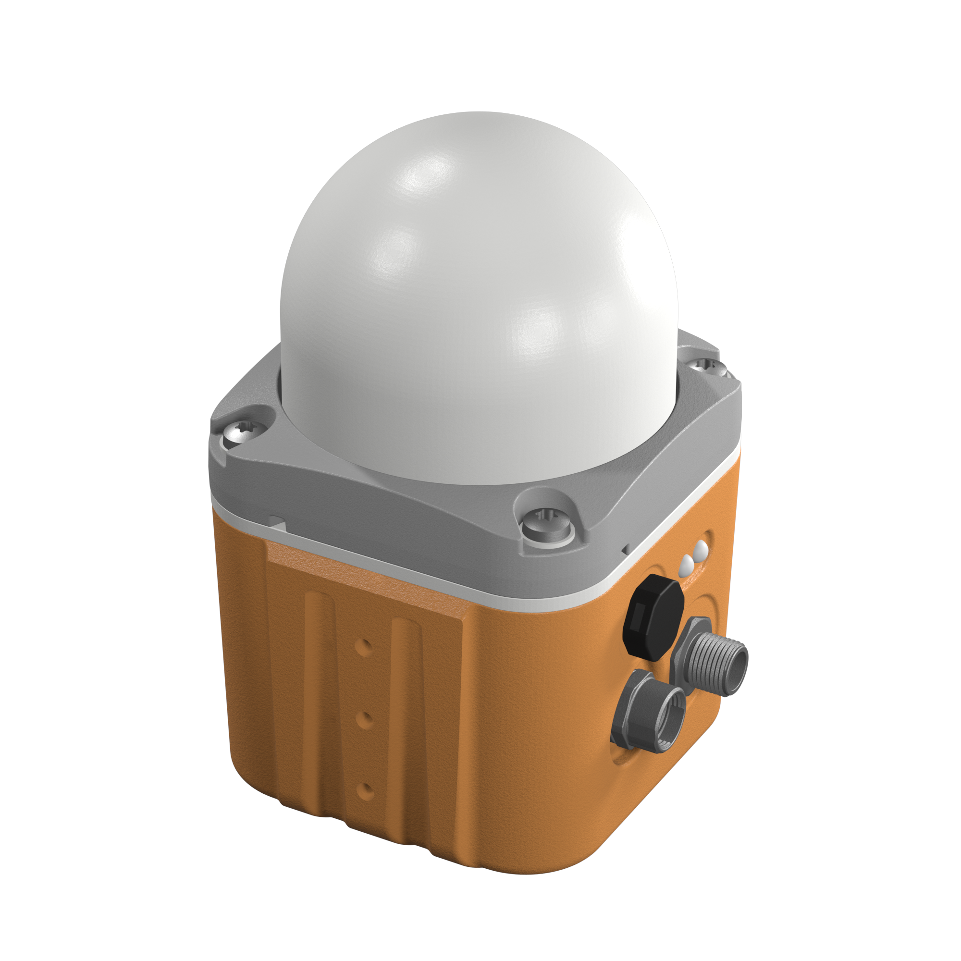
Image source: Symeo
The LPR-1DHP-291 industrial radar system is suitable for applications in the fields of crane positioning, collision avoidance, and goods tracking.

Symeo GmbH
Symeo GmbH develops and markets products and solutions for precise, non-contact, maintenance-free position detection, distance measurement, and collision avoidance. Symeo GmbH’s products feature extremely robust designs to make them suitable for applications in harsh industrial environments.
Symeo GmbH’s LPR® locating technology offers a wireless and real-time capable measuring system that is ideally suited for industrial applications. Symeo has many years of experience in the development of cost-efficient and customer-specific industrial solutions on the basis of LPR® technology.
The company delivers standardized products and complete solutions to system integrators, original equipment manufacturers (OEMs), and end customers worldwide.
Headquarters: Symeo GmbH, Prof.-Messerschmitt-Strasse 3, 85579 Neubiberg, Germany
Phone: (+49-89) 6607-7960, Fax: (+49-89) 66077-96190
E-mail: info@symeo.com, Website: www.symeo.com

Press contact:
HighTech communications GmbH
Marcus Planckh
Brunhamstrasse 21 (Building 202/2nd floor)
81249 Munich
Germany
Phone.: (+49-89) 500-77822
Fax: (+49-89) 5007-7877
E-mail: m.planckh@htcm.de
Website: www.htcm.de

