PRESS RELEASE
New Security Key: Swissbit Introduces iShield Key Pro
In addition to the FIDO2 standard, the new hardware token now supports security features like HOTP and PIV

Bronschhofen, Switzerland. April 27, 2023 – With the iShield Key Pro, Swissbit is expanding its range of hardware security keys with more than simply another FIDO stick. Thanks to the addition of further security standards and features, the new security key provides even more flexibility for secure password-free, phishing-resistant authentication and protection of online accounts. Alongside FIDO2, the stick also supports HOTP (Hash-Based-One-Time-Password) to enable automatic fallback to a compliant authentication method with a seamless user experience. This allows the stick to be used in offline and remote access circumstances where FIDO2 is not available. In addition, PIV (Personal Identity Verification) technology ensures secure personal credential storage. iShield Key Pro features an NFC interface on top of USB Type-A, and is packaged in a robust, waterproof, industrial-grade plastic shell. With its latest security key, Swissbit specifically addresses enterprise IT applications as well as security extensions of existing web-based services and opens up new application opportunities with its extended range of functions.
With iShield Key Pro, online accounts and web services can be properly safeguarded against threats like phishing, social engineering attacks or account takeovers. Businesses are given even more flexible deployment alternatives. In addition to support for all FIDO2/WebAuthn- and U2F-compatible websites and services (including Microsoft Azure Active Directory), HOTP is also included in the functional scope. The event-based method, which secures two-factor authentication (2FA) for web services that do not support WebAuthn, combines a private key and a counter-based one-time password. Moreover, HOTP can be applied in situations when users do not have Internet connectivity, such as offline application scenarios.
PIV functionality is a further new feature, which uses a Public Key Infrastructure (PKI) and the PKCS #11 cryptographic standard to store digital certificates and private keys. PIV is an open standard that is widely used in industry and by government agencies for authentication, digital signatures, encryption and physical access credentials. PIV enables iShield Key Pro to be used for Windows logon (for local accounts or through Microsoft Active Directory), even when drive encryption with BitLocker is also enabled. Configuring HOTP and PIV is made possible by a free management tool.
iShield Key Pro is manufactured at Swissbit's own semiconductor manufacturing facility in Berlin, Germany, in industrial quality and is designed for the extended operating temperature range from -25 °C to 70 °C. The security key allows storage of up to 32 passkeys for password-free website login in addition to being certified for the latest FIDO2 standard and its predecessor U2F.
Availability
iShield Key Pro is available from the online retailers Digi-Key, Distrelec, Farnell and Mouser Electronics. Individual inquiries can also be directed at any time to sales@swissbit.com.

Available images
The following images are available for download in printable format at: https://kk.htcm.de/press-releases/swissbit/
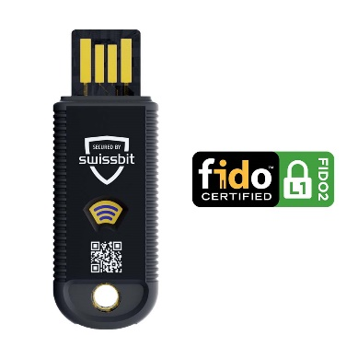  Source: Swissbit  Made in Germany: The new iShield Key Pro hardware security key from Swissbit. | 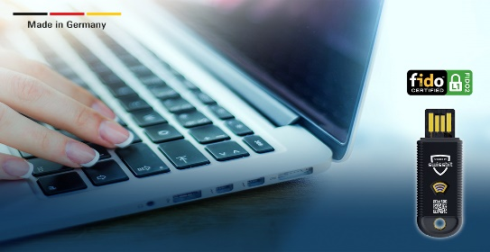  Source: Swissbit  Maximum security and even more flexibility: iShield Key Pro supports HOTP and PIV in addition to FIDO2.

About Swissbit
Swissbit AG is the leading European manufacturer of storage, security and embedded IoT solutions for demanding applications. Swissbit combines its unique competences in storage and embedded IoT technology with its advanced packaging know how. This expertise allows our customers to reliably store and protect data in industrial, NetCom, automotive, medical and fiscal applications as well as across the Internet of Things (IoT).
Swissbit develops and manufactures industrial-grade storage and security products “Made in Germany” with high reliability, long-term availability, and custom optimization.
Swissbit’s storage range includes SSDs with PCIe and SATA interface such as mSATA, Slim SATA, CFast™, M.2 and 2.5” as well as CompactFlash, USB flash drives, SD Memory Cards, micro SD Memory Cards and managed NAND BGAs like e.MMC. Security products are available in various application specific editions as USB flash drives, SD Memory Cards, and micro SD Memory Cards.
Swissbit was founded in 2001 and has offices in Switzerland, Germany, USA, Japan and Taiwan. Swissbit owns the registered trademarks Swissbit® and Hyperstone®. Since 2020, the independent investment firm Ardian is holding a majority stake in the company to support its growth.
For further information, please visit www.swissbit.com
Regional Headquarters:
Swissbit Germany AG
Bitterfelder Strasse 22
12681 Berlin
Germany
Tel: +49 30 936 954 0
Email: info@swissbit.com
www.swissbit.com
Headquarters:
Swissbit AG
Industriestrasse 4
9552 Bronschhofen
Switzerland
Tel: +41 71 913 03 03
Email: info@swissbit.com
www.swissbit.com
Contact:  Swissbit AG  Marian Weber  Industriestrasse 4  9552 Bronschhofen  Switzerland  Tel: +49 172 854 88 26  Email: marian.weber@swissbit.com  www.swissbit.com | Press Agency:  HighTech communications GmbH  Brigitte Basilio  Brunhamstrasse 21  81249 Munich  Germany  Tel: +49 89 500778-20  Fax: +49 89 500778-77  Email: b.basilio@htcm.de  www.htcm.de

