PRESS RELEASE
ASMPT Semiconductor at PCIM 2023
Power for e-mobility
Munich, April 4, 2023 – ASMPT offer solutions for the entire power module assembly process chain, one of the greatest production challenges in e-mobility. At PCIM Europe 2023, which will be held May 9 to 11 in Nuremberg, the market leader in semiconductor manufacturing equipment will present two machines for separation and sintering at Booth 6-448.
The Semiconductor Solutions segment of ASMPT will be present with its own booth at the internationally leading trade fair for power electronics, intelligent drive technologies, renewable energies and energy management.
The market leader in semiconductor manufacturing and processing technology will focus especially on power supply technology in the automotive sector. Two machines will demonstrate what innovative manufacturing technology can accomplish today:
- The LASER1205 UVP semiconductor separation platform operates with an accuracy rating of less than 1.5 µm, a heat-affected zone of less than 2 µm, and a gap width of less than 12 µm. This laser dicing technology can support the technology roadmap of the power semiconductor market.
- The silver sintering machines of the SilverSAM series process substrates measuring up to 355 × 293 mm in an oxidation-free and copper-friendly environment supporting die, clip, double-sided-cooled and heatsink sintering processes. They are particularly suited for power module production where sintering is the best and most reliable bonding technology for high-volume manufacturing.
Power for ADAS, connectivity, and the drivetrain
“The car of the future requires a lot of electrical energy for entertainment/infotainment, connectivity, advanced driver assistance systems (ADAS) and, of course, the drivetrain,” explains David Felicetti, Business Development & Product Marketing Manager at ASMPT. “This requires power distribution systems than cope as well with the high power density as with the frequently rough environmental conditions, and that can be manufactured at a competitive price.
“When automotive manufacturers talk with ASMPT, they have come to the right address. ASMPT is the only supplier that seamlessly covers the power module production process with its machines – from the wafer to the finished sintered module. At the ASMPT booth, visitors can see what this looks like in practice and discuss each step with our specialist staff. How do you achieve more yield and lower TCO when dicing SiC wafers? How exactly does the production of power modules progress from the laboratory to mass production? Our experts and exhibits provide answers to these and many other questions.”

Illustrations for downloading
The following print-ready artwork is available on the internet for downloading:
https://kk.htcm.de/press-releases/asmpt/

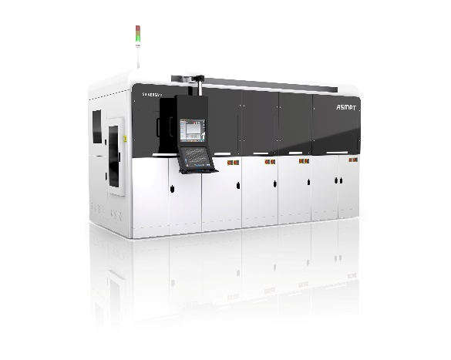 | 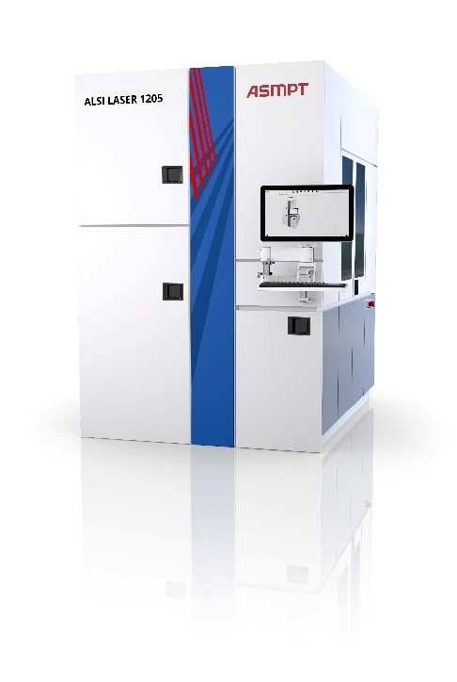
SilverSAM silver sintering machine: Enabling high power density connections for power modules.  Image credit: ASMPT | The LASER1205 UVP laser separation technology, addressing the roadmap of power semiconductors.  Image credit: ASMPT

About ASMPT Limited (“ASMPT”)
ASMPT Limited is a leading global supplier of hardware and software solutions for the manufacture of semiconductors and electronics. Headquartered in Singapore, ASMPT’s offerings encompass the semiconductor assembly & packaging, and SMT (surface mount technology) industries, ranging from wafer deposition to the various solutions that organise, assemble and package delicate electronic components into a vast range of end-user devices, which include electronics, mobile communications, computing, automotive, industrial and LED (displays). ASMPT partners with customers very closely, with continuous investment in R&D helping to provide cost-effective, industry-shaping solutions that achieve higher productivity, greater reliability, and enhanced quality.
ASMPT is listed on the Stock Exchange of Hong Kong (HKEX stock code: 0522), and is one of the constituent stocks of the Hang Seng Composite MidCap Index under the Hang Seng Composite Size Indexes, the Hang Seng Composite Information Technology Industry Index under Hang Seng Composite Industry Indexes and the Hang Seng HK 35 Index.
To learn more about ASMPT, please visit us at asmpt.com.

For more information about ASMPT Semiconductor Solutions visit semi.asmpt.com.

Media contacts:
Global ASM Press Office
ASM Assembly Systems GmbH & Co. KG
Susanne Oswald
Rupert-Mayer-Str. 48
81379 Munich
Germany
Tel: +49 89 20800-26439
E-mail: susanne.oswald@asmpt.com
Website: www.asm-smt.com

HighTech communications GmbH
Barbara Ostermeier
Brunhamstr. 21
81249 Munich
Germany
Tel.: +49-89 500778-10
E-mail: b.ostermeier@htcm.de
Website: www.htcm.de

