PRESS RELEASE
ASMPT’s expert system provides relief for quality assurance staff – now also open to third-party equipment
WORKS Process Expert: Optimization along the entire line
Shanghai (China), March 23, 2023 – Greater yields, less routine work for the operators on the shop floor: WORKS Process Expert from ASMPT, the world’s first self-learning in line expert system for electronics production, reduces scrap and operator assists along the entire SMT line. The latest version of the process-optimizing software now also includes the placement process in addition to solder paste printing and even works with SPI and AOI systems from other manufacturers.
SMT lines learn and optimize themselves: Together with the DEK printing platform, the high-speed Process Lens SPI system and the SIPLACE placement machines from ASMPT, the WORKS Process Expert software forms a self-learning inline expert system that lets electronics manufacturers produce faster, more cost-effectively, and with significantly higher yield. While autonomous process control was previously limited to solder paste printing, the new version of WORKS Process Expert in combination with end-of-line AOI systems now also supports the optimization of the placement process by driving the operators to the tasks with the highest positive impact on the process. With its connection to SPI and AOI systems, it supports process and quality engineers in identifying the defect root-cause across the complete SMT line, thus ensuring its elimination and higher yield.
Following its Open Automation principle, the SMT specialist has also opened up the trend-setting software to third-party equipment, allowing WORKS Process Expert to process data from SPI and AOI systems made by other manufacturers. Seamless connectivity of the inspection solutions in the SMT line is ensured by the open IIoT and communication standard IPC-CFX. The smart software thus becomes a powerful solution for higher yields and better quality while simultaneously reducing operator assists along the entire SMT line, making it a significant contributor to the realization of the integrated smart factory.
“Hardware and software for industrial inspection solutions are available from many manufacturers,” says Jérôme Rousval, Product Manager Process Solutions at ASMPT, “but hardly anyone has such a wealth of experience and comprehensive process knowledge as ASMPT. Since we cover the entire electronics manufacturing process chain with our hardware and software as well as with our automation solutions, we are also one step ahead when it comes to process automation. And this is especially beneficial for our customers’ employees.”
Online show: Facts on Open Automation
Providing the best possible support for operators with intelligent software and smart process optimization is also the subject of the next installment of the ‘Facts on Open Automation’ show on Wednesday April 26, 2023. “Where in the past several operators used to be responsible for a single SMT line, today often only one operator remains,” explains host Laszlo Sereny. “He or she must keep the entire line running, replace stencils in the solder paste printer according to customer specifications, and ensure timely material replenishments at the placement machines – all while keeping an eye on the key performance indicators at all times. Multitasking and process know-how are in demand, and emergency operations are not uncommon.” Sereny and his studio guests will discuss how software supports operators during assists based on their qualifications and the respective task priorities, and how autonomous process control solutions help with quality assurance. Axel Lindloff, Senior Process Specialist at Koh Young, will join them remotely.
More information about ‘Facts on Open Automation’:
https://facts-on-open-automation.smt.asmpt.events/

Illustrations for downloading
The following print-ready artwork is available on the internet for downloading:
https://kk.htcm.de/press-releases/asmpt/

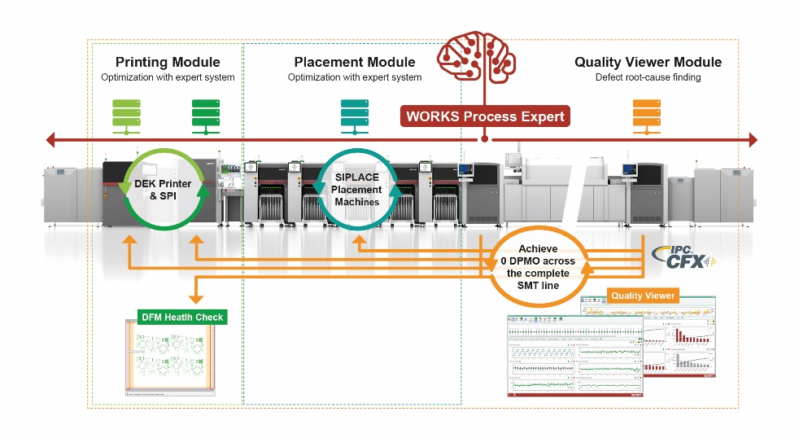
Based on ASMPT’s Open Automation concept, WORKS Process Expert is retrofittable, vendor independent, and covers the entire SMT line.

Image credit: ASMPT

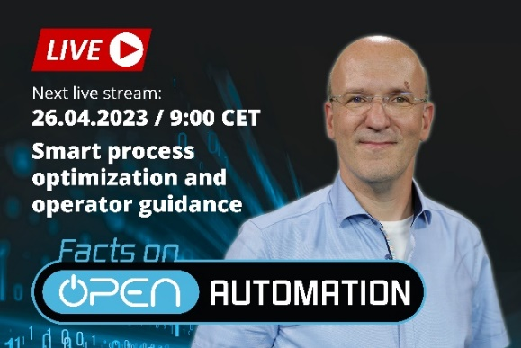
Facts on Open Automation: In this installment, host Laszlo Sereny and his guests will focus on maximum operator support through intelligent software and smart process optimization.

Image credit: ASMPT

About ASMPT Limited (“ASMPT”)
ASMPT (HKEX stock code: 0522) is a leading global supplier of hardware and software solutions for the manufacture of semiconductors and electronics. Headquartered in Singapore, ASMPT’s offerings encompass the semiconductor assembly & packaging, and SMT (surface mount technology) industries, ranging from wafer deposition, to the various solutions that organise, assemble and package delicate electronic components into a vast range of end-user devices, which include electronics, mobile communications, computing, automotive, industrial and LED (displays). ASMPT partners with customers very closely, with continuous investment in R&D helping to provide cost-effective, industry-shaping solutions that achieve higher productivity, greater reliability and enhanced quality.
ASMPT is one of the constituent stocks of the Hang Seng Composite MidCap Index under the Hang Seng Composite Size Indexes, the Hang Seng Composite Information Technology Industry Index under Hang Seng Composite Industry Indexes and the Hang Seng HK 35 Index.

To learn more about ASMPT, please visit us at asmpt.com.

The ASMPT SMT Solutions segment
The mission of the SMT Solutions segment within ASMPT is to implement and support the Integrated Smart Factory at electronics manufacturers worldwide.
ASMPT solutions support the networking, automation and optimization of central workflows with hardware, software and services that enable electronics manufacturers to transition to the Integrated Smart Factory in stages and enjoy dramatic improvements in productivity, flexibility and quality. With the integrated concept "Open Automation", ASMPT opens the door for its customers to economically feasible automation, entirely in accordance with their individual requirements - modular, flexible, and vendor-independent.
The product range includes hardware and software such as SIPLACE placement solutions, DEK printing solutions, inspection and storage solutions, and the Smart Shopfloor Management Suite WORKS. With WORKS, ASMPT offers electronics manufacturers high-quality software for planning, controlling, analyzing and optimizing all processes on the Shopfloor.
Since maintaining close relationships with customers and partners is a central component of ASMPT’s strategy, the company has established the SMT Smart Network as a global forum for the active exchange of information between and with smart champions.

For more information about ASMPT visit smt.asmpt.com.

Media contacts:
China ASMPT Press Office
SMT Solutions
Guan Jing
Tel.: +86 (755) 26934550-2109
E-mail: jing.guan@asmpt.com
Website: smt.asmpt.com

Global ASMPT Press Office
ASMPT GmbH & Co. KG
Susanne Oswald
Rupert-Mayer-Strasse 48
81379 Munich
Germany
Tel: +49 89 20800-26439
E-mail: susanne.oswald@asmpt.com
Website: smt.asmpt.com

