FOR THE MEDIA
ASMPT announces key SEMI Solutions Segment leadership changes to prepare it for the future

Singapore, 17 March 2023 – ASMPT Ltd (“the Group”), the leading global supplier of integrated hardware and software solutions for the manufacture of semiconductors and electronics has been profitable ever since listing in Hong Kong in 1989 and it has successfully grown its business organically and inorganically for more than 40 years. It recently announced its full year 2022 results (https://www.asmpt.com/en/investors/financials-results/), achieving its second highest ever revenue and bookings in spite of a challenging macroeconomic environment and an industry downcycle.
The Group is pleased to announce developments in its Semiconductor Solutions (SEMI) Segment leadership team that will help it to be prepared for further growth. The Group sees the SEMI Segment’s focus on developing an even more integrated organization that can best serve the needs of its customers and partners, while enabling it to continue growing and competing well. Beginning in mid-2022, this essentially involved combining all its CRM, PLM and SCM activities under one business entity to enable end-to-end business ownership, with dedicated Marketing & Sales, Product Development and Supply-Chain Management functions.

Semi Segment Leadership Enhancements
Leadership enhancements are a key part of this integration, including the appointments of Isaac Law, SVP and MD, China Manufacturing Operations, to an additional role as SEMI Segment COO; and the appointment of Justin Tham, Senior Director for Investor Relations, to a VP and SEMI Segment CFO role.
Crucially, the two existing CEOs for the various SEMI Business Groups (BGs) and its subsidiaries have been designated Co-CEOs for the entire SEMI Segment. They are jointly responsible for managing an integrated, global SEMI team in addition to their ongoing responsibilities as CEOs of their respective BGs.

Lim Choon Khoon (CK Lim), Senior Vice President; Co-CEO, Semiconductor Solutions Segment; CEO, ICD & CIS Business Units
CK Lim began his career with US semiconductor companies before joining the Group in Malaysia, with positions in Hong Kong and Singapore. His previous responsibilities included equipment product marketing and sales, key account management and leading advanced packaging initiatives. As Co-CEO, his portfolio covers mainstream ICD, Advanced Packaging, Consumer & Automotive CIS, as well as the NEXX, AEi and ALSI business units.
“The evolution of the SEMI organization in tandem with the whole of ASMPT is an ongoing process,” said CK Lim. “To me, it enables us to serve our customers even better by enhancing the way we work with them, and the way we support and develop our broad portfolio suite. With an improved business focus, Joe and I firmly believe an integrated SEMI team structure and leadership is making an impact.”

Poh Tson Cheong, Joseph (Joe Poh), Senior Vice President; Co-CEO, Semiconductor Solutions Segment; CEO, Opto & Display Business Unit
Joe Poh joined the Group as a Service Engineer and during his career with the Group, has held various positions in its IC, CIS, SMT Solutions and Opto businesses. Joe Poh’s wide exposure to the electronics supply chain has enabled him to develop extensive customer contacts and a deep understanding of market needs. As Co-CEO, his portfolio covers optoelectronics, LEDs, as well as Silicon Photonics with the AMICRA business unit.
“We have made good progress,” said Joe Poh. “We are laser focused on presenting a compelling SEMI organization to our customers and partners that not only boosts operational efficiency but will turbocharge new product development and new business development capabilities. CK and I look forward to tapping the synergies and power of the entire ASMPT organization, including deeper integration with our SMT segment.”

Illustrations for downloading
The following print-ready artwork is available on the internet for downloading:
https://kk.htcm.de/press-releases/asmpt/

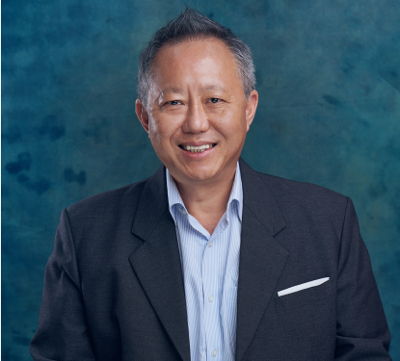 | 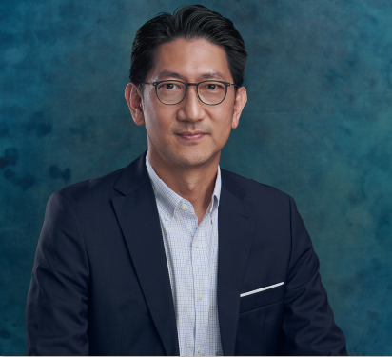
Lim Choon Khoon (CK Lim) is a Senior Vice President, Co-CEO of the Semiconductor Solutions Segment, and CEO of the Segment’s ICD & CIS Business Units, ASMPT  Source: ASMPT | Poh Tson Cheong, Joseph (Joe Poh) is a Senior Vice President and Co-CEO of the Semiconductor Solutions Segment, and CEO of the Opto & Display Business Unit, ASMPT  Source: ASMPT

About ASMPT Limited (“ASMPT”)
ASMPT (HKEX stock code: 0522) is a leading global supplier of hardware and software solutions for the manufacture of semiconductors and electronics. Headquartered in Singapore, ASMPT’s offerings encompass the semiconductor assembly & packaging, and SMT (surface mount technology) industries, ranging from wafer deposition, to the various solutions that organise, assemble and package delicate electronic components into a vast range of end-user devices, which include electronics, mobile communications, computing, automotive, industrial and LED (displays). ASMPT partners with customers very closely, with continuous investment in R&D helping to provide cost-effective, industry-shaping solutions that achieve higher productivity, greater reliability and enhanced quality.

ASMPT is one of the constituent stocks of the Hang Seng Composite MidCap Index under the Hang Seng Composite Size Indexes, the Hang Seng Composite Information Technology Industry Index under Hang Seng Composite Industry Indexes and the Hang Seng HK 35 Index. To learn more about ASMPT, please visit us at www.asmpt.com.

Media contacts:
ASMPT Singapore Pte. Ltd.
Lim Ee Guan
2 Yishun Avenue 7
Singapore 768924
Tel: +65 6450 1445
eg.lim@asmpt.com

ASMPT GmbH & Co. KG
Susanne Oswald Rupert-Mayer-Str. 44
81379 Munich Germany
Tel: +49 89 20800-26439
susanne.oswald@asmpt.com
asmpt.com

