Press release
Schröder Group introduces the hydraulic PowerShear
Less models, more options
Wessobrunn-Forst (Germany), 2 March 2023 – Instead of the previous PowerShear Professional, Universal and Basic shear models, the Schröder Group now offers PowerShear as a single individually configurable sheet metal cutting solution. Customers no longer need to choose one model but have maximum flexibility in selecting the equipment and tooling options they need. PowerShear is a hydraulic shear for up to six millimeter thick sheet, featuring energy- and hydraulic oil-saving drives. The shear is available with either 3000 or 4000 mm working length.
In addition to the single cut operation, it is above all the automatic operation for fast series production with which PowerShear scores points. The motorized back gauge is frequency-controlled, and the shear operates at a speed of up to 44 strokes per minute. The control, which can be operated via a touch display, automatically adjusts the shear angle and blade gap to the sheet thickness. A pneumatic sheet support protects particularly sensitive sheets. The blade gap is LED illuminated.
Useful options
Customers can now freely choose from numerous useful options that were previously assigned to specific models. First and foremost, here is the scrap and part separator to the front. Narrow strips of sheet metal are guided forward over the entire useful length, and when trimming cuts, the scrap separator disposes of unneeded sections. When cutting oversized metal sheets, the back gauge rail ensures that the back gauge "makes room". This group of options also includes a back gauge with linear guide and recirculating ball screws.
Depending on the size of sheets, Schröder Group offers various table extensions that can be moved on a guide rail, including ball rollers. A movable scrap container is also one of the options.

Available images
The following images are available for download in printable format at:
https://kk.htcm.de/press-releases/schroeder/
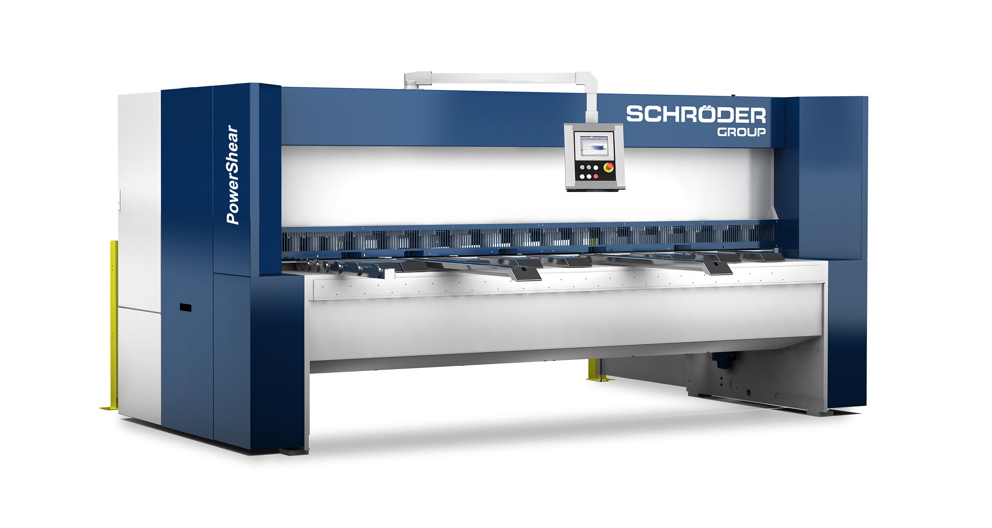  Image source: Schröder Group  Schröder Group’s hydraulic PowerShear | 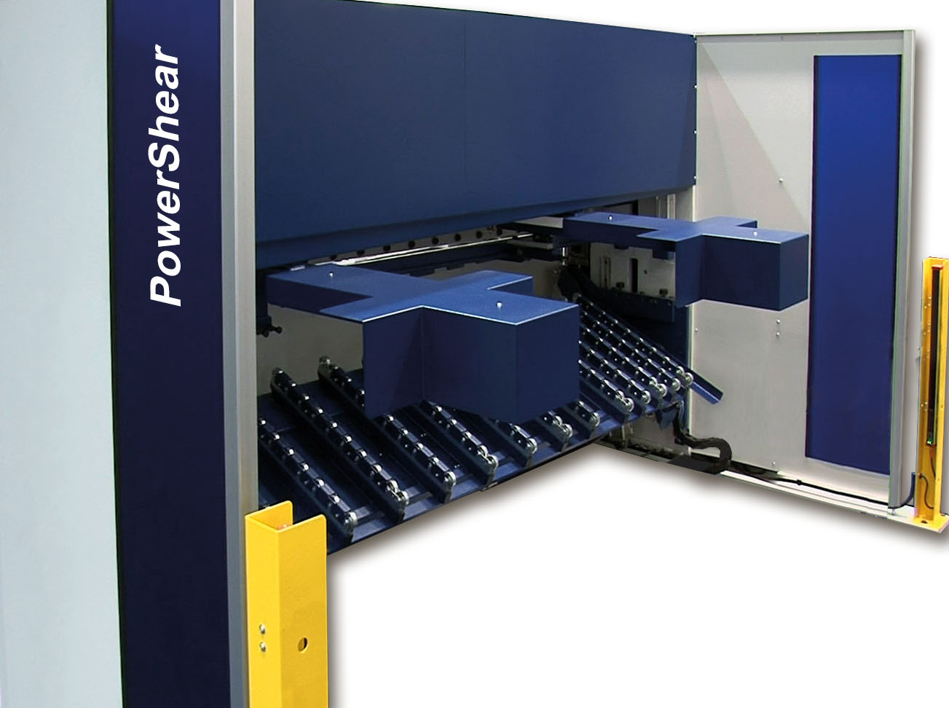  Image source: Schröder Group  PowerShear motorized backgauge, sheet holding-up device and rear guarding

About Schröder Group
The Schröder Group consists of Hans Schröder Maschinenbau GmbH, which is located in Wessobrunn-Forst, Germany, SCHRÖDER-FASTI Technologie GmbH, located in Wermelskirchen, Germany and the SMU GmbH, located in Leinburg-Weißenbrunn.
Founded in 1949, Hans Schröder Maschinenbau GmbH unifies traditional and modern approaches in machine building: Successfully managed as a quality and customer-oriented, family-owned company, Hans Schröder Maschinenbau is specialized in the development of modern machine concepts for bending and cutting sheet metal.
The successful integration of the Fasti Company in 2006 and its worldwide presence make the Schröder Group one of today‘s leading providers of machines for bending, cutting, beading, flanging, and circular bending all types of sheet metal. The company‘s precision machines range from proven solutions for craftsmen to innovative, high-performance machines for automatic industrial production processes. 2021 the Schröder Group was expanded by the tool manufacturer SMU GmbH. Overall, the Schröder Group currently employs more than 300 people at various locations at home and abroad.
Further information is available at www.schroedergroup.eu/en.

Press contact:
Schröder Group
Hans Schröder Maschinenbau GmbH
Janina Biró
Feuchten 2
82405 Wessobrunn-Forst
Germany
T: +49 8809 9220-68
E-mail: jj@schroedergroup.eu
Website: www.schroedergroup.eu

HighTech communications GmbH
Brigitte Basilio
Brunhamstraße 21
81249 München
Germany
T: +49 89 500778-20
E-mail: b.basilio@htcm.de
Website: www.htcm.de

