FOR THE MEDIA
ASMPT at SEMICON KOREA 2023
Combining the best of two worlds: SEMI and SMT
Singapore, January 31, 2023 – End-to-end data communication, automation and the high-speed processing of dies are currently the greatest challenges facing the semiconductor industry. Global technology leader for electronics manufacturing ASMPT with its Semiconductor (SEMI) and SMT Solutions segments presents intelligent and efficiency-enhancing solutions under the motto “Enabling the digital world” from February 1 to 3 at booth D620 in hall D of the SEMICON KOREA 2023 trade fair. One highlight is the new hybrid SIPLACE CA2 placement solution for the SiP market. It combines the processing of SMDs and dies directly from diced wafers in a single work step. By combining the best of the two worlds, the SIPLACE CA2 improves throughput in advanced packaging tremendously. Targeting the power module and automotive market, ASMPT presents two other impressive machines: the POWER VECTOR component tacking tool for power modules and power-integrated modules (PIM) and CamSpector Pro, the world’s first sub-micron AOI system with foreign materials (FM) cleaning. Thus, ASMPT offers the most comprehensive suite of packaging & assembly and SMT solutions for multiple end applications.
While advanced packaging is becoming ever more complex, time and cost pressures are steadily increasing and floor space is getting scarce and expensive, production activities in the semiconductor field continue to be split into many individual and time-consuming processes carried out with expensive and slow special-purpose machines. As a result, seamless data communication or even smart automation is nearly impossible. “By combining the SMT and semiconductor worlds with their respective strengths in a single machine, ASMPT revolutionizes the system-in-package (SiP) production with its SIPLACE CA2,” declares DS Kim, general manager Korea with ASMPT.

SMD, die-attach and flip-chip in a single work step
The new SIPLACE CA2 processes SMDs and dies from a diced wafer in the same step, handling up to 40,000 flip-chips, 50,000 chips in die-attach mode and up to 75,000 SMDs per hour, and it does it all with a precision rating of up to 10 μm @ 3 σ. Thanks to its wafer exchange system, up to 50 different wafers can be used and exchanged in less than 6 seconds. And as a specialty in the semiconductor field, the machine can trace each die from which wafer it was taken to where on the substrate it was finally placed (full single-die-level traceability). The ability to pick up dies directly from the diced wafer also eliminates the need for pre-taping them, which reduces costs dramatically and prevents mountains of waste.

Maximum efficiency: Silver sintering process for third-generation semiconductors
For smart automotive, power train and power station applications, the POWER VECTOR component tacking tool for power modules and power-integrated modules (PIMs) provides multi-chip bonding capabilities with high efficiency, high reliability, and high-temperature stability. Its flexible material handling enables die sizes from 0.5 mm to 16 mm or even bigger on request and ultra-thin die handling. It supports different silver sintering materials such as film stamping and pre-form. The unique silver film quality inspection system ensures optimal silver coverage for perfect thermal and electrical conductivity.

Top quality: Unique AOI system for CMOS modules
The CamSpector Pro is the first machine worldwide to provide sub-micron capabilities combined with a patented foreign materials (FM) cleaner for the assembly of CMOS modules in both automotive and consumer electronics. The machine’s smart vision system can detect contaminants down to 0.5 μm and it can be configured in-line with other process equipment to enable fully automated, inline scalable production.

Best-in-class equipment for advanced packaging
For advanced packaging applications, such as a fan-out solution, the SIPLACE TX micron will be shown. Also present will be the new
DEK TQ L high-speed solder paste printer with maximum speed and precision for large boards measuring up to 600 by 510 millimeters, as well as the high-end Process Lens SPI system, which can control and optimize printing processes entirely on its own when it is combined with the WORKS Process Expert software.

“With all the industry-leading capabilities of ASMPT machines in combination with open and standardized interfaces and smart software solutions, we make it possible to integrate a multitude of processes in the advanced packaging field into ASMPT’s modular Open Automation concept for the “Integrated Smart Factory”. After all, ASMPT’s vision of “Enabling the digital world” also applies to the electronics manufacturing world of semiconductor and SMT,” says DS Kim.

Illustrations for downloading
The following images are available for download in printable format at:
https://kk.htcm.de/press-releases/asmpt/

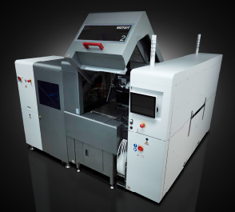 | 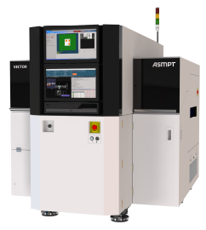
The SIPLACE CA2 revolutionizes the production of SiPs by combining the processing of SMDs and dies directly from the wafer in a single machine with maximum speed and precision.  Image credit: ASMPT | Component tacking with POWER VECTOR: Multi-chip bonding for die sizes from 0.5 mm to 16 mm or even bigger on request.  Image credit: ASMPT

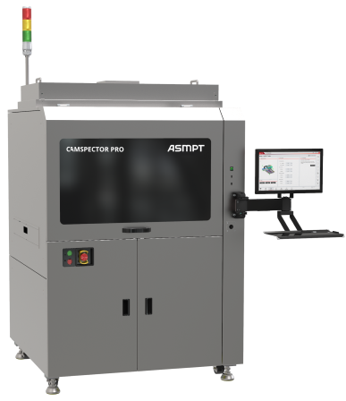
CamSpector Pro is the world’s first sub-micron AOI system combined with a foreign materials (FM) cleaner.

Image credit: ASMPT

About ASMPT Limited (“ASMPT”)
ASMPT (HKEX stock code: 0522) is a leading global supplier of hardware and software solutions for the manufacture of semiconductors and electronics. Headquartered in Singapore, ASMPT’s offerings encompass the semiconductor assembly & packaging, and SMT (surface mount technology) industries, ranging from wafer deposition, to the various solutions that organize, assemble and package delicate electronic components into a vast range of end-user devices, which include electronics, mobile communications, computing, automotive, industrial and LED (displays). ASMPT partners with customers very closely, with continuous investment in R&D helping to provide cost-effective, industry-shaping solutions that achieve higher productivity, greater reliability, and enhanced quality.
ASMPT is one of the constituent stocks of the Hang Seng Composite MidCap Index under the Hang Seng Composite Size Indexes, the Hang Seng Composite Information Technology Industry Index under Hang Seng Composite Industry Indexes and the Hang Seng HK 35 Index.

To learn more about ASMPT, please visit us at asmpt.com.

The ASMPT SMT Solutions segment
The mission of the SMT Solutions segment within ASMPT is to implement and support the Integrated Smart Factory at electronics manufacturers worldwide.
ASMPT solutions support the networking, automation and optimization of central workflows with hardware, software and services that enable electronics manufacturers to transition to the Integrated Smart Factory in stages and enjoy dramatic improvements in productivity, flexibility and quality. With the integrated concept “Open Automation”, ASMPT opens the door for its customers to economically feasible automation, entirely in accordance with their individual requirements - modular, flexible, and vendor-independent.
The product range includes hardware and software such as SIPLACE placement solutions, DEK printing solutions, inspection and storage solutions, and the Smart Shopfloor Management Suite WORKS. With WORKS, ASMPT offers electronics manufacturers high-quality software for planning, controlling, analyzing and optimizing all processes on the shop floor.
Since maintaining close relationships with customers and partners is a central component of ASMPT’s strategy, the company has established the SMT Smart Network as a global forum for the active exchange of information between and with smart champions.

For more information about ASMPT SMT Solutions visit smt.asmpt.com.

Media contacts:
ASMPT ROA Press Office
SMT Solutions
ASMPT SMT Singapore Pte. Ltd.
Janet Loh
Tel.: +65 6877 3948
E-mail: Janet.loh@asmpt.com
Website: smt.asmpt.com

Global ASMPT Press Office
ASMPT GmbH & Co. KG
Susanne Oswald
Rupert-Mayer-Str. 48
81379 Munich
Germany
Tel: +49 89 20800-26439
E-mail: susanne.oswald@asmpt.com
Website: wwwasmpt.com

