FOR THE MEDIA
WORKS Material Demand Calculation from ASMPT
Dynamic material flow planning for SMT production
Shanghai (China), January 30, 2023 – While many processes are already automated and run quite smoothly in modern electronics factories, the flow of materials is still an exception in many cases and causes unnecessarily high costs. The initial plans and the actual needs on the line often diverge because of static material requirements planning. This leads either to material bottlenecks during production runs and ultimately to line stops or to the preventive accumulation of space-wasting “emergency stocks” directly at the SMT line. A new application in the WORKS smart shopfloor management suite from market and technology leader ASMPT effectively counteracts this. WORKS Material Demand Calculation dynamically calculates the material requirements for definable time intervals taking all incidents into account and continuously adjusts the material requirements. The goal is to always have the right material available at the right time in the right quantity in the right place and to create maximum transparency in warehouses and around the lines.
Always up to date
Many electronics manufacturers still calculate their material requirements in static processes prior to the start of production and use the results for the entire production cycle. Too tightly calculated material supplies or unexpected events can quickly lead to expensive line downtime. If the calculations include overly large buffers, however, materials may back up at the line WORKS Material Demand Calculation (MDC) continuously analyses material consumption, cycle times and production progress and combines this data. In this way, it continuously computes actual material requirements and updates them dynamically.
Since no two factories are alike, the time intervals for the material requirements calculations can be defined individually. WORKS Material Demand Calculation thus turns rigid material planning and supply into a time-based and flexible closed-loop control system that dynamically computes even non-linear material consumption during setups and teardowns and compensates for disturbances such as increased scrap or non-scheduled maintenance cycles. “This new solution optimally complements our proven applications in the WORKS smart shop floor management suite for the the ‘Logistics’ workflow. It enables us to offer our customers unprecedented added value by providing them a basis for their comprehensively automated material supply that is always adapted to current conditions,” says Erwin Beck, Head of Product Management Automation Solutions at ASMPT.
Valuable space on the shop floor
Like unscheduled line downtimes, unnecessary manual activities or travel times between lines and warehouses, wasted space on the shop floor is a disruptive factor that drives up costs. If “emergency stocks” no longer need to be stored at the line, the freed-up space can be used much more effectively for productive machines, special equipment or autonomous transport systems (AIVs).
Seamlessly integrated into ASMPT’s Open Automation concept
“Like all the applications in our WORKS suite, the Material Demand Calculation fits seamlessly into our modular Open Automation concept and paves the way for electronics manufacturers to implement their Integrated Smart Factory in stages,” says Erwin Beck. WORKS Material Demand Calculation completely eliminates manual reordering processes and thus makes an important contribution to the automation and optimization of internal logistics. AIV fleets can now take over the material supply completely and independently, whether according to the milk-run principle, with dedicated deliveries, or according to other criteria. In addition, employees get relief from unnecessary trips and are notified and instructed automatically and just in time regarding new material supply requests by WORKS Command Center – via smartphone, tablet, or smartwatch.
WORKS Material Demand Calculation in the ‘Facts on Open Automation’ livestream
WORKS Material Demand Calculation is also a topic in our ‘Facts on Open Automation’ livestream on February 22, 2023, in which everything revolves around perfection in material management.
This ASMPT show format offers viewers each month a roughly half-hour English-language livestream around ASMPT’s Open Automation concept with live feeds from international SMT hot-spots, interviews with experts, practical examples from SMT productions, and much more.
More information about the ‘Facts on Open Automation’ series of livestreams is available at https://facts-on-open-automation.smt.asmpt.events/.

Illustrations for downloading
The following print-ready artwork is available on the internet for downloading:
https://kk.htcm.de/press-releases/asmpt/

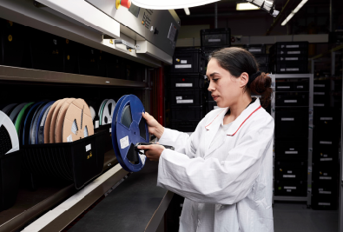 | 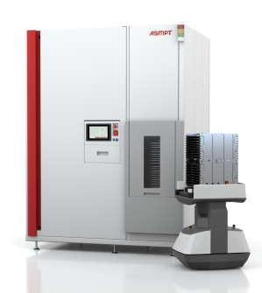
No more overly tight or excessively generous material calculations – WORKS Material Demand Calculation computes your material requirements dynamically and continuously.  Image credit: ASMPT | WORKS Material Demand Calculation optimizes your internal logistics and paves the way for timely material supplies via AIV solutions.  Image credit: ASMPT

 | 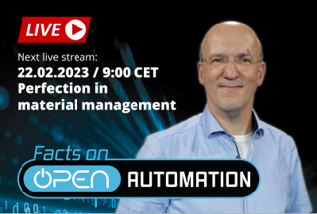
WORKS Command Center notifies employees about material supply requests automatically and just in time via their mobile devices.  Image credit: ASMPT | The first installment of the “Facts on Open Automation” livestreams in 2023 is all about perfect materials management.  Image credit: ASMPT

About ASMPT Limited (“ASMPT”)
ASMPT (HKEX stock code: 0522) is a leading global supplier of hardware and software solutions for the manufacture of semiconductors and electronics. Headquartered in Singapore, ASMPT’s offerings encompass the semiconductor assembly & packaging, and SMT (surface mount technology) industries, ranging from wafer deposition, to the various solutions that organise, assemble and package delicate electronic components into a vast range of end-user devices, which include electronics, mobile communications, computing, automotive, industrial and LED (displays). ASMPT partners with customers very closely, with continuous investment in R&D helping to provide cost-effective, industry-shaping solutions that achieve higher productivity, greater reliability and enhanced quality.
ASMPT is one of the constituent stocks of the Hang Seng Composite MidCap Index under the Hang Seng Composite Size Indexes, the Hang Seng Composite Information Technology Industry Index under Hang Seng Composite Industry Indexes and the Hang Seng HK 35 Index.

To learn more about ASMPT, please visit us at asmpt.com.

The ASMPT SMT Solutions segment
The mission of the SMT Solutions segment within ASMPT is to implement and support the Integrated Smart Factory at electronics manufacturers worldwide.
ASMPT solutions support the networking, automation and optimization of central workflows with hardware, software and services that enable electronics manufacturers to transition to the Integrated Smart Factory in stages and enjoy dramatic improvements in productivity, flexibility and quality. With the integrated concept "Open Automation", ASMPT opens the door for its customers to economically feasible automation, entirely in accordance with their individual requirements - modular, flexible, and vendor-independent.
The product range includes hardware and software such as SIPLACE placement solutions, DEK printing solutions, inspection and storage solutions, and the Smart Shopfloor Management Suite WORKS. With WORKS, ASMPT offers electronics manufacturers high-quality software for planning, controlling, analyzing and optimizing all processes on the Shopfloor.
Since maintaining close relationships with customers and partners is a central component of ASMPT’s strategy, the company has established the SMT Smart Network as a global forum for the active exchange of information between and with smart champions.

For more information about ASMPT SMT Solutions visit smt.asmpt.com.

Media contacts:
China ASMPT Press Office
SMT Solutions
Guan Jing
Tel.: +86 (755) 26934550-2109
E-mail: jing.guan@asmpt.com
Website: smt.asmpt.com

Global ASMPT Press Office
ASMPT GmbH & Co. KG
Susanne Oswald
Rupert-Mayer-Strasse 48
81379 Munich
Germany
Tel: +49 89 20800-26439
E-mail: susanne.oswald@asmpt.com
Website: smt.asmpt.com

