PRESS RELEASE
OPEN MIND Releases hyperMILL® 2023
Load faster, calculate faster and create backbores
Wessling (Germany), January 10, 2023 – The shift to hyperMILL® Release 2023 makes the CAD/CAM suite from OPEN MIND Technologies AG even more powerful and introduces innovative functions. Not only does the software load faster, but the calculation time of tool paths was able to be accelerated as well. In addition, the “General Transformation Pattern” function assures that you save time when machining recurring geometries. The new back boring machining strategy attains the highest degree of convenience and safety via its use of VIRTUAL Machining technology.
OPEN MIND has equipped hyperMILL® 2023 with a machining strategy for back boring. Programming the controller for the tools used to deburr and mill a countersink on the inaccessible back side of a hole can now be done with incredible ease. Because collision control is carried out using a 3D model of the tool in the virtual machine, damage created when inserting and retracting tools is safely avoided.
Automatically transform any function
Up to now, standard features such as pockets and holes were able to be selected automatically. With the “General Transformation Pattern” function, OPEN MIND now makes it possible to select any reference geometry and search for that same reference in all other models – regardless of its spatial orientation. This creates a general transformation pattern including a frame at each reference feature. This makes it easy to program recurring shapes with a single click. The function is also suitable for multiple setups, for example.
5-axis strategy for more uniform surfaces
The “5-axis halfpipe finishing” strategy makes it incredibly convenient to program continuous toolpaths for grooves, tubes, and halfpipes with any cross-section along an arched guide curve. This is a great advantage for users, as previously, this machining operation may have had to be divided into several steps. This strategy opens a wide range of applications, for example, in molds and dies where the tool axis points in the demolding direction.
CAM in dialog
The example of back boring and its collision control based on a digital twin shows how hyperMILL® VIRTUAL Machining is already playing a role in standard functions. Simulation technology based on real NC and machine data is becoming increasingly more important. OPEN MIND is driving the necessary communication between CAM system and machine controller forward. Currently hyperMILL® VIRTUAL Machining supports controllers from HEIDENHAIN, SIEMENS, Mazak, FANUC, FIDIA, OKUMA, rödersTEC, D.ELECTRON, HURCO, and Haas. Others are to follow.
CAD, CAM and data
hyperMILL® 2023 not only leverages advances in computing power and software engineering to increase performance, but it also streamlines processes. For example, the hyperMILL® SIMULATION Center loads faster because it does not include unnecessary data for the calculation at hand. The optimized handling of data also proves to be an improvement in another area. hyperMILL® now makes it possible to import individual components from assemblies. Users can now use filters to select individual components when importing assemblies from other design systems’ native data. This reduces loading times for large assemblies and eliminates the need to subsequently delete individual parts that are not required.
Another new feature in hyperCAD®-ShyperCAD-S, the CAD part of the software suite tailored to CAM programmers’ needs, is the revision of the “Holes” function. A hole can be composed and parameterized from a library of hole fits, countersinks, and hole ends via a dialog, which includes a preview. To improve graphic clarity, threads can also be displayed if required.

Available images
The following images are available for download in printable format at:
https://kk.htcm.de/press-releases/open-mind/
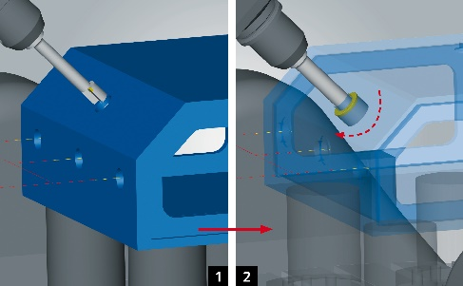  Source: OPEN MIND  2.5D back boring: Collisions when inserting and retracting tools are reliably avoided. | 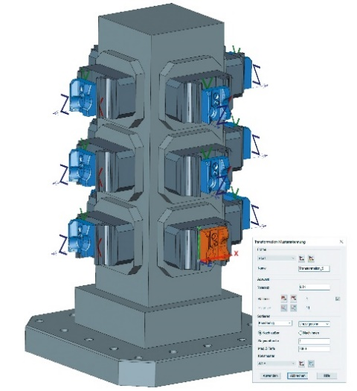  Source: OPEN MIND  The new “General Transformation Pattern” feature makes it easy to program recurring shapes with a single click.
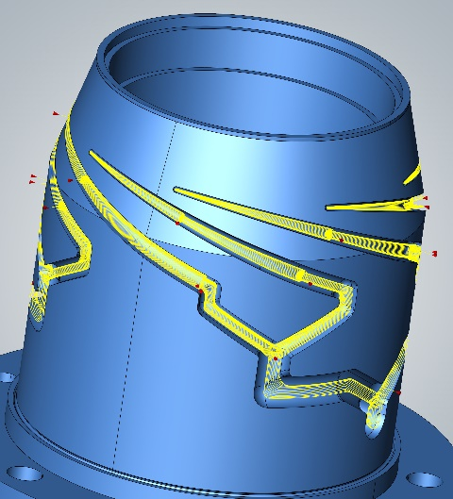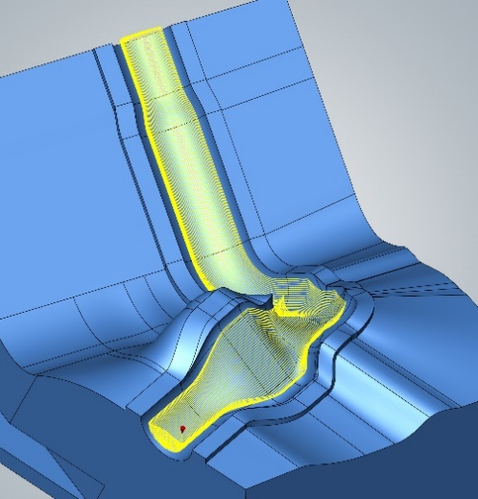

Source: OPEN MIND

Convenient programming of continuous tool paths for grooves, tubes, and half pipes with any cross-section.

Available videos
You can find the following videos on our YouTube channel:
https://youtu.be/sgjZFmleU88
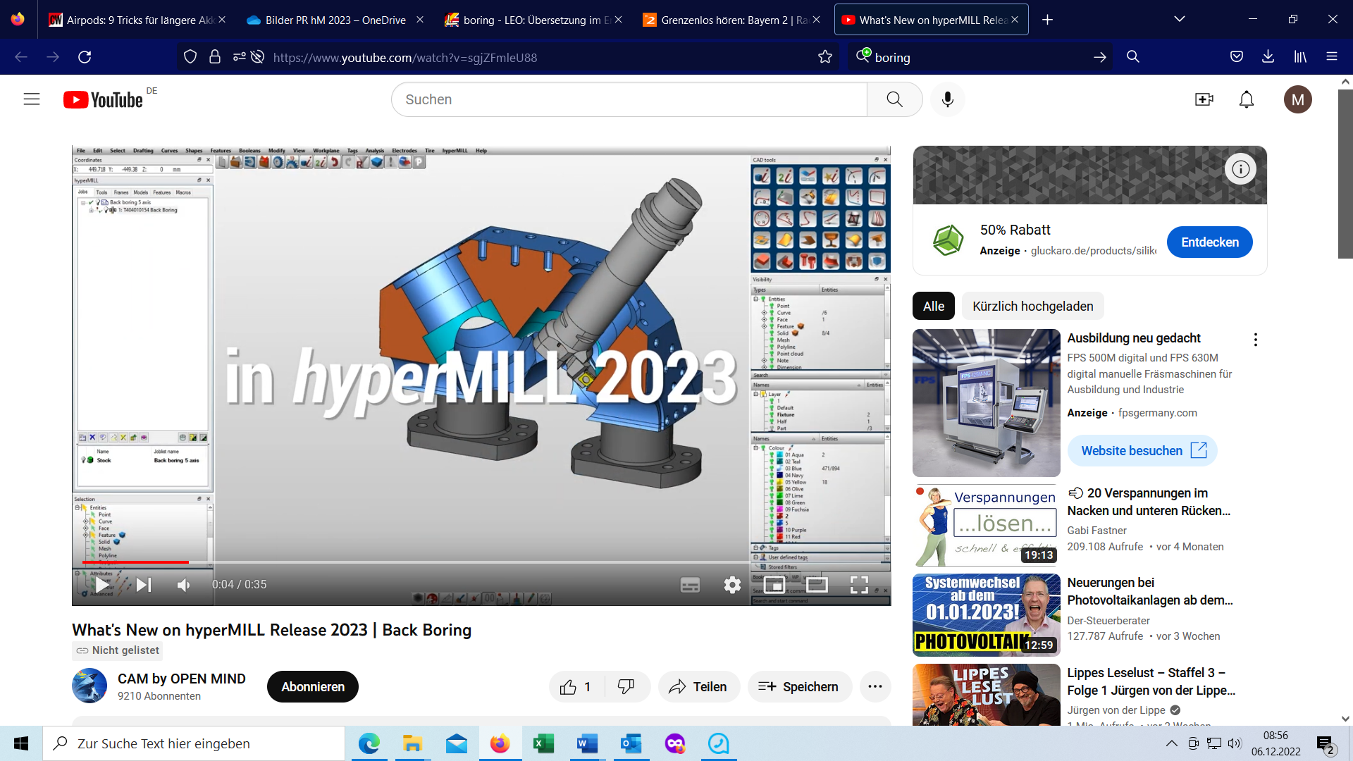
Source: OPEN MIND

Simple and reliable programming for 2.5D back boring.

About OPEN MIND Technologies AG
OPEN MIND is one of the world’s most sought-after developers of powerful CAM solutions for machine and controller-independent programming.
OPEN MIND develops optimized CAM solutions that include a high number of innovative features not available elsewhere to deliver significantly higher performance in both programming and machining. Strategies such as 2.5D, 3D as well as 5-axis milling/mill turning, and machining operations like HSC and HPC are efficiently built into the hyperMILL® CAM system. hyperMILL® provides the maximum possible benefits to customers thanks to its full compatibility with all current CAD solutions and extensive programming automation.
OPEN MIND strives to be the best and most innovative CAD/CAM manufacturer in the world, helping it become one of the top five in the CAM industry according to the “NC Market Analysis Report 2022” compiled by CIMdata. The CAD/CAM solutions of OPEN MIND fulfil the highest demands in the automotive, tool and mold manufacturing, production machining, medical, job shops, energy and aerospace industries. OPEN MIND is represented in all key markets in Asia, Europe and America, and is a Mensch und Maschine company.

You can find more information at www.openmind-tech.com.

OPEN MIND Technologies UK Ltd., Oxford
Unit 3
Bicester Business Park
Telford Road
Bicester
Oxfordshire OX26 4LN
England
Phone: +44 1869 290 003
Fax: +44 1869 369 429
E-mail: Info.UK@openmind-tech.com

OPEN MIND Technologies USA, Inc.
1492 Highland Avenue, Unit 3
Needham MA 02492
USA
Phone: +1 339 225 4557 office
Phone: +1 888 516 1232 x0 toll-free
Fax: +1 270 912 5822
E-mail: Info.Americas@openmind-tech.com

Head office:
OPEN MIND Technologies AG, Argelsrieder Feld 5, 82234 Wessling, Germany
Tel.: (+49-8153) 933-500, Fax: (+49-8153) 933-501
E-mail: Info@openmind-tech.com, website: www.openmind-tech.com

Press contact:
HighTech communications GmbH
Brigitte Basilio
Brunhamstrasse 21
81249 Munich
Germany
Tel.: (+49-89) 500778-20
Fax: (+49-89) 500778-78
E-mail: b.basilio@htcm.de
Website: www.htcm.de

