PRESS RELEASE

Würth Elektronik partners with student-run, fighting robot team
Build the best. Destroy the rest.
Watertown (USA), December 6, 2022—Würth Elektronik is pleased to announce that it will be a major sponsor of Team Uairrior and their fighting robot, Black Dragon, as they compete in the BattleBots Season 7 Tournament on The Discovery Channel in January 2023.
Würth Elektronik, a global electronic and electromachnical manufacturer, is excited to be part of the action where real robotics education and knowledge is put to the test. With robots becoming more prevalent in everyday living, this sponsorship offers real access to the industry.
“When we decided to partner with a fighting robot team, we knew we wanted Team Uairrior. Our focus on students and engineering education made this student-run team the perfect fit. They have the a lot of spirit, positive attitude, and a great reputation,“ says Melissa Hansen, Customer Outreach Specialist on the Marketing Department at Würth Elektronik. „We’ve received a lot of support, not only from our colleagues who are super excited to sponsor a BattleBot, but we even had people cheer on Black Dragon when we walked down the road in Las Vegas!“
Black Dragon, the 250 pound fighting robot with an egg beater spinner as a weapon, made it’s televised debut in 2019; taking home the championship trophy of the competition.
But Wait, There’s More!
Black Dragon is not the only robot to don the Würth Elektronik name in 2022 / 2023. In total, 28 fighting robots will be emblazoned with the electronic manufacturing giants‘ logo, along with multiple autonomous robots that compete in both the Sumo and the Follow Line categories. Team Uairrior has a fighting robot for all weight divisions, including bot Kowalski, the current champion in the Fairyweight (150 grams or 0.3 lbs.) division; bot Bacon, current champion in the Antweight (454 grams or 1 lbs.) division; Federal, world champion in the Lightweight (27.7 kilo or 60 lbs.) division; and General, world champion in the Middleweight (54.4 kilo or 120 lbs.) division.
This is not the first time Würth Elektronik has been on the fighting robot circuit. In 2017, they sponsored the AVC SparkFun robotics competition at Maker Faire in Denver, Colorado.
Along with a financial sponsorship, Würth Elektronik offers technical assistance to the team through their expert engineering staff, and free samples delivered upon request.

Available images
The following images can be downloaded from the Internet in printable quality: https://kk.htcm.de/press-releases/wuerth/
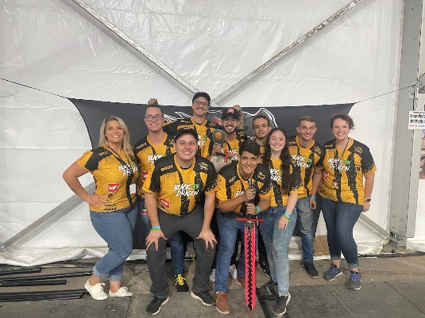  Image source: Wurth Electronics  The Team of Fighting Robot Black Dragon supported by Würth Elektronik: Along with a financial sponsorship, Würth Elektronik offers technical assistance | 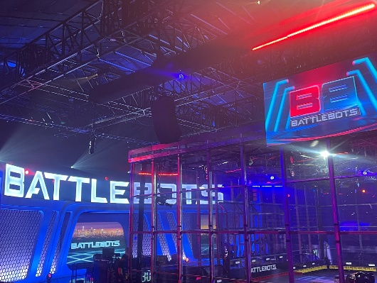  Image source: Wurth Electronics  Let’s ready to rumble: 28 fighting robots will be emblazoned with the Würth Elektronik logo

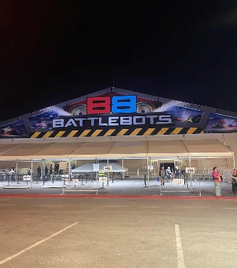
Image source: Wurth Electronics
The arena for the BattleBots Season 7 Tournament and Team Uairrior: “They have the a lot of spirit, positive attitude, and a great reputation.”

About the Würth Elektronik eiSos Group
Würth Elektronik eiSos Group is a manufacturer of electronic and electromechanical components for the electronics industry and a technology company that spearheads pioneering electronic solutions. Würth Elektronik eiSos is one of the largest European manufacturers of passive components and is active in 50 countries. Production sites in Europe, Asia and North America supply a growing number of customers worldwide.
The product range includes EMC components, inductors, transformers, RF components, varistors, capacitors, resistors, quartz crystals, oscillators, power modules, Wireless Power Transfer, LEDs, sensors, connectors, power supply elements, switches, push-buttons, connection technology, fuse holders and solutions for wireless data transmission.
The unrivaled service orientation of the company is characterized by the availability of all catalog components from stock without minimum order quantity, free samples and extensive support through technical sales staff and selection tools.
Würth Elektronik is part of the Würth Group, the world market leader for assembly and fastening technology. The company employs 8,000 staff and generated sales of 1.09 Billion Euro in 2021.
Würth Elektronik: more than you expect!
Further information at www.we-online.com

Further information:  Wurth Electronics Midcom, Inc.  Amelia Thompson  121 Airport Drive  PO Box 1330  Watertown, SD 57201 USA  Phone: +1 605 886 4385  Toll-free (in the U.S.):  Phone: +1 800 643 2661  E-mail: amelia.thompson@we-online.com  www.we-online.com | Press contact:  HighTech communications GmbH  Brigitte Basilio  Brunhamstrasse 21  81249 Munich  Germany  Phone: +49 89 500778-20  Fax: +49 89 500778-77  E-mail: b.basilio@htcm.de  www.htcm.de

