PRESS RELEASE
OPEN MIND presents the new function in its CAD/CAM suite
hyperMILL®: Precision for Tool and Mold Making
Wessling (Germany), November 16, 2022 – The hyperMILL® CAD/CAM suite from OPEN MIND is a highly regarded end-to-end complete solution in the mold and die industry, as it also covers aspects such as electrode manufacturing and wire EDM. It is now the introduction of the function – 5-axis radial machining – to take center stage. This function is especially suitable for the process-optimized production of round molds with surfaces that require zero post-processing, such as in blow molds. In bumper production, high surface qualities are achieved by using high-precision machining technology.
The rise in complexity of bottle designs is also increasing the quality expectations put on blow molds. There is a wide variety of containers that often have additional features that double up as functional elements. This can include handles, decorations, and individual brand logos. The 3-axis machining of these types of molds sometimes requires very long tools and part reclamping to mill undercut areas. A 3-axis approach also means that the point where the milling tool makes contact with the semicircular profile varies, which can result in uneven surfaces. This is where optimized 5-axis strategies can help.
Even surfaces and sharp edges
The improvements to the current version of hyperMILL® combined with 5-axis radial machining are setting standards in blow mold machining. Thanks to a new, radial projection method, the toolpaths are calculated extremely quickly, and the user can apply various machining strategies to respond flexibly to the component conditions. The new ‘Flow Equidistant’ infeed strategy is the first of its kind that supports the generation of toolpaths with a constant infeed for vertical and challenging surfaces. This means these surfaces can be integrated into the overall machining sequence and processed in a single step. Seamless machining with a very high surface quality is guaranteed. Every machining sequence needs to produce sharp corners at the junction of the upper and lower halves of the mold to avoid problems during the molding process. An automatic tangent extension feature eliminates the manual CAD steps needed to extend the numerous surface elements found in complex designs.
Bumper segments with a high level of surface quality
hyperMILL® high-precision machining technologies are also used in the tool and mold making to manufacture bumper segments, for example. The highly superior quality of the components’ surface is achieved using ball and barrel cutters. Two CAM technologies ensure that the various tools and positions during machining are no longer recognizable after the process has been completed. The first of these is the ‘Surface precision mode,’ which calculates the toolpath directly on the surfaces of the CAD model. The machining tolerance can be controlled down to the µm range. The distribution of the NC point is optimally adapted to the machining tolerance, resulting in a homogeneous milling pattern. The second of these is the ‘Smooth overlap’ function, which improves the surface quality of transitional areas, making transitions so smooth that they are hard to measure and almost invisible to the naked eye.
A complete solution for tool and mold making
The new 5-axis radial machining makes hyperMILL® even more important for industries that require high-quality molds, such as the food and beverage, pharmaceutical, cosmetics, household goods and automotive industries. The CAD/CAM suite covers every process from the data import to the NC code simulation – and that includes electrode manufacturing and wire EDM. hyperMILL® offers extensive options to automate the CAM programming process and can be integrated into higher-level systems such as MES or PLM systems.

Available images
The following images are available for download in printable format at:
https://kk.htcm.de/press-releases/open-mind/

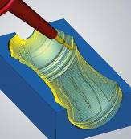  Source: OPEN MIND  A highly efficient strategy for blow-mold manufacturing: 5-axis radial machining | 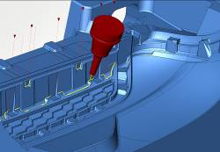Source: OPEN MIND  hyperMILL® rest material machining: perfect transitions for a bumper mold

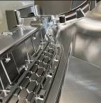  Source: OPEN MIND  hyperMILL® high-precision machining technologies make extremely high surface qualities achievable | 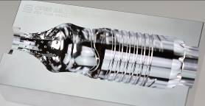  Source: OPEN MIND  Blow-bottle molds: high-gloss surfaces and perfectly smooth transitions thanks to hyperMILL®

Available videos
You can find the following videos on our YouTube channel:
https://youtu.be/F5lBGfmowHg
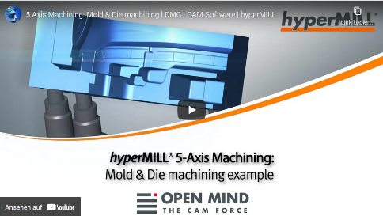

Source: OPEN MIND

High-precision machining of a bumper segment

About OPEN MIND Technologies AG
OPEN MIND is one of the world’s most sought-after developers of powerful CAM solutions for machine and controller-independent programming.
OPEN MIND develops optimized CAM solutions that include a high number of innovative features not available elsewhere to deliver significantly higher performance in both programming and machining. Strategies such as 2.5D, 3D as well as 5-axis milling/mill turning, and machining operations like HSC and HPC are efficiently built into the hyperMILL® CAM system. hyperMILL® provides the maximum possible benefits to customers thanks to its full compatibility with all current CAD solutions and extensive programming automation.
OPEN MIND strives to be the best and most innovative CAD/CAM manufacturer in the world, helping it become one of the top five in the CAM industry according to the “NC Market Analysis Report 2022” compiled by CIMdata. The CAD/CAM solutions of OPEN MIND fulfil the highest demands in the automotive, tool and mold manufacturing, production machining, medical, job shops, energy and aerospace industries. OPEN MIND is represented in all key markets in Asia, Europe and America, and is a Mensch und Maschine company.

You can find more information at www.openmind-tech.com.

OPEN MIND Technologies UK Ltd., Oxford
Unit 3
Bicester Business Park
Telford Road
Bicester
Oxfordshire OX26 4LN
England
Phone: +44 1869 290 003
Fax: +44 1869 369 429
E-mail: Info.UK@openmind-tech.com

OPEN MIND Technologies USA, Inc.
1492 Highland Avenue, Unit 3
Needham MA 02492
USA
Phone: +1 339 225 4557 office
Phone: +1 888 516 1232 x0 toll-free
Fax: +1 270 912 5822
E-mail: Info.Americas@openmind-tech.com

Head office:
OPEN MIND Technologies AG, Argelsrieder Feld 5, 82234 Wessling, Germany
Tel.: (+49-8153) 933-500, Fax: (+49-8153) 933-501
E-mail: Info@openmind-tech.com, website: www.openmind-tech.com

Press contact:
HighTech communications GmbH
Brigitte Basilio
Brunhamstrasse 21
81249 Munich
Germany
Tel.: (+49-89) 500778-20
Fax: (+49-89) 500778-78
E-mail: b.basilio@htcm.de
Website: www.htcm.de

