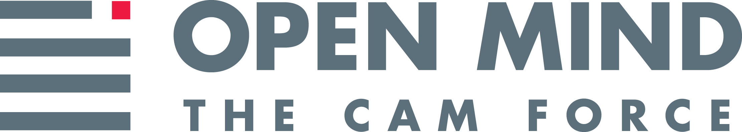

NEWS RELEASE

For Release: IMMEDIATELY With Art: Digital Image

Editorial Michael McCue OPEN MIND Alan Levine
Contact: McCue & Associates LLC Contact: OPEN MIND Technologies USA, Inc.
978-733-1353 339-225-4557 mmccue@mccueassociates.com alan.levine@openmind-tech.com

OPEN MIND to Highlight Advanced hyperMILL®
CAD/CAM Software Suite at MD&M West 2022

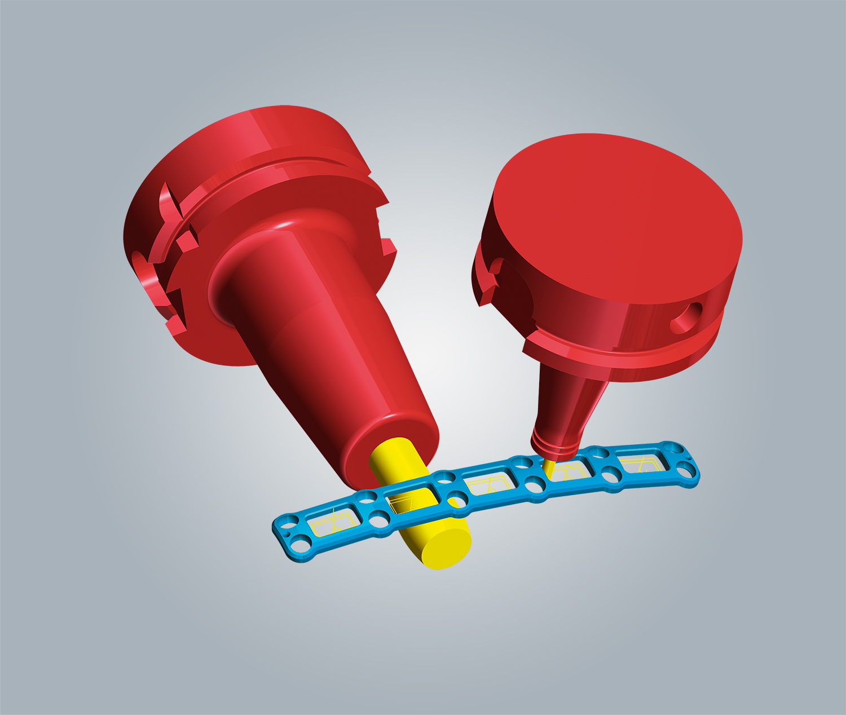
NEEDHAM, MA U.S.A. (January 31, 2022) – OPEN MIND Technologies, a leading developer of CAD/CAM software solutions worldwide, has announced it will be featuring its hyperMILL® CAD/CAM software suite at MD&M West - Booth #2977, at the Anaheim Convention Center, CA from April 12-14, 2022. hyperMILL® offers medical manufacturers powerful NC programming in applications for 2.5D, 3D and 5-axis machining in prototype and production manufacturing, especially when maximum speed, precision and flexibility are critical.
hyperMILL® 5-axis swarf cutting is ideal for slightly curved surfaces such as on this bone plate.

MD&M attendees can see hyperMILL® MAXX Machining which offers three powerful modules for roughing, drilling and finish milling often beneficial on complex 5-axis components. hyperMILL® MAXX Machining enables high-performance cutting including in challenging materials such as titanium and stainless steel alloys. Enabling uninterrupted cutting, OPEN MIND will feature hyperMILL® 3D and 5-axis equidistant finishing for machining surfaces with a uniform 3D infeed, resulting in very fine surface finishes when used in combination with high precision surface mode and smooth overlap techniques. These finishing strategies are especially well-suited for high-speed cutting. Also to be highlighted at the show, the hyperMILL® 5-axis swarf cutting and barrel cutter capabilities are ideal for slightly curved surfaces such as those on bone plates. This functionality significantly reduces machining time and optimizes surface finishes.

Parts with similar geometries such as component families and variants, recurring shape elements, features such as holes or pockets and repetitive processes, provide an ideal opportunity to implement automated CAM programming. hyperMILL® automation technology, which helps to reduce programming times, standardize processes, eliminate human error and improve overall throughput will also be demonstrated at the show.

- more -

OPEN MIND will also feature the ADDITIVE Manufacturing capability option in hyperMILL® CAM software to support 3D printing/ additive processes. hyperMILL® with ADDITIVE Manufacturing provides efficient hybrid processing with additive and subtractive processing, including material deposition, on one machine. For highly complex 5-axis simultaneous processing, hyperMILL® ADDITIVE Manufacturing enables an array of flexible options for any Directed Energy Deposition process (DED) such as Wire Arc Additive Manufacturing (WAAM), Laser Powder, Laser Hot-Wire, and Electro-Beam Hot-Wire, and more. hyperMILL® enables users to perfectly program the cladding and milling together. True-to-detail additive and subtractive simulation as well as stock tracking between the individual process steps, guarantee the greatest possible reliability.

More Information about the latest version of hyperMILL®

About OPEN MIND Technologies AG
Headquartered in Wessling, Germany, OPEN MIND is one of the world's leading developers of powerful CAM solutions for machine and controller-independent programming. The company develops optimized CAM solutions that include many innovative features unavailable elsewhere, to deliver significantly higher performance in both programming and machining. Strategies such as 2.5D, 3D, as well as 5-axis milling, mill/ turning, and machining operations like HSC and HPC, are efficiently designed into the hyperMILL® CAM system, providing maximum user benefit and compatibility with all current CAD solutions and extensive programming automation. OPEN MIND strives to be the best, most innovative CAD/ CAM developer in the world, and has earned the top five ranking in the CAD/ CAM industry according to the 2021 NC Market Analysis Report by CIMdata. OPEN MIND CAD/ CAM solutions meet and exceed the requirements of the most demanding industries such as automotive, tool and mold manufacturing, production machining, medical, job shops, energy and aerospace industries, and is represented in all key markets of Asia, Europe and the Americas. OPEN MIND is a Mensch und Maschine Company. http://www.mum.de/ For more information visit https://www.openmind-tech.com/en.html.

# # # # #

