

NEWS RELEASE

For Release: IMMEDIATELY With Art: Two Digital Images

Editorial Michael McCue OPEN MIND Alan Levine
Contact: McCue & Associates LLC Contact: OPEN MIND Technologies USA, Inc.
978-733-1353 339-225-4557 mmccue@mccueassociates.com alan.levine@openmind-tech.com

OPEN MIND To Highlight Advanced hyperMILL® CAD/CAM Software Suite at IMTS

Virtual Machining, Additive Manufacturing, Automation Capabilities, Toolpath Optimization,
Preview of New hyperMILL® 2023.1 and More to be Featured

NEEDHAM, MA U.S.A. (June 10, 2022) – OPEN MIND Technologies, a leading developer of CAD/CAM software solutions worldwide, will be highlighting the advanced capabilities of its latest hyperMILL® CAD/CAM software suite at IMTS Booth #133351 located in the Controls and CAD/CAM Pavilion, East Hall in McCormick Place, Chicago IL from Sept 12- 17, 2022. Efficient programming and machining strategies in high performance hyperMILL® enable accurate, efficient 2.5D, 3D, 5-Axis and mill/turn machining.

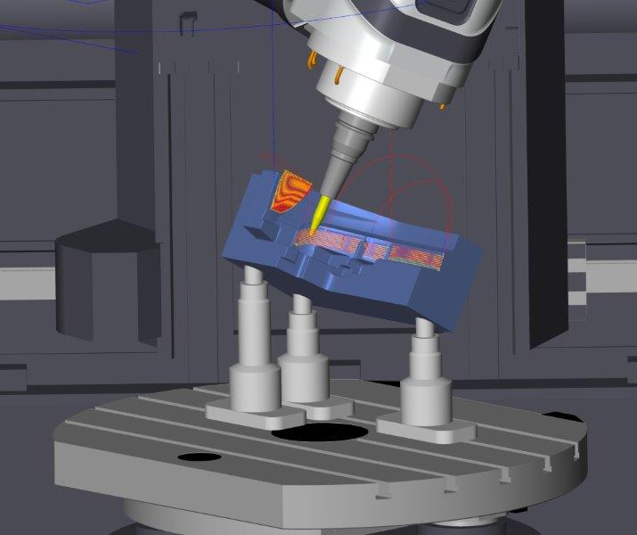
Developed with Industry 4.0 in mind, OPEN MIND will be featuring hyperMILL® VIRTUAL Machining which provides postprocessing, and G-code simulation including a VIRTUAL Machining Optimizer which offers innovative solutions to improve toolpaths that are traditionally calculated in the CAM engine. The Optimizer also incorporates knowledge of the part model, tooling, the toolpath calculation and collision check engine, and the machine tool model with its physical constraints. New, improved linking logic in hyperMILL® VIRTUAL Machining Optimizer for 5-axis table-table machines will be highlighted at IMTS. The VIRTUAL Machining Optimizer module links individual part programs with smooth and safe connections and an "Optimized Table-Table Logic" option automatically calculates smooth connections between a retract move and subsequent insert, including optimization of clearance planes.
hyperMILL® VIRTUAL Machining Optimizer enables individual part programs to be linked with smooth, safe connections.

Attendees can also see a new VIRTUAL Machining capability for Additive Manufacturing processes, where machines often have limited axis ranges. The hyperMILL® VIRTUAL Machining Optimizer can be used during NC code generation to simulate and optimize additive tool paths.

- more -
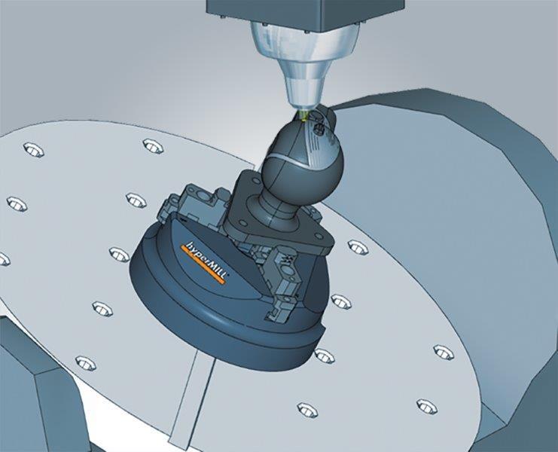
The powerful ADDITIVE Manufacturing process in hyperMILL® CAM software supports both 3D printing/ and subtractive machining on one machine tool. hyperMILL® ADDITIVE Manufacturing technology offers flexible strategies for additive material applications, including filling strategies for both planes and free-form shapes, and in 2D and 3D sections. Applications also include hybrid machining to fix damaged parts and additive machining of an existing component.
hyperMILL® ADDITIVE Manufacturing offers flexible strategies for additive material applications.

A new hyperMILL® Automation Center allows users to automate the job list creation processes in hyperCAD®-S, serving as both a development and runtime environment. New features also include the ability to select and position the clamping device, as well as define a uniform process for all programmers.

Also to be highlighted at IMTS is a new break-edge function for contour milling, combined pocket milling together with a finish path allowing cutter compensation, and increased efficiency for 3D plane machining. The new automated 3D plane machining strategy improves machining quality by searching for suitable, high performance path layouts according to parameters including when adaptive pockets are present. New extensions to the hyperMILL® MILL-TURN capability that enable more streamlined programming, simulation processing and management for machines with main and counter spindle configurations will also be demonstrated.

IMTS attendees can also get a sneak preview of the new version of hyperMILL® 2023.1 that will include more efficient roughing tool path layout capabilities, the next level of surface finish improvements from high precision surface mode, enhancements to hyperMILL® Turning Solutions and additional improvements to the VIRTUAL Machining environment. For more information on OPEN MIND at IMTS, please visit https://bit.ly/3lCSprn.

About OPEN MIND Technologies AG
Headquartered in Wessling, Germany, OPEN MIND is one of the world’s leading developers of powerful CAM solutions for machine and controller-independent programming. The company develops optimized CAM solutions that include many innovative features unavailable elsewhere, to deliver significantly higher performance in both programming and machining. Strategies such as 2.5D, 3D, as well as 5-axis milling, mill/ turning, and machining operations like HSC and HPC, are efficiently designed into the hyperMILL® CAM system, providing maximum user benefit and compatibility with all current CAD solutions and extensive programming automation. OPEN MIND strives to be the best, most innovative CAD/ CAM developer in the world, and has earned the top five ranking in the CAD/ CAM industry according to the 2021. NC Market Analysis Report by CIMdata. OPEN MIND CAD/ CAM solutions meet and exceed the requirements of the most demanding industries such as automotive, tool and mold manufacturing, production machining, medical, job shops, energy and aerospace industries, and is represented in all key markets of Asia, Europe and the Americas. OPEN MIND is a Mensch und Maschine Company. http://www.mum.de/ For more information visit https://www.openmind-tech.com/en.html.

