PRESS RELEASE
Lead-free high-current contacts for PCBs from Würth Elektronik ICS
LF PowerPlus 2.0 – Powerelements of the latest generation
Niedernhall, Germany, 11 October 2022 – Würth Elektronik ICS, inventor of Powerelements for PCB contacting, presents a new generation of its proven, lead-free high-current contacts: the second PowerPlus generation, LF PowerPlus 2.0, has the same properties in terms of torque and current-carrying capacity as the previous version, but it is now even simpler and more efficient in terms of processing and assembly.
With the LF PowerPlus product family, Würth Elektronik ICS offers robust and efficient high-current contacts for PCB contacting in press-fit technology applications. They are ideal for connecting components and cables to the PCB or as fastening elements, especially when high torques are required or little installation space is available.
Lead-free design and high torques
All LF PowerPlus high-current elements consist of a stamped brass base body (CuZn37) and a stainless steel screw element as bolt or bush. The special design of the base body of the LF PowerPlus elements allows population on both sides in the same position, thus delivering a highly compact design. Important: All Powerelements do not contain any lead and are therefore not subject to any time-limited exemption regulation of the RoHS Directive.
The stainless steel screw of the LF PowerPlus Powerelements supports a higher tightening torque than other high-current contacts: from 1.8 Nm with the smallest thread, M4, up to 42 Nm with the largest version, M12. Depending on the layout, the LF PowerPlus high-current contacts can carry currents of up to 400 amperes.
Proven quality and new advantages in assembly
The new LF PowerPlus 2.0 series offers the same mechanical and electrical properties as its predecessor, but is substantially easier to process:
- The new screw tip facilitates easier insertion and positioning of the nut, making automatic screwing effortless.
- The pin or nut is now firmly attached to the element, which increases stability and further facilitates automatic screwing
- The new pin arrangement (symmetrical instead of asymmetrical) facilitates processing.
- An improved pin design reduces the required press-in forces.
- Special press-in tools are no longer required.
LF PowerPlus 2.0 high-current contacts are available in sizes M5, M6 and M8, each as a socket or pin version. Changing over from the old to the new system is very simple: the elements are compatible with the old generation as regards their drilling pattern and height. LF PowerPlus 1.0 is therefore easily interchangeable with LF PowerPlus 2.0. Torque and current-carrying capacity also remain the same.
Designed in proven press-fit technology
Designed as press-fit elements, the new LF PowerPlus 2.0 power supply elements naturally have all the specific advantages of this technology: the PCBs are not exposed to temperature stress when the components are installed. The press-fit process is easy to integrate into the process chain. The press-fit is mechanically very stable and has an extremely low contact resistance of 100–200 μOhm.
The new LF PowerPlus 2.0 series is also available in the Original Powerelement online shop of Würth Elektronik ICS (www.powerelement.de).

Available images
The following images are available for download in printable format at:
https://kk.htcm.de/press-releases/wuerth-ics/
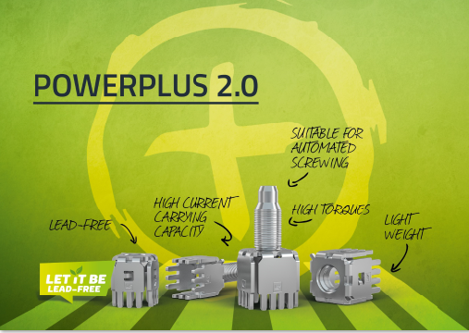
Image source: Würth Elektronik ICS
LF PowerPlus 2.0 – Lead-free high-current contacts in press-fit technology

About Würth Elektronik ICS GmbH & Co. KG
Würth Elektronik ICS is a system supplier for electromechanical and electronic solutions for signal and electricity distribution, controlling functions and display and operating solutions. Its main customers include well-known manufacturers of construction and agricultural machinery, as well as commercial vehicles. Sectors such as industrial technology or renewable energies also benefit from products and services provided by ICS. Its company headquarters are located in Niedernhall-Waldzimmern, Germany. There are subsidiaries of the company in France, Italy, the UK, the US and India.
As a member of the Würth Elektronik group of companies, the company belongs to the Würth Group, the world market leader for assembly and fastening technology. In 2021, the 8,000 employees of the Würth Elektronik group of companies generated sales of €1.09 billion.
Würth Elektronik: more than you expect!

Further information:  Würth Elektronik ICS GmbH & Co. KG  Sandra Herter  Gewerbepark Waldzimmern  Würthstrasse 1  74676 Niedernhall, Germany  Tel.: (+49-7940) 9810-1503  E-mail: sandra.herter@we-online.de  www.we-online.de/ics | Press contact:  HighTech communications GmbH  Christian Resch  Brunhamstrasse 21  81249 Munich, Germany  Tel.: (+49-89) 5007-7823  Fax: (+49-89) 5007-7877  E-mail: c.resch@htcm.de  www.htcm.de/en/

