FOR THE MEDIA
Two-day customer event focused on Industry 4.0 Open Automation solutions
ASMPT and SMarTsol celebrate grand opening of new training facility in Querétaro, Mexico
Suwanee, GA (USA), September 07, 2022 – ASMPT and its partner SMarTsol Technologies today announced the official grand opening SMarTsol’s training facility in the Mexican state of Querétaro, which is becoming an increasingly influential region for electronics manufacturing. To mark the milestone, ASMPT and SMarTsol welcomed over 50 attendees representing several local electronics companies for a two-day event dedicated to ASMPT technology.
The program began with a presentation about Open Automation and the factory efficiency and quality benefits of ASMPT’s open communication protocols. Following this introduction, customers and future customers were divided among four rotational demonstrations for in-depth learning and discussions about specific ASMPT technologies and their role in enabling Open Automation. These included the SIPLACE TX placement platform with WORKS Command Center operator guidance tools; DEK TQ high-speed, high-accuracy screen printer, which maximizes operating time with minimal required assists; Factory Equipment Center for modular, scalable maintenance and management of all factory equipment, independent of supplier; and, ASMPT Academy learning platform that delivers a learn-as-you-like approach with interactive online, instructor-led and 3D virtual reality options.
ASMPT’s Americas Marketing Manager, Mark Ogden, who participated in the event, commented on the importance of this resource: “As major electronics OEMs, particularly in the automotive sector, have established a notable presence in Querétaro to serve the Americas markets, training facilities like SMarTsol’s are critical. ASMPT has a long and established commitment to the Mexican electronics industry, and our investment in Querétaro alongside our partner, SMarTsol, is the natural progression of our promise to serve customers locally to enable manufacturing success.”
High demand for Smart Factory training
According to ASMPT and SMarTsol staff, the response to the facility grand opening and two-day ASMPT instructional overview was overwhelmingly positive. Many attendees commented that this program was the first of its kind in the region, allowing them to dive deep into the benefits of ASMPT equipment and software, and understand more about SMarTsol’s comprehensive sales, support and training expertise.
“We have been serving the electronics sector in Mexico for over ten years,” said Ivan Romo, SMarTsol General Manager. “Our Querétaro distribution, demonstration and training center joins six other Mexico-based SMarTsol locations to support high-tech customers with differentiated service from a team with an average of 25 years of experience. Clearly, this expertise resonated with our attendees, as the appetite for local, in-depth training was evident.”
Following the launch of last month’s ASMPT training, classes at SMarTsol’s Querétaro facility for September, October and November are already filling up. Please contact your local ASM or SMarTsol sales representative for more details.

Illustrations for downloading
The following images are available for download in printable format at:
http://www.htcm.de/kk/asm

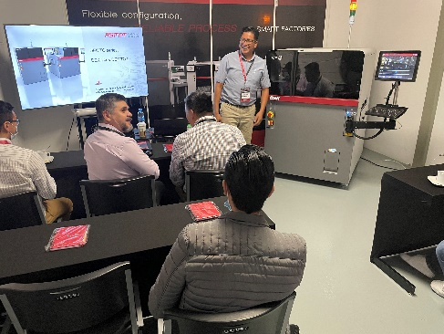 | 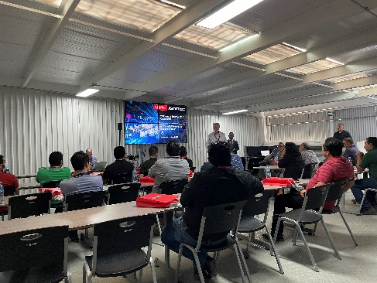
ASMPT Applications Engineer Filemon Villanueva demonstrates the latest DEK TQ high speed screen printer.  Source: ASMPT | AMPT’s Latin America Sales Manager, Gary Burroughs, welcomes attendees to the new SMarTsol facility.  Source: ASMPT

About ASMPT Limited (“ASMPT”)
ASMPT (HKEX stock code: 0522) is a leading global supplier of hardware and software solutions for the manufacture of semiconductors and electronics. Headquartered in Singapore, ASMPT’s offerings encompass the semiconductor assembly & packaging, and SMT (surface mount technology) industries, ranging from wafer deposition, to the various solutions that organise, assemble and package delicate electronic components into a vast range of end-user devices, which include electronics, mobile communications, computing, automotive, industrial and LED (displays). ASMPT partners with customers very closely, with continuous investment in R&D helping to provide cost-effective, industry-shaping solutions that achieve higher productivity, greater reliability and enhanced quality.
ASMPT is one of the constituent stocks of the Hang Seng Composite MidCap Index under the Hang Seng Composite Size Indexes, the Hang Seng Composite Information Technology Industry Index under Hang Seng Composite Industry Indexes and the Hang Seng HK 35 Index.

To learn more about ASMPT, please visit us at asmpt.com.

The ASMPT SMT Solutions segment
The mission of the SMT Solutions segment within ASMPT is to implement and support the Integrated Smart Factory at electronics manufacturers worldwide.
ASM solutions support the networking, automation and optimization of central workflows with hardware, software and services that enable electronics manufacturers to transition to the Integrated Smart Factory in stages and enjoy dramatic improvements in productivity, flexibility and quality. With the integrated concept "Open Automation", ASM opens the door for its customers to economically feasible automation, entirely in accordance with their individual requirements - modular, flexible, and vendor-independent.
The product range includes hardware and software such as SIPLACE placement solutions, DEK printing solutions, inspection and storage solutions, and the Smart Shopfloor Management Suite Works. With Works, ASMPT offers electronics manufacturers high-quality software for planning, controlling, analyzing and optimizing all processes on the Shopfloor.
Since maintaining close relationships with customers and partners is a central component of ASMPT’s strategy, the company has established the SMT Smart Network as a global forum for the active exchange of information between and with smart champions.

For more information about ASMPT visit smt.asmpt.com.

Media contacts:
AMCAS ASMPT Press Office
SMT Solutions
Mark Ogden
Tel.: +1 (770) 797 3189
E-mail: ogden.mark@asmpt.com
Website: smt.asmpt.com

Global ASMPT Press Office
ASM Assembly Systems GmbH & Co. KG
Susanne Oswald
Rupert-Mayer-Strasse 44
81379 Munich
Germany
Tel: +49 89 20800-26439
E-Mail: susanne.oswald@asmpt.com
Website: smt.asmpt.com

