MEDIA INFORMATION

Mini Smart Warehouse
Modular storage system from cts now also available in compact version
Burgkirchen, 25 August 2022 – Intralogistics and automation specialist cts GmbH is now launching its successful Smart In-Production Warehouse for the electronics and automotive industries in compact form. The flexible and automated Mini Smart Warehouse is suitable for capacities from 80 to 280 PCB magazines and can now even be used in clean rooms. The new system uses the same state-of-the-art technologies as the established solution.
If you are looking for an intelligent and space-saving storage system for printed circuit boards, you will find the right solution at cts since 2020: In the cts Smart In-Production Warehouse, PCB magazines or, with modifications, standardized small load carriers (KLT boxes) can be temporarily stored near production lines. The automated, compact warehouse thus saves space and transport distances. If desired, storage and retrieval can also be fully automated.
„Many customers asked for a smaller variant in the range well below 400 units," says Philipp Eberherr, Head of Smart Logistics at cts GmbH. "With the Mini Smart Warehouse, we now have a suitable solution in a very compact design in our portfolio."
Small, smart, individual
With a narrow footprint of only four to five meters edge length, the standard version of the new Mini Smart Warehouse already offers space for 80 to 200 units. It can be expanded to a maximum of 280 rack locations. As with the large version, the Mini Smart Warehouse can be customized according to customer requirements. An automated gripping system inside is controlled by intelligent algorithms to ensure the most efficient retrieval and storage possible.
The I/O port of the Mini Smart Warehouse can be supplied or disposed of with material either manually or fully automatically by autonomous vehicles (AMRs - Autonomous Mobile Robots). State-of-the-art software makes flexible integration into the production process possible and offers maximum traceability. With this combination of warehouse and AMR systems, cts provides an integrated, flexible and fully networked solution for effective transport and storage of PCB magazines and KLT boxes.
Another advantage: Compared to the large version, the Mini Smart Warehouse makes far fewer demands on the surface, which increases the area of application and reduces the installation effort. This makes the Mini Smart Warehouse suitable for cleanrooms up to Class 6.
„Customers remain flexible in terms of dimensioning and scaling in any case," emphasizes Eberherr. „If customers need more buffer storage in production, they can cascade the Mini Smart Warehouse or combine it with the large variant. All solutions are compatible on the software side and can be combined as required."
Optimized storage and retrieval
Storage and retrieval takes place via identification features such as RFID chips or DMC/barcodes. Open REST (Representational State Transfer) interfaces enable efficient connection to manufacturing management and material requirements planning systems (MES and ERP). Like the hardware, the algorithms for optimizing storage and retrieval are freely configurable. In principle, access to the control system is possible with any browser-capable end device.
„With the Mini Smart Warehouse, cts has also built on its many years of experience in intralogistics as well as AMR fleets," Eberherr continues. „The new, compact solution not only rounds off our product portfolio at the bottom end. It also opens up completely new areas of application in semiconductor manufacturing, which is becoming increasingly important in Germany. Regardless of whether memory requirements are large or small, in the factory or in the clean room: our flexible solutions and our experienced development team offer the optimum solution for every customer."
Available images
The following image material is available for download in printable form on the Internet: http://www.htcm.de/kk/cts

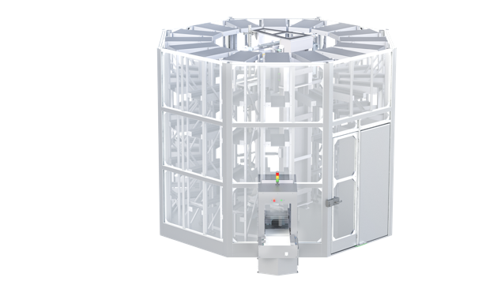  Image source: cts  Smart Octagon: With its compact dimensions, the Mini Smart Warehouse can even be used in clean rooms and uses the same intelligent software as the larger variants. | 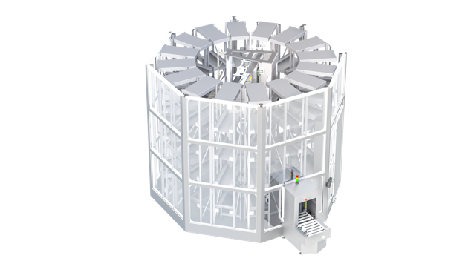  Image source: cts  Space-saving and efficient: An automated gripping system inside the Mini Smart Warehouse intelligently stores and thus quickly retrieves stock.

About cts GmbH
„cts - more than automation": Burgkirchen-based cts GmbH, founded in 2006, offers customers a complete range of services for process and manufacturing automation. More than 350 employees develop innovative solutions at several locations in Germany, Austria, the Czech Republic and Slovenia. They range from the construction of a single control cabinet to the automation of complete production plants, including information management. The comprehensive range of services offered by the established system integrator from southern Bavaria includes feasibility studies, conceptual design, planning, implementation, maintenance and servicing of running systems and plants.
cts installs stationary and mobile robots in machinery and equipment for high-tech industries such as automotive, electronics, radiopharmaceuticals and the semiconductor sector. As one of the leading companies for the integration and operation of heterogeneous fleets of autonomous, intelligent transport vehicles (AMR/AIV/AGV/FTS), cts also sets standards in automated material supply. Here, cts solutions are often used in combination with production-related or centralized automated storage systems.
In highly sensitive industrial segments such as chemicals and petrochemicals, life sciences or pharmaceuticals, cts supports its customers in the context of plant automation from planning to qualification. The Robotics business segment of cts includes the programming, installation and optimization of welding and production robots as well as fully automated packaging systems. The extensive portfolio of the specialist for process and factory automation is complemented by software solutions for data acquisition, evaluation, visualization and optimization of machines as well as plants and a suitable service and support offer.

Further information is available at www.group-cts.de

Kontakt:  cts GmbH  Susanne Meidl  Fuhrmannstraße 10  84508 Burgkirchen  Deutschland  Mobil: +49 163 3054 186  E-Mail: Susanne.Meidl@group-cts.de  www.group-cts.de | Presseagentur:  HighTech communications GmbH  Christian Resch  Brunhamstraße 21  81249 München  Deutschland  Telefon: +49 89 500778-23  E-Mail: c.resch@htcm.de  www.htcm.de

